Lesson 10: Problem Solving With Perimeter and Area

Standards Alignments
Addressing | 3.MD.D.8, 3.OA.C.7, 3.OA.D.8

Teacher-facing Learning Goals
- Solve problems that involve perimeter and area of rectangles.

Student-facing Learning Goals
- Let’s solve problems involving perimeter and area.

Lesson Purpose
The purpose of this lesson is for students to solve problems that involve both perimeter and area of rectangles in order to reinforce the difference between perimeter and area.
In previous lessons, students learned what area is and how to find the area of rectangles and figures made up of rectangles. They also learned how to measure the perimeter of other shapes, solve problems that involved perimeter, and recognize situations in which perimeter is and is not relevant. By the end of this lesson, students confirm that while perimeter and area are both measurements that can appear together in problems, perimeter is a linear measurement while area is two-dimensional.

Access for:

Students with Disabilities
- Representation (Activity 2)

English Learners
- MLR1 (Activity 1)

Instructional Routines
MLR4 Information Gap (Activity 2), True or False (Warm-up)

Materials to Copy
- Info Gap: A Garden and a Playground (groups of 2): Activity 2

Lesson Timeline
Warm-up | 10 min
Activity 1 | 15 min
Activity 2 | 20 min
Lesson Synthesis | 10 min
Cool-down | 5 min

Teacher Reflection Question
What was the best question you asked students today? Why would you consider it the best one based on what students said or did?

Cool-down
(to be completed at the end of the lesson) 5min
Lin’s Garden Fence

Standards Alignments
Addressing | 3.MD.D.8

Student-facing Task Statement
Lin is building a fence around her rectangular garden. A diagram is shown. The area of the garden is 36 square feet. How many feet of fencing material will she need to enclose the whole garden?
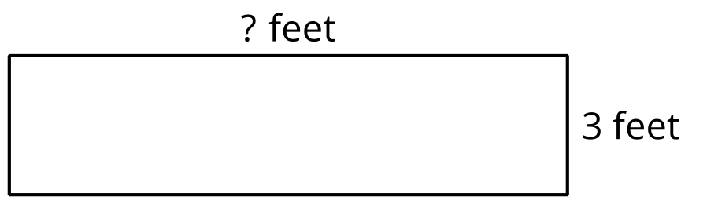

Student Responses
30 feet. Sample response: If the area is 36 square feet and one side is 3, I can divide 36 by 3 to find the missing side. Since $3×12=36$, the missing side is 12 feet long. The perimeter can be found by adding $2×12$ and $2×3$, which is 24 and 6. $24+6=30$.

