Lesson 20: What’s the Story?
- Let’s write story problems to match equations.

Warm-up: How Many Do You See: 10-Frames
How many do you see?
How do you see them?
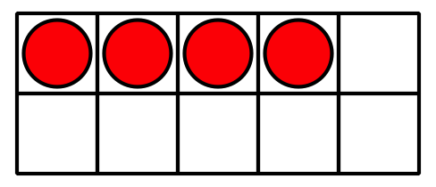
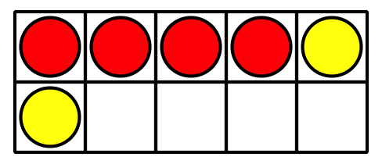
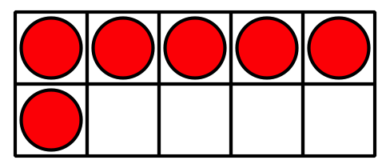
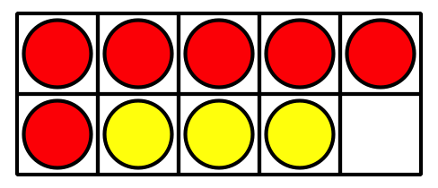

20.1: Write Story Problems
Choose 2 equations. Write a story problem for each equation.
- 3+5=8
- 4+3=7
- 10−5=5
- 9=5+4
- 3+7=10
- 6+3=9
- 8=2+6
- Equation: ________________________________
- Story Problem:
- Equation: ________________________________
- Story Problem:

20.2: I've Got the Answer
Circle a number that represents your answer.
2
3
4
5
6
7
8
9
10
Write an equation that includes the number you chose.
Put a box around the number.
Equation: ________________________________
Write a story problem that matches your equation.
Share your story problem with a partner.
Solve your partner’s story problem.
Write the equation that matches the story problem.
Equation: ________________________________
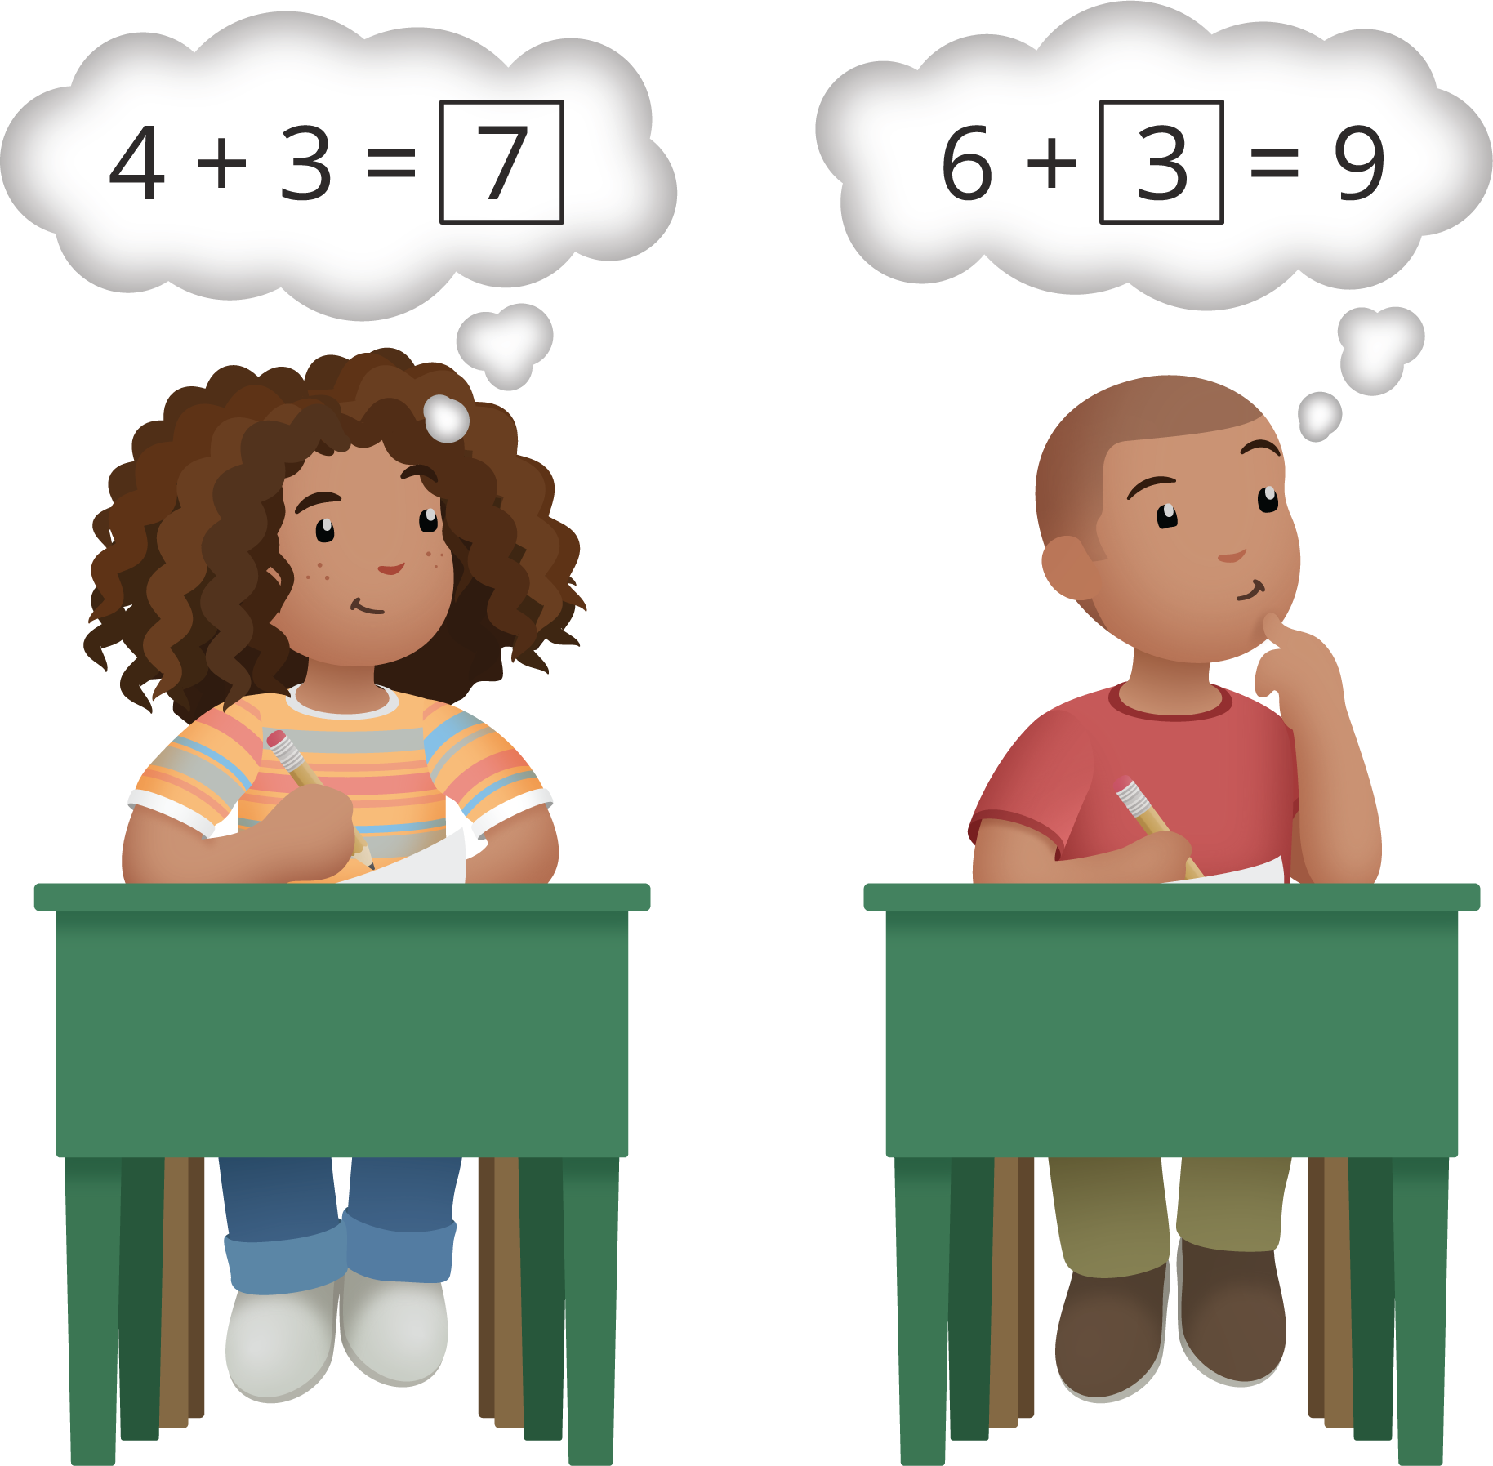

20.3: Centers: Choice Time
Choose a center.
Capture Squares
Shake and Spill
What's Behind My Back
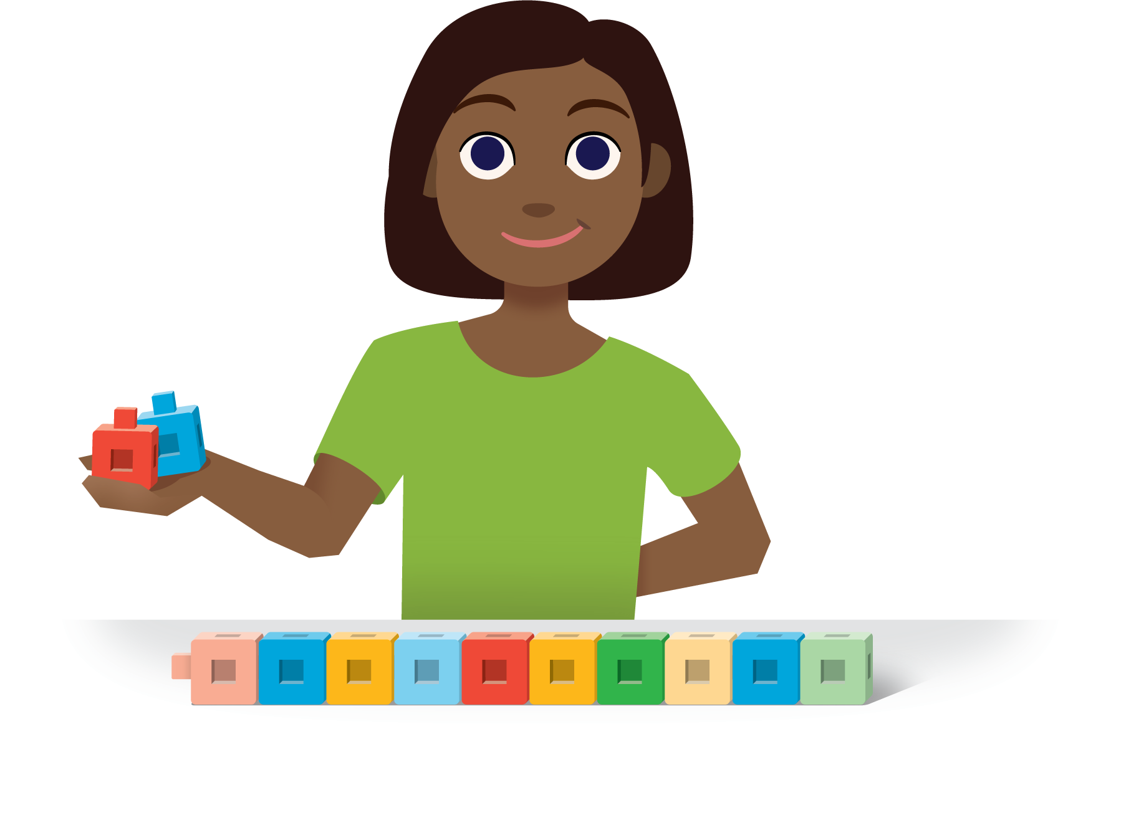

Section Summary
Section Summary
- We learned about equations where a number is missing and related them to story problems.
- Lin has 5 bingo chips on her board.
She also has some chips on the table.
All together she has 9 bingo chips.
How many chips does Lin have on the table?
- 9−5=4
and
5+4=9
- We thought about how addition and subtraction are related by solving story problems using both addition and subtraction.
- 9 students are playing bingo.
3 students are using blue chips to cover their boards.
The other students are using yellow chips.
How many students are using yellow chips?
- Clare wrote 3+6=9
Jada wrote 9−3=6
- We wrote our own story problems to match equations.
- Try writing a story to match these equations.
- 7+2=3
6+3=9
© CC BY 2021 Illustrative Mathematics®

