Lesson 1: Shapes That Are Solid
- Let’s sort and describe solid shapes.

Warm-up: Which One Doesn’t Belong: Shapes
Which one doesn’t belong?
A
B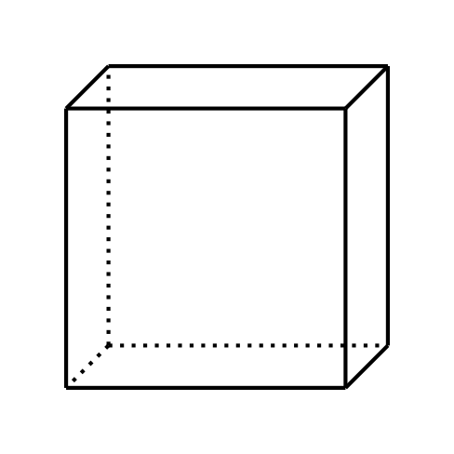
C
D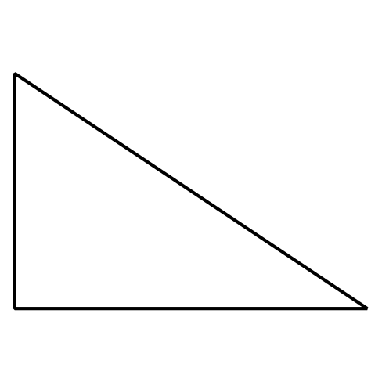

1.1: Sort Solid Shapes
- Sort some of the shapes into categories in a way that makes sense to you.
- Explain how you sorted the shapes.
- Sort some of your shapes into categories in a different way.
- Explain how you sorted the shapes.
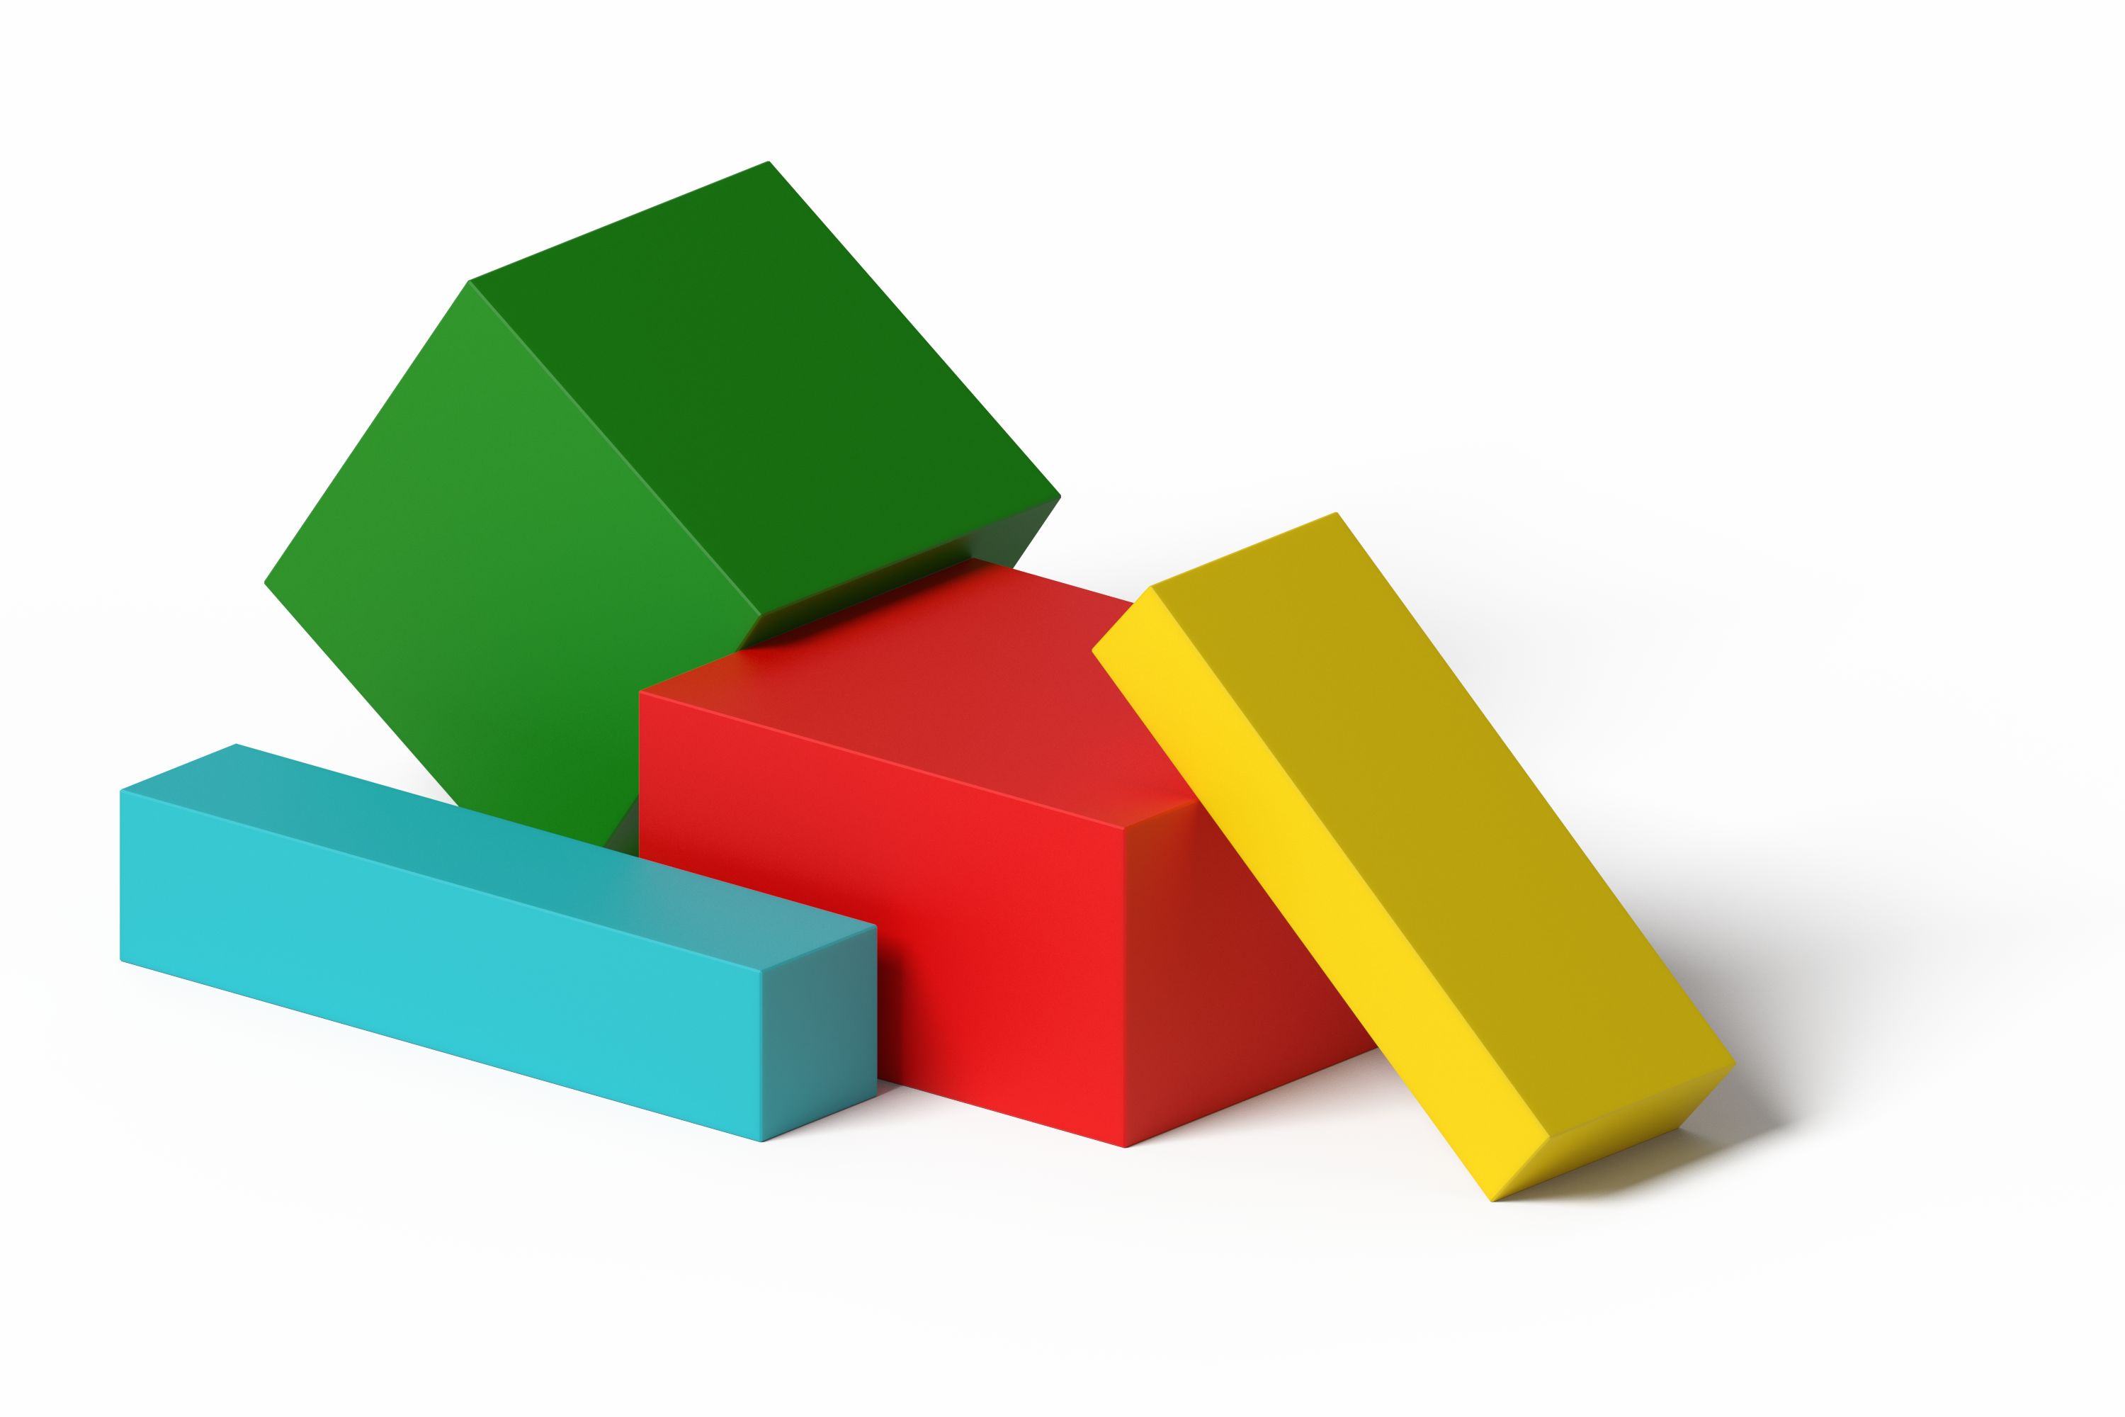

1.2: Describe and Find Shapes
- Pick a bag.
- Each partner feels the shape in the bag without looking at it and thinks about which shape it is.
- Each partner tells which shape they think it is and why.
- Look in the bag to check.
- Pick a different bag.
© CC BY 2021 Illustrative Mathematics®

