Lesson 10: Center Day 2
- Let’s play games to practice adding and subtracting.

Warm-up: Notice and Wonder: Compare the Representations
What do you notice? What do you wonder?

- 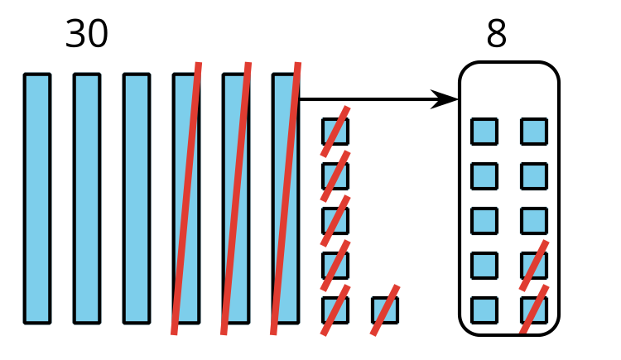
- $66−28$
$66=50+16$
$16−8=8$
$50−20=30$
$30+8=38$
$66−28=38$

10.2: Centers: Choice Time
Choose a center.
Target Numbers
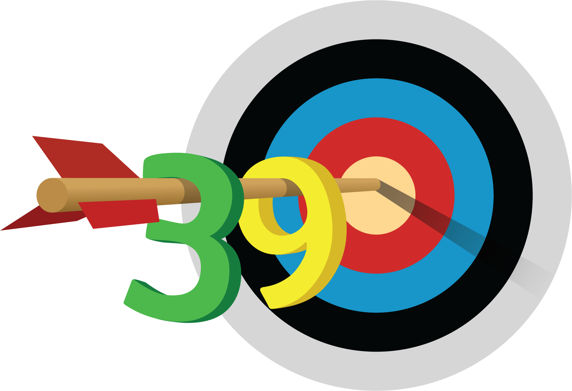
Capture Squares
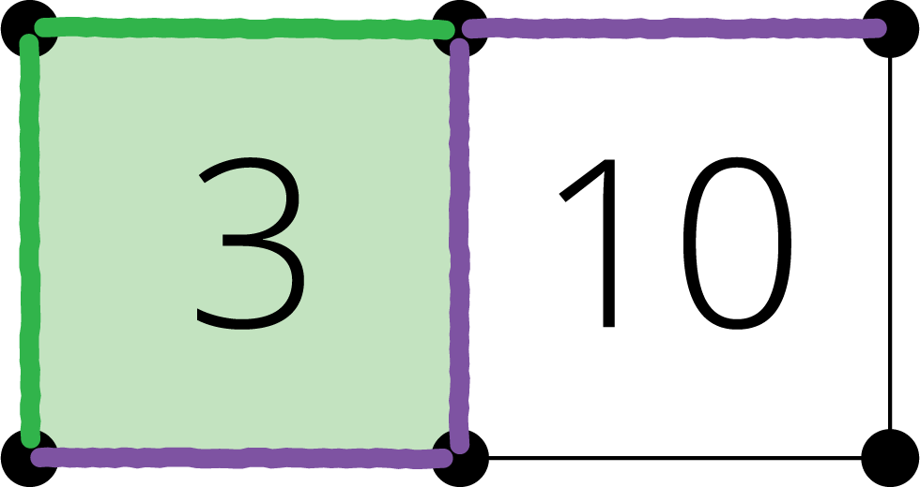
Five in a Row
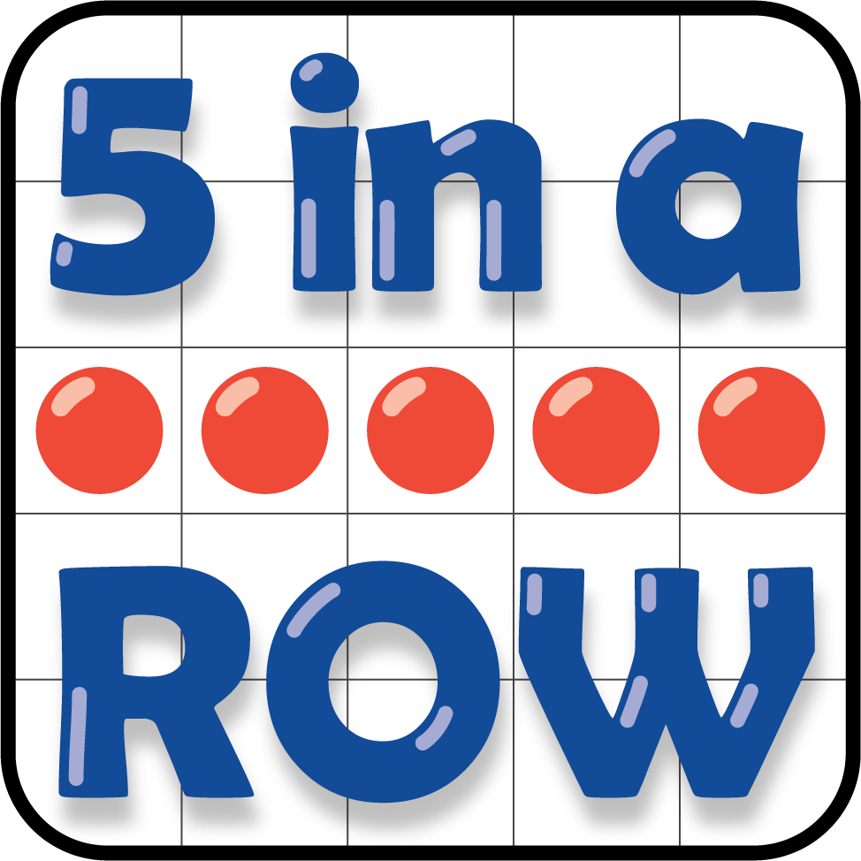
© CC BY 2021 Illustrative Mathematics®

