Lesson 8: More Than One Way
- Let’s find more than one way to solve a problem.

Warm-up: Number Talk: Expressions
Find the value of each expression.
- $3+1$
- $1+3$
- $4−1$
- $4+1$

8.1: Citrus Juice
Han squeezed 9 pieces of fruit to make juice.
Some of the fruits were satsumas.
The rest of the fruits were grapefruits.
How many of the fruits were satsumas?
Then how many of the fruits were grapefruits?
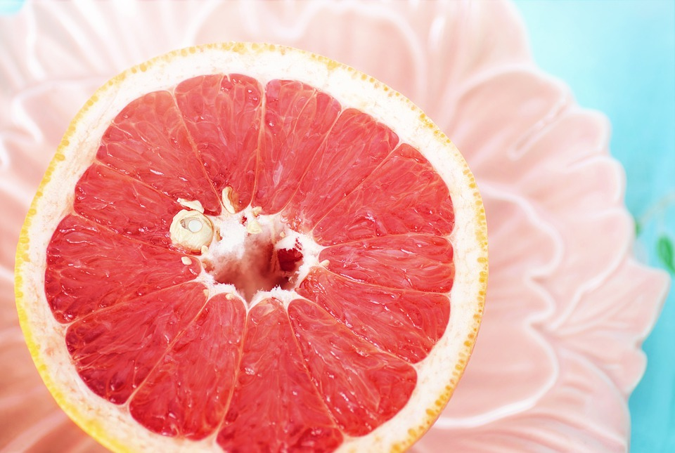
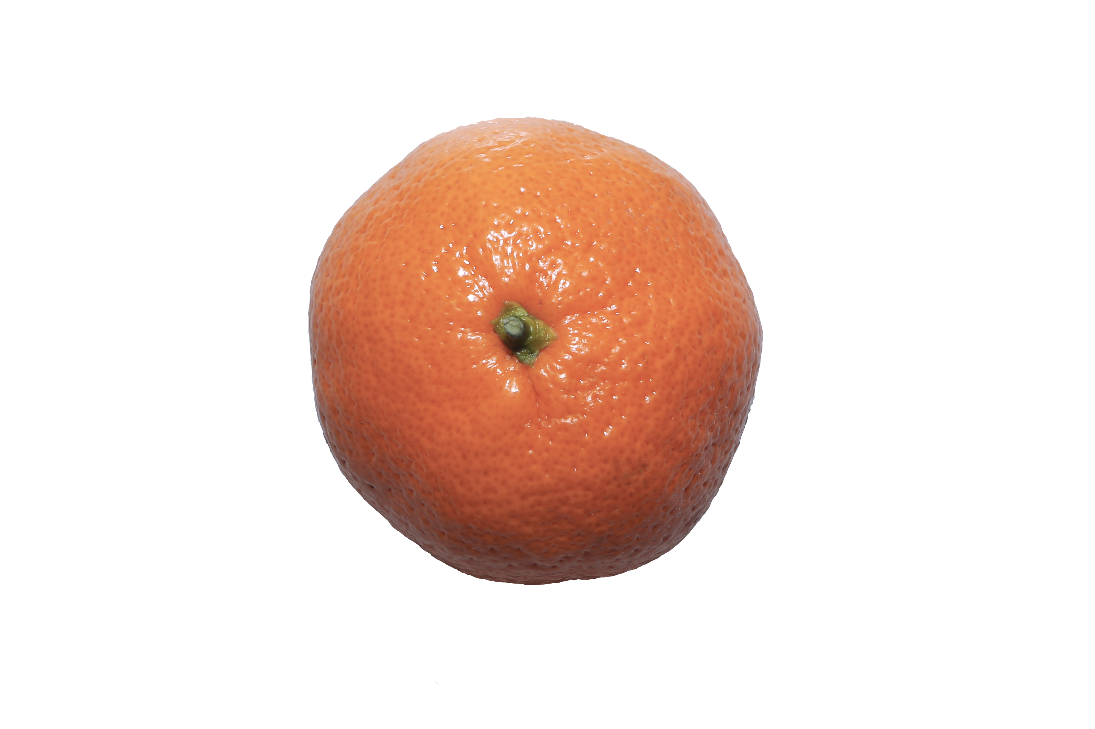
Clare:
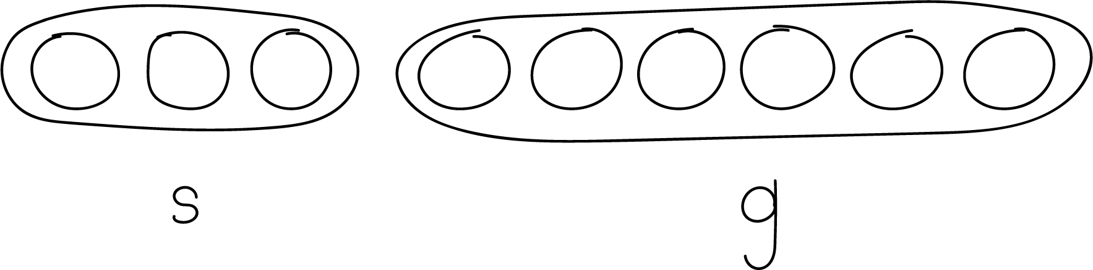
Diego:
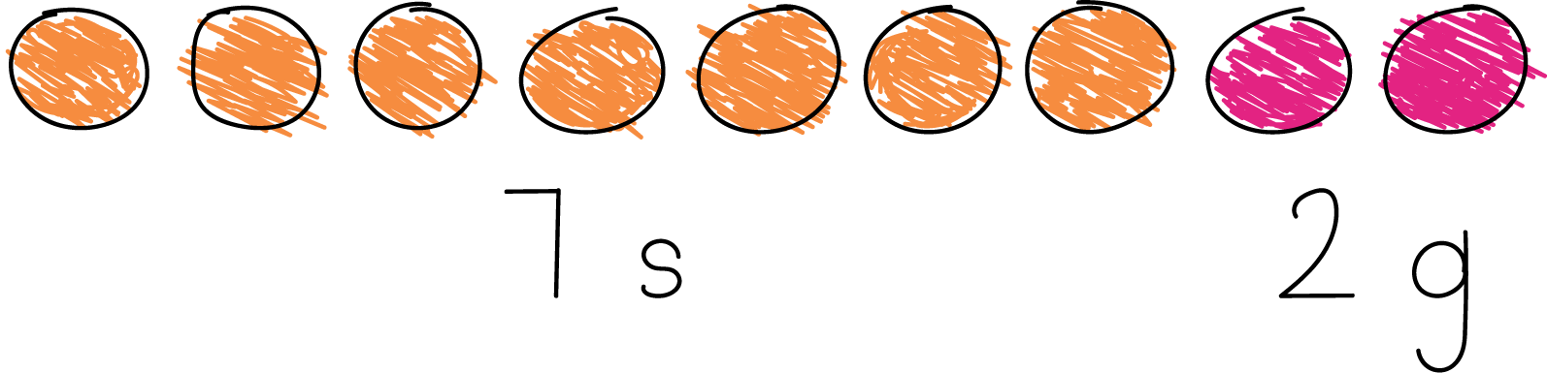
Han squeezed 9 pieces of fruit to make juice.
Some of the fruits were satsumas.
The rest of the fruits were grapefruits.
How many of the fruits were satsumas?
Then how many of the fruits were grapefruits?
Show your thinking using objects, drawings, numbers, or words.
Expression: ____________________________________

8.2: Dates to Stuff
Andre and his older brother have 8 dates.
They stuff some of the dates with cheese.
They stuff the rest of the dates with almonds.
How many of the dates did they stuff with cheese?
Then how many of the dates did they stuff with almonds?
Expression: _______________________________
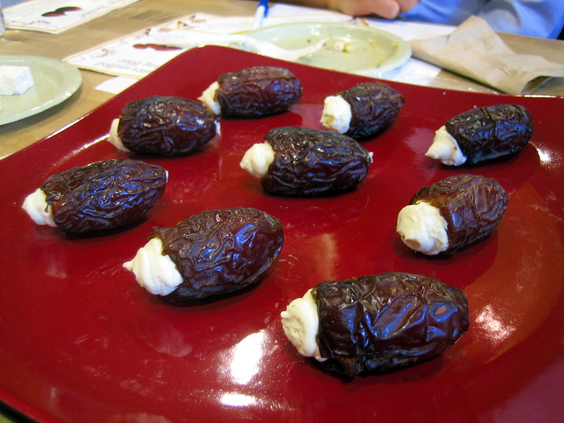
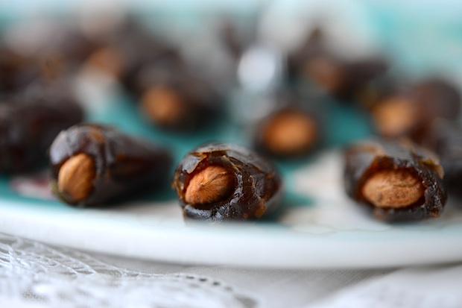

8.3: Centers: Choice Time
Choose a center.
What’s Behind My Back?
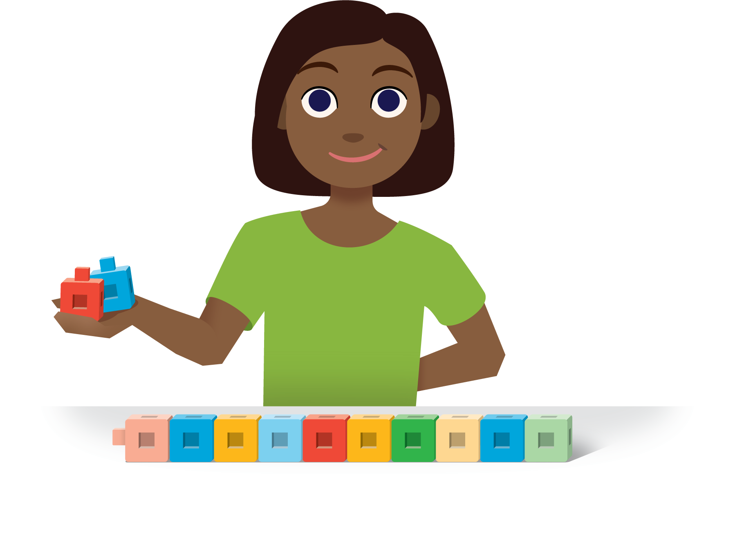
5-frames
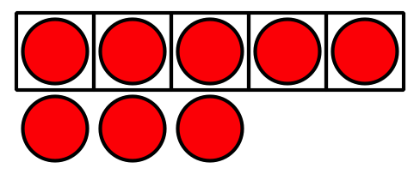
Make or Break Apart Numbers
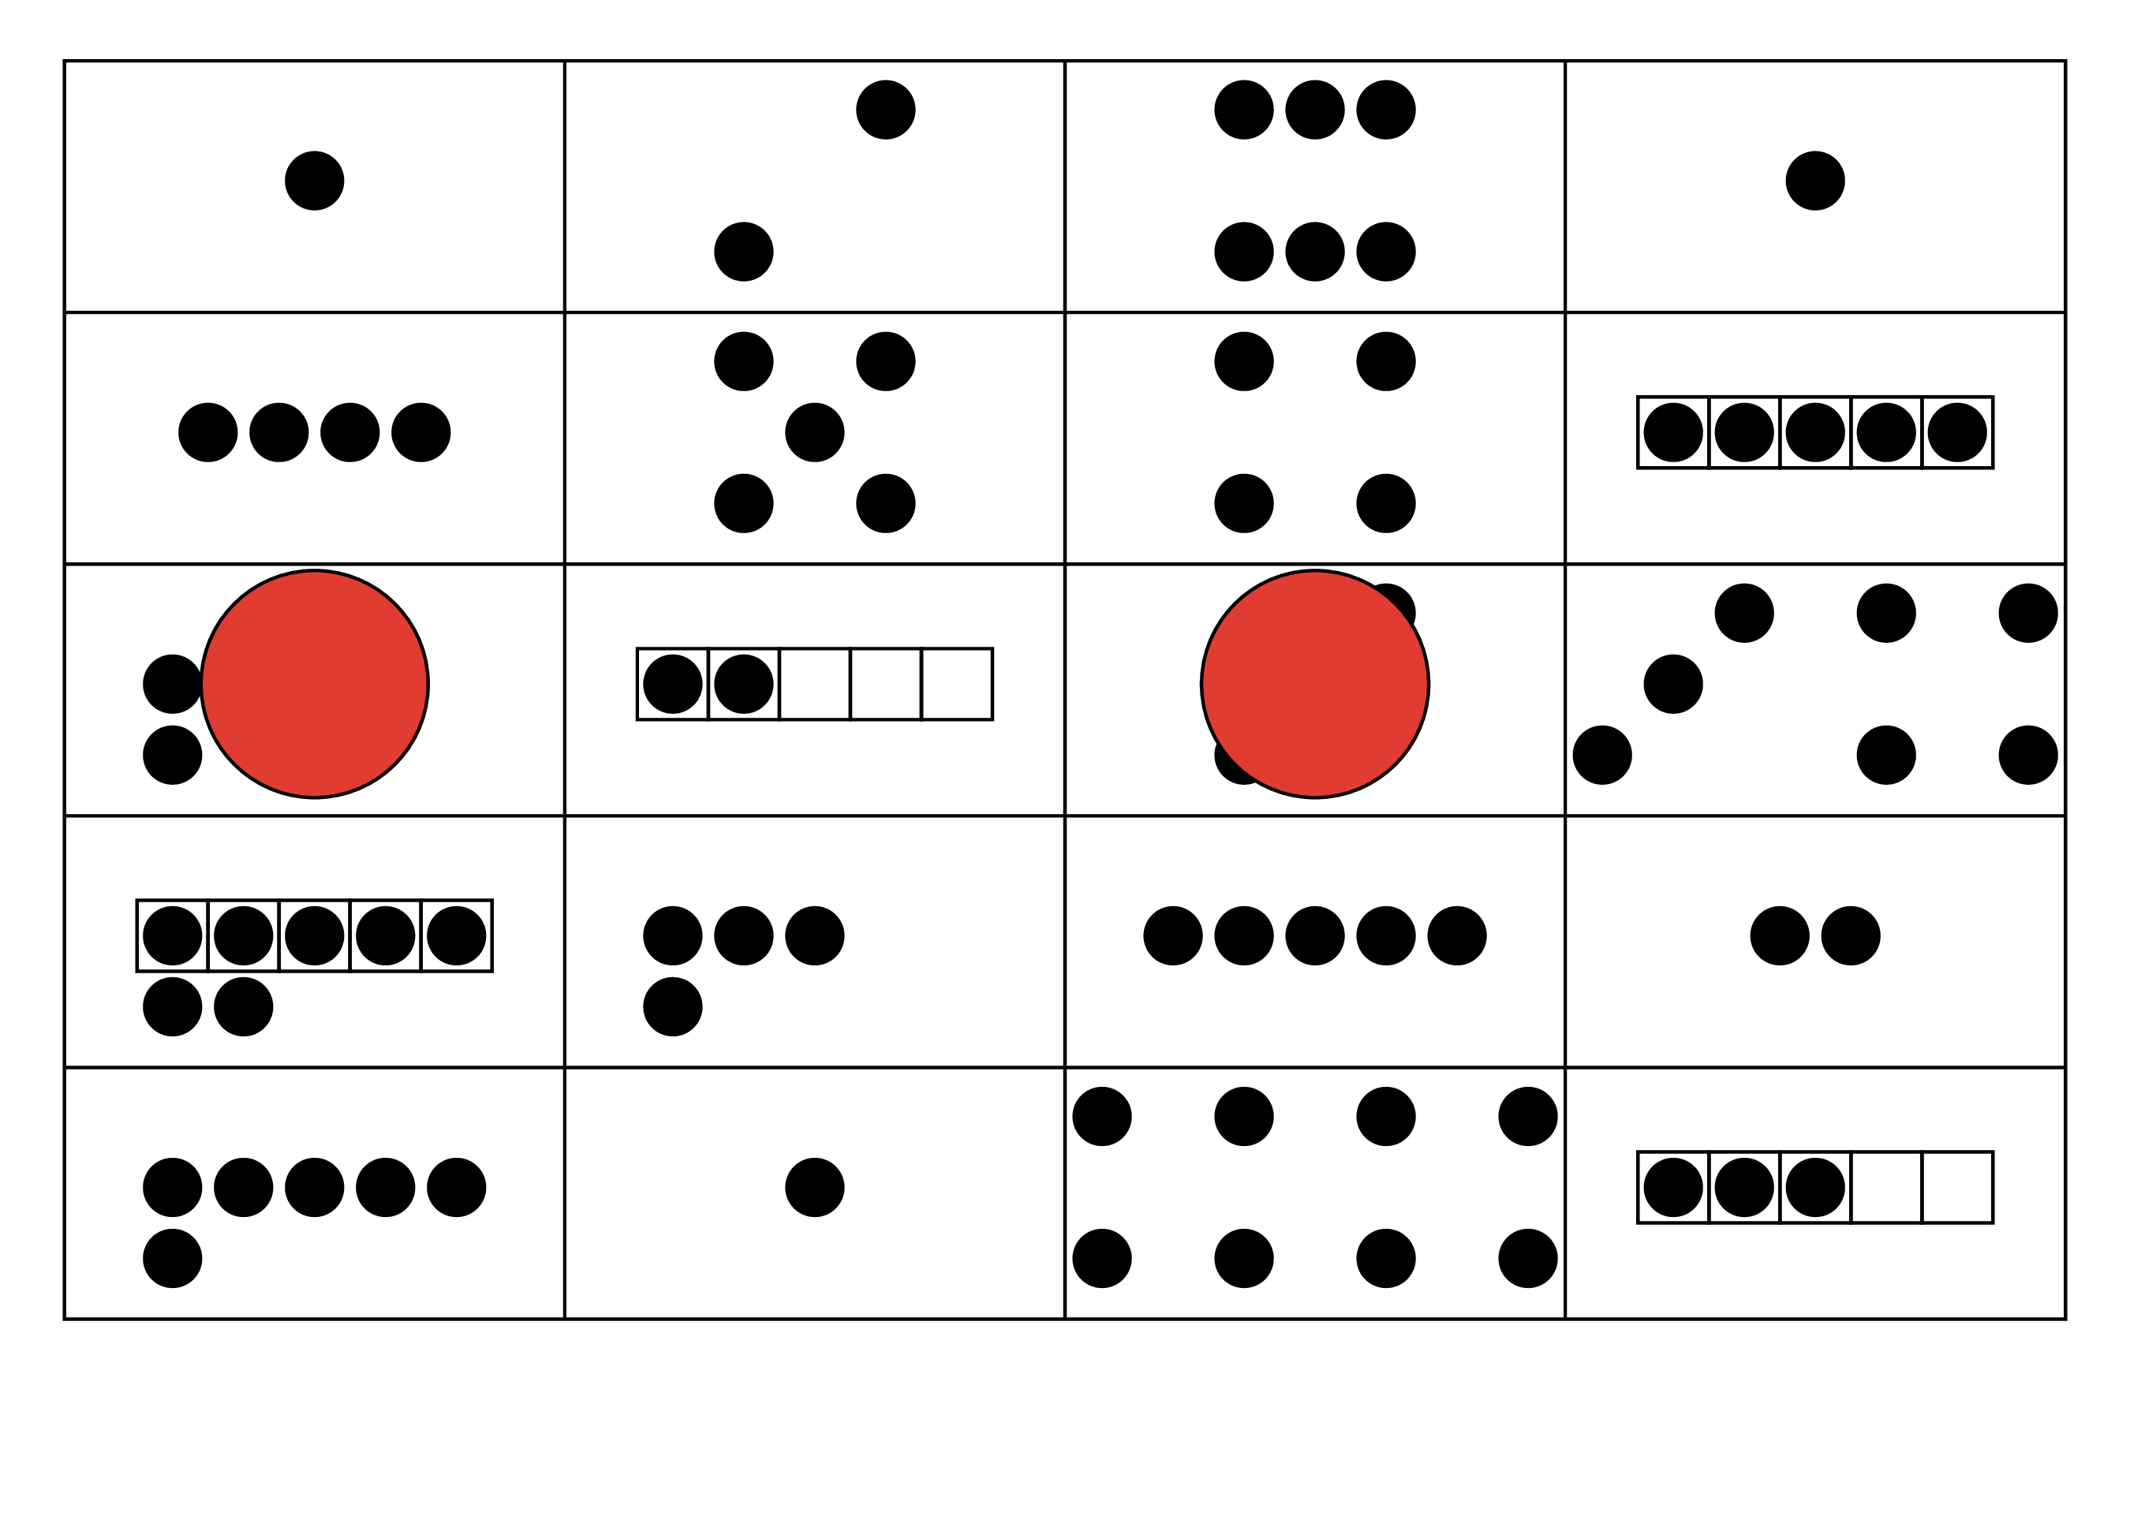
Math Stories
© CC BY 2021 Illustrative Mathematics®

