Lesson 20: Dividing Decimals by Decimals

20.1: Number Talk: Dividing by 4
Find each quotient mentally.
$80÷4$
$12÷4$
$1.2÷4$
$81.2÷4$

20.2: Dividends and Divisors
Analyze the dividends, divisors, and quotients in the calculations, and then answer the questions.
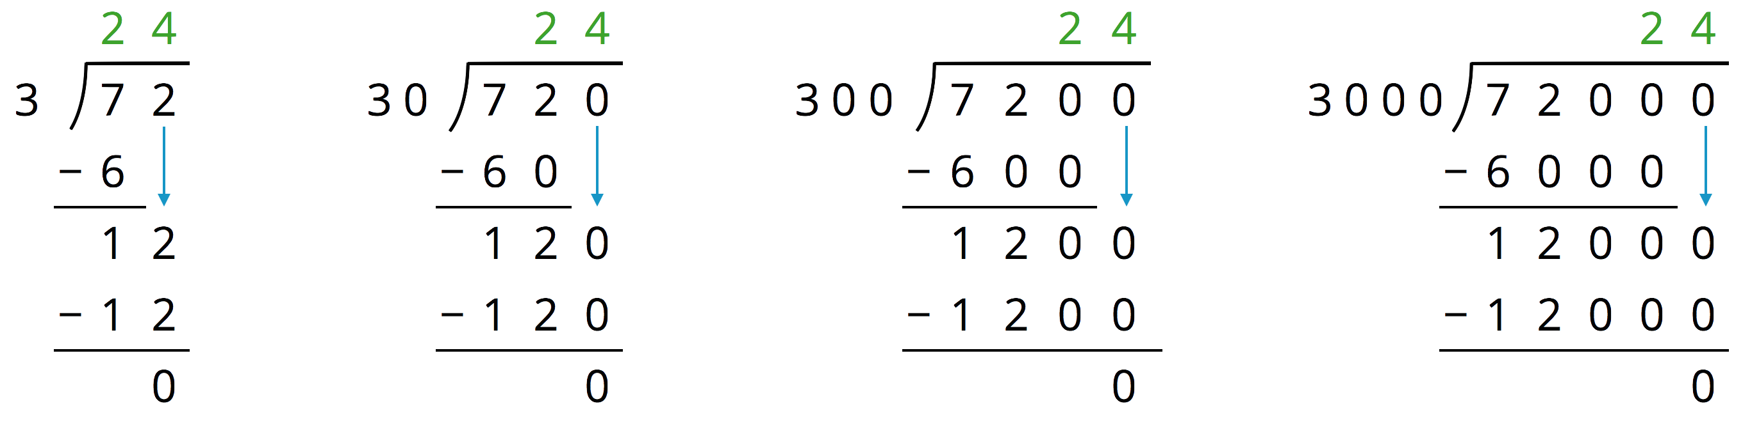
- Complete each sentence. In the calculations shown:
  - Each dividend is ______ times the dividend to the left of it.
  - Each divisor is ______ times the divisor to the left of it.
  - Each quotient is _____________________ the quotient to the left of it.
- Suppose we are writing a calculation to the right of $72,​000÷3,​000$. Which expression has a quotient of 24? Be prepared to explain your reasoning.
  - $72,​000÷30,​000$
  - $720,​000÷300,​000$
  - $720,​000÷30,​000$
  - $720,​000÷3,​000$
- Suppose we are writing a calculation to the left of $72÷3$. Write an expression that would also give a quotient of 24. Be prepared to explain your reasoning.
- Decide which of the following expressions would have the same value as $250÷10$. Be prepared to share your reasoning.
  - $250÷0.1$
  - $25÷1$
  - $2.5÷1$
  - $2.5÷0.1$
  - $2,500÷100$
  - $0.25÷0.01$

20.3: Placing Decimal Points in Quotients
- Think of one or more ways to find $3÷0.12$. Show your reasoning.
- Find $1.8÷0.004$. Show your reasoning. If you get stuck, think about what equivalent division expression you could write.
- Diego said, “To divide decimals, we can start by moving the decimal point in both the dividend and divisor by the same number of places and in the same direction. Then we find the quotient of the resulting numbers.”
- Do you agree with Diego? Use the division expression $7.5÷1.25$ to support your answer.

Are you ready for more?
Can we create an equivalent division expression by multiplying both the dividend and divisor by a number that is not a multiple of 10 (for example: 4, 20, or $\frac{1}{2}$)? Would doing so produce the same quotient? Explain or show your reasoning.

20.4: Practicing Division with Decimals
Find each quotient. Discuss your quotients with your group and agree on the correct answers. Consult your teacher if the group can't agree.
- $106.5÷3$
- $58.8÷0.7$
- $257.4÷1.1$
- Mai is making friendship bracelets. Each bracelet is made from 24.3 cm of string. If she has 170.1 cm of string, how many bracelets can she make? Explain or show your reasoning.

Lesson 20 Summary
One way to find a quotient of two decimals is to multiply each decimal by a power of 10 so that both products are whole numbers.
If we multiply both decimals by the same power of 10, this does not change the value of the quotient. For example, the quotient $7.65÷1.2$ can be found by multiplying the two decimals by 10 (or by 100) and instead finding $76.5÷12$ or $765÷120$.
To calculate $765÷120$, which is equivalent to $76.5÷12$, we could use base-ten diagrams, partial quotients, or long division. Here is the calculation with long division:
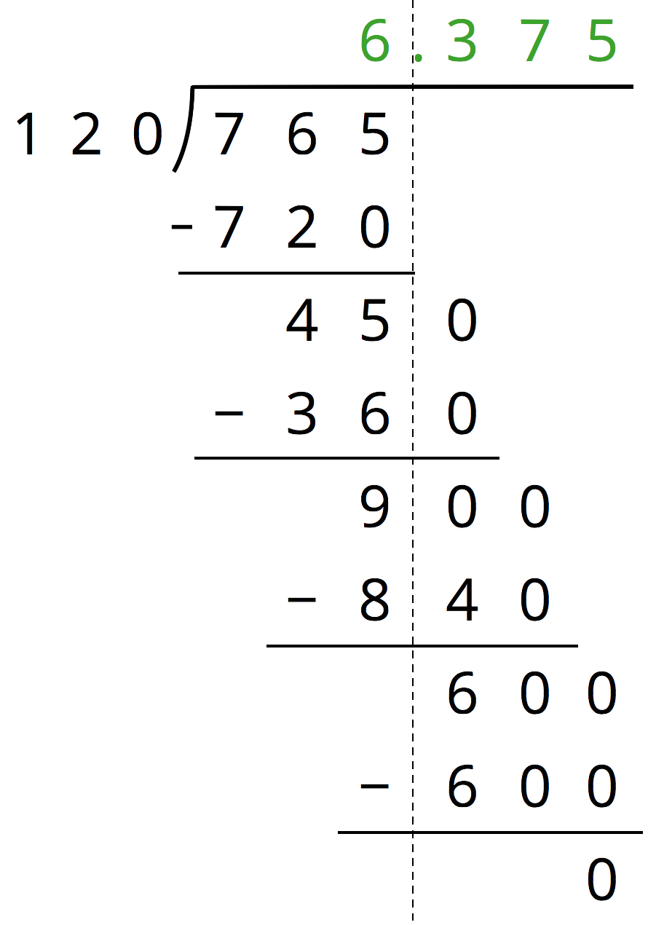
© CC BY Open Up Resources. Adaptations CC BY IM.

