Unit 4 Lesson 10: The Distributive Property, Part 2

1 Possible Areas (Warm up)

Student Task Statement
- A rectangle has a width of 4 units and a length of $m$ units. Write an expression for the area of this rectangle.
- What is the area of the rectangle if $m$ is:
- 3 units?
- 2.2 units?
- $\frac{1}{5}$ unit?
- Could the area of this rectangle be 11 square units? Why or why not?

2 Partitioned Rectangles When Lengths are Unknown

Student Task Statement
- Here are two rectangles. The length and width of one rectangle are 8 and 5. The width of the other rectangle is 5, but its length is unknown so we labeled it $x$.
- Write an expression for the sum of the areas of the two rectangles.
- The two rectangles can be composed into one larger rectangle as shown.
- What are the width and length of the new, large rectangle?
- Write an expression for the total area of the large rectangle as the product of its width and its length.

3 Areas of Partitioned Rectangles

Student Task Statement
For each rectangle, write expressions for the length and width and two expressions for the total area. Record them in the table. Check your expressions in each row with your group and discuss any disagreements.
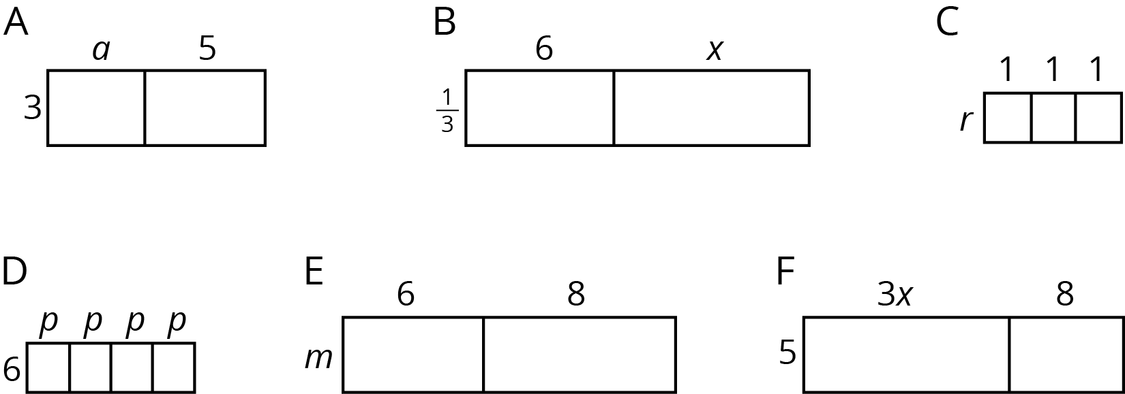

rectangle | width | length | area as a product of  width times length | area as a sum of the areas  of the smaller rectangles
A
B
C
D
E
F

© CC BY Open Up Resources. Adaptations CC BY IM.

