Lesson 6: Red and Yellow Apples
- Let’s show what happens in a story.

Warm-up: Act It Out: All About Apples
Mai was picking apples at the orchard.
Mai picked 5 yellow apples and 2 red apples.
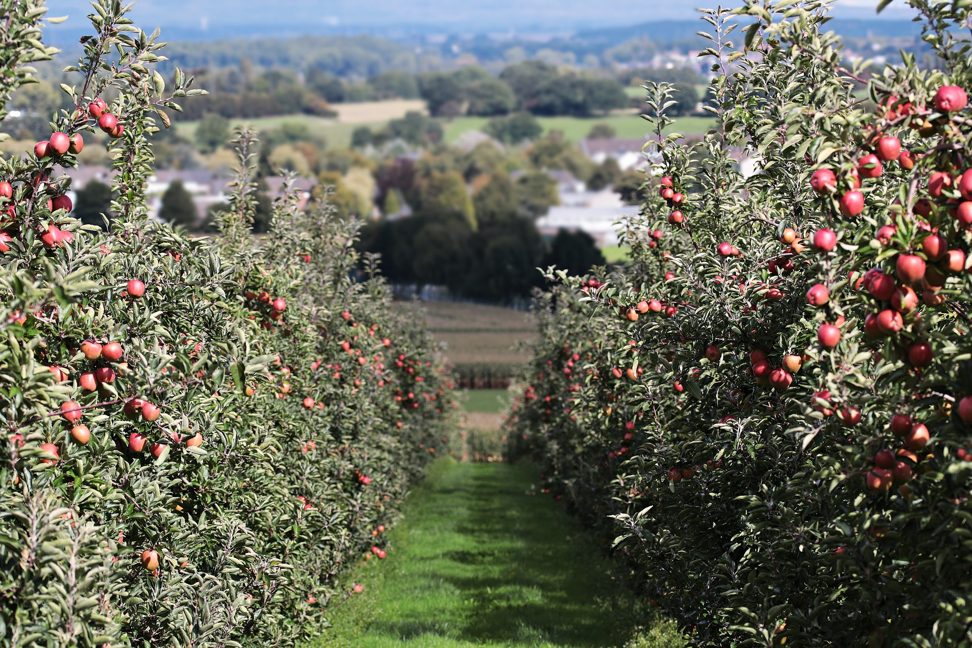

6.1: Two Problems about Apples
- Mai was picking apples at the orchard.
- Mai picked 5 yellow apples and 2 red apples.
- Lin picked 8 apples at the orchard.
- Some of the apples were yellow.
- The rest of the apples were red.
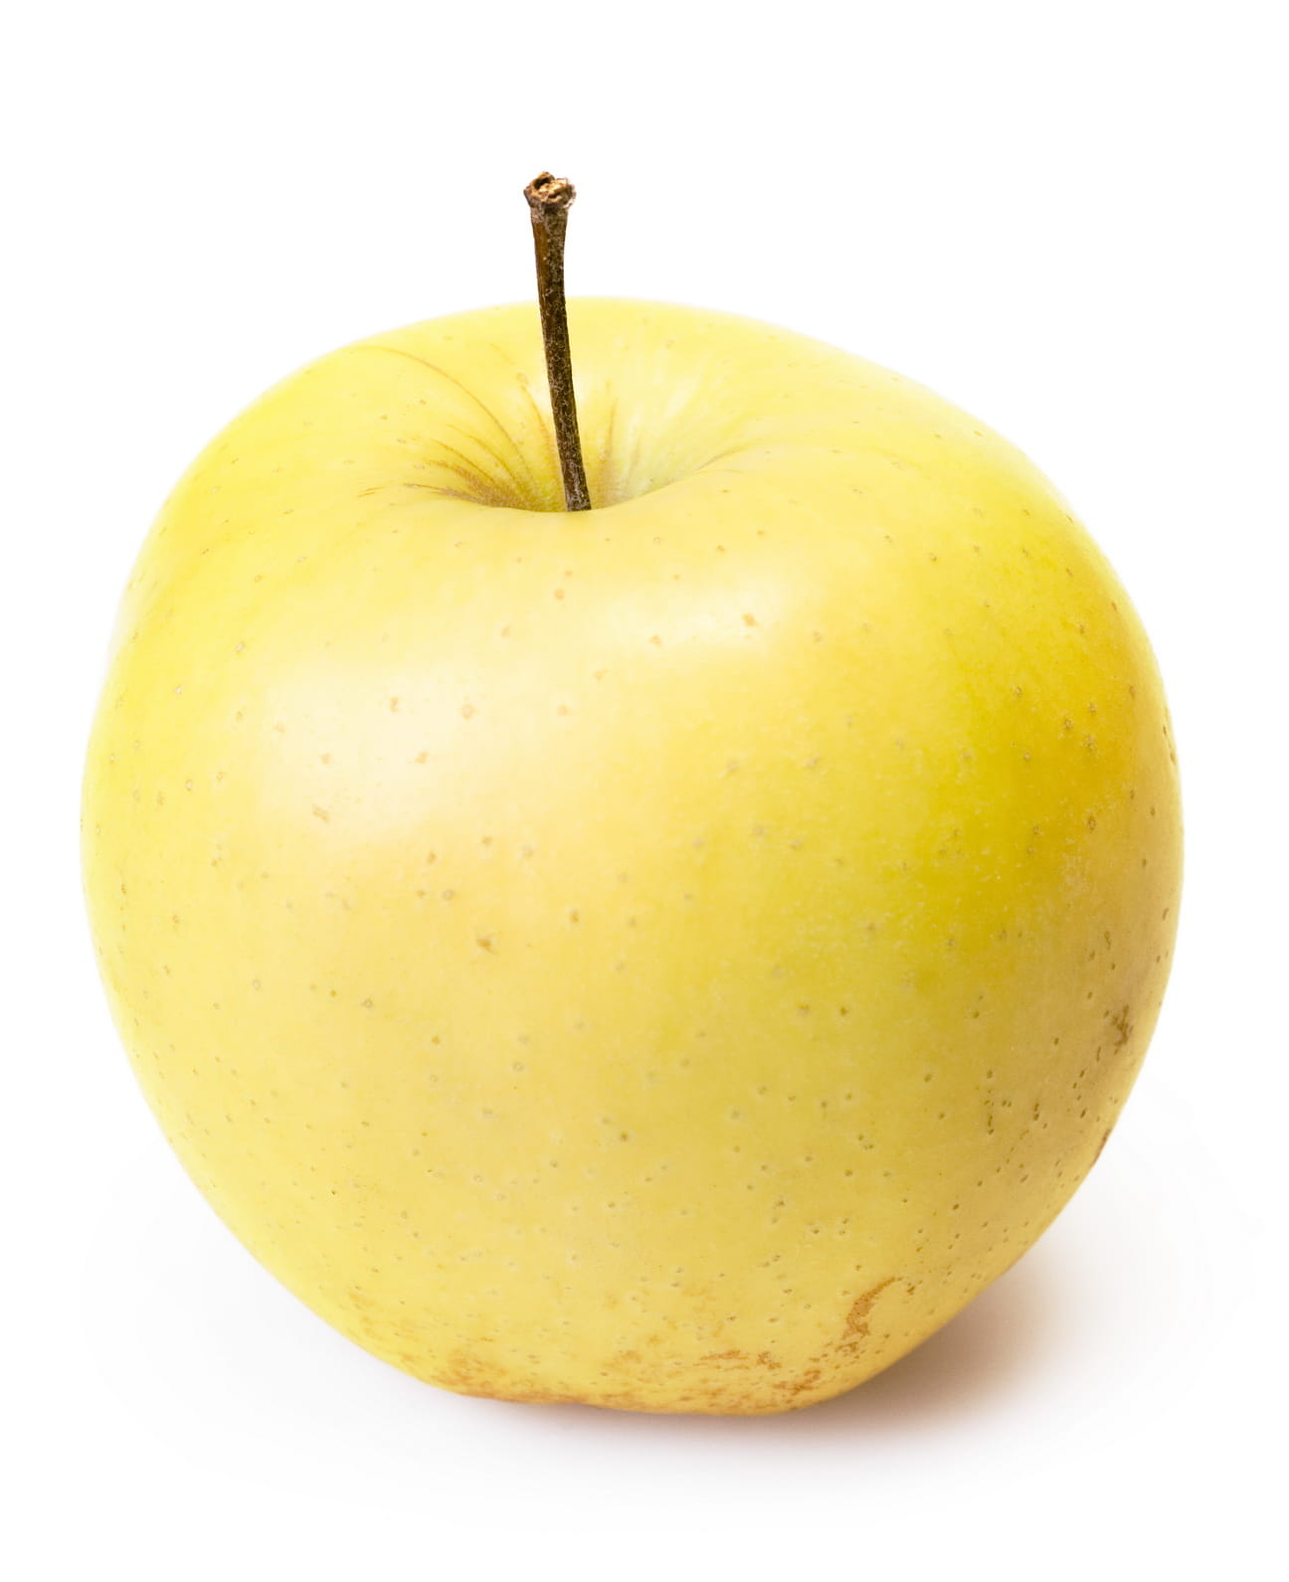
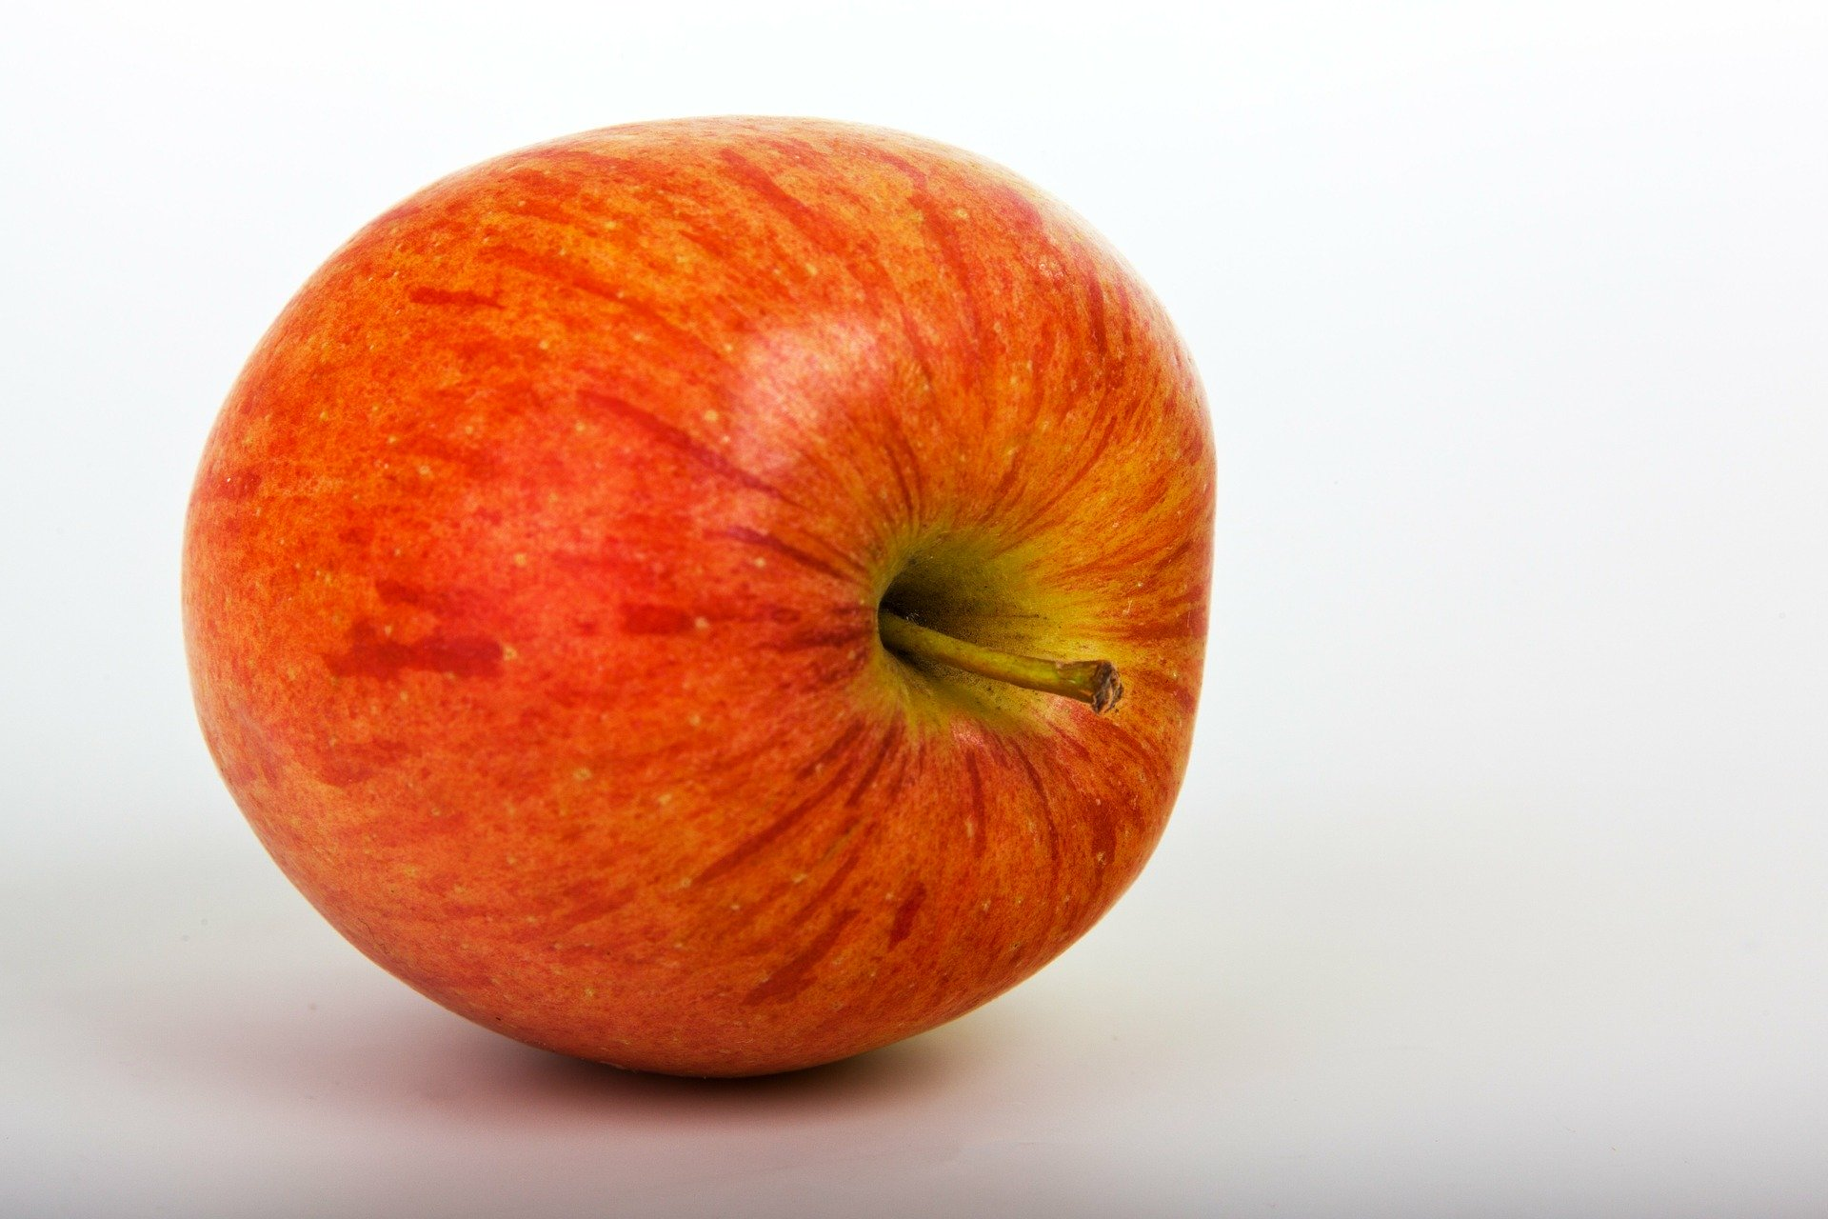

6.2: Yellow Apples and Red Apples
Lin picked 8 apples at the orchard.
Some of the apples were yellow.
The rest of the apples were red.

6.3: Centers: Choice Time
Choose a center.
What’s Behind My Back?
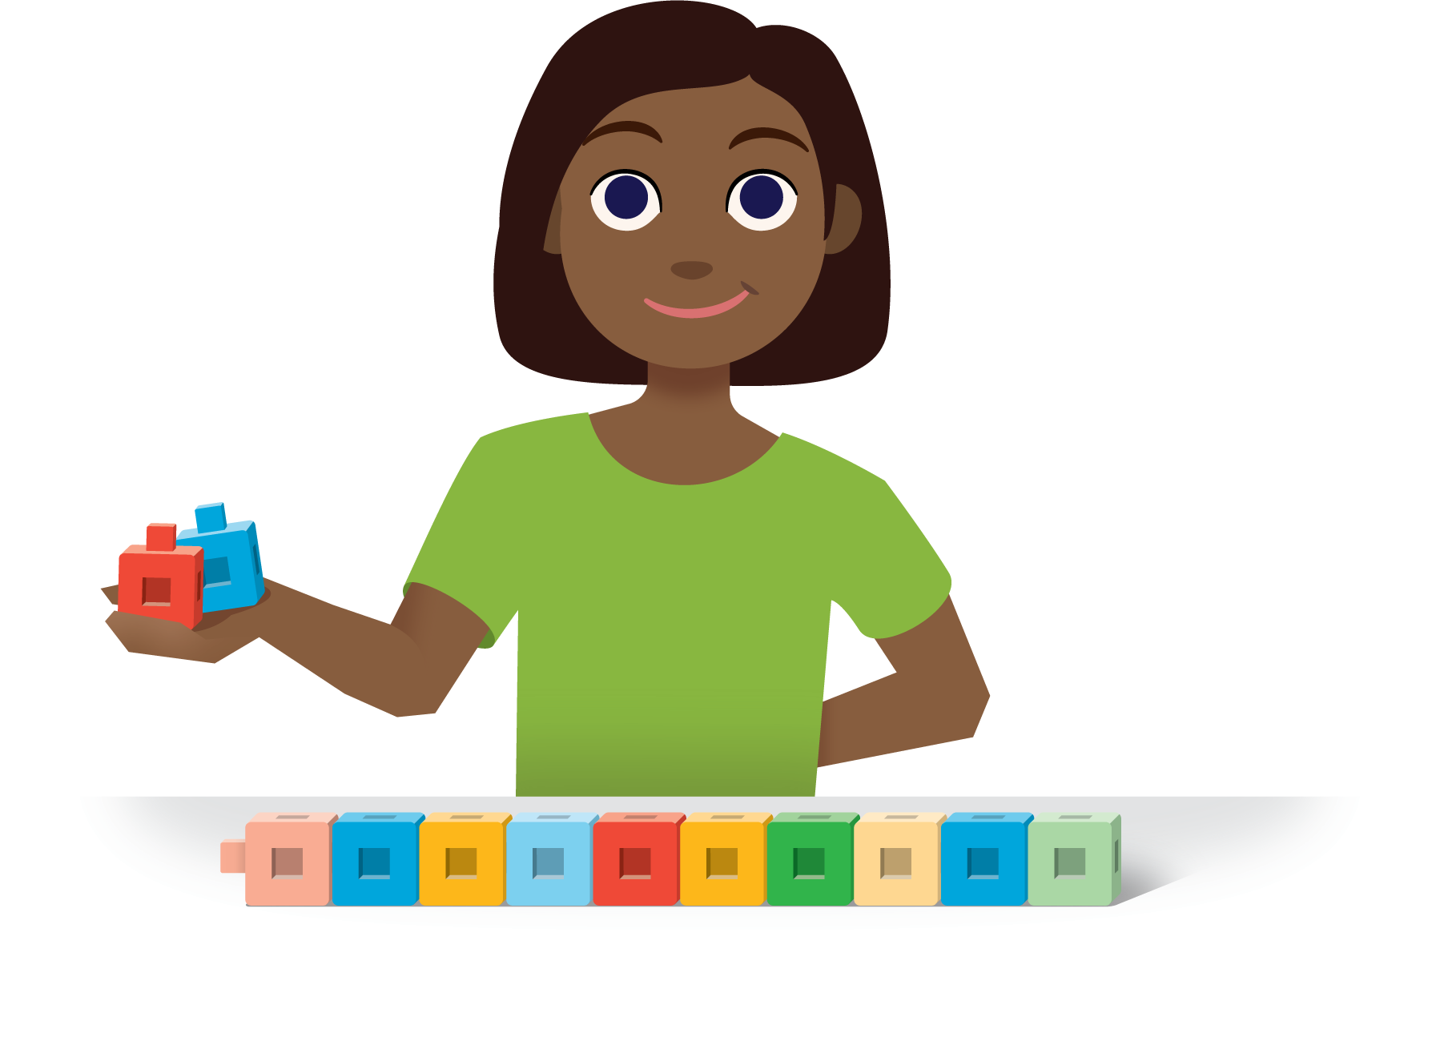
5-frames
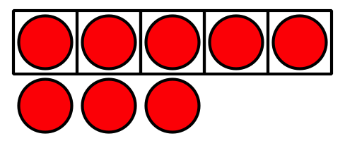
Make or Break Apart Numbers
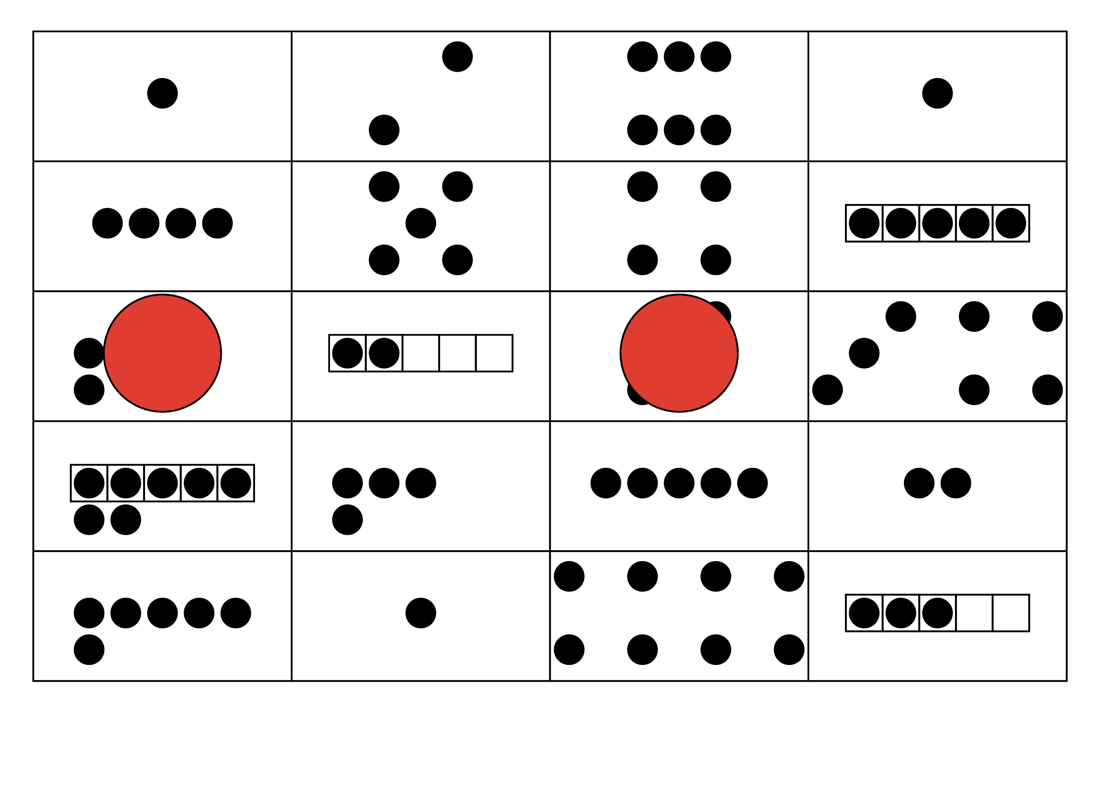
© CC BY 2021 Illustrative Mathematics®

