Lesson 15 Practice Problems
- Noah's cousin is exactly 7 years younger than Noah. Let $C$ represent Noah's cousin's age and $N$ represent Noah's age. Ages are measured in years.
  - Write a function that defines the cousin's age as a function of Noah's age. What are the input and output of this function?
  - Write the inverse of the function you wrote. What are the input and output of this inverse function?
- Noah's cousin is exactly 7 years younger than Noah. Let $M$ represent Noah's cousin's age in months and $N$ represent Noah's age in years.
  - If Noah is 15 years old, how old is his cousin, in months?
  - When Noah's cousin is 132 months old, how old is Noah, in years?
  - Write a function that gives the age of Noah's cousin in months, as a function of Noah's age in years.
  - Write the inverse of the function you wrote. What are the input and the output of this inverse function?
- Each equation represents a function. For each, find the inverse function.
  - $c=w+3$
  - $y=x−2$
  - $y=5x$
  - $w=\frac{d}{7}$
- The number of years, $y$, is a function of the number of months, $m$. The number of months, $m$, is also a function of the number of years, $y$.
  - Write two equations, one to represent each function.
  - Explain why the two functions are inverses.
- Sketch a graph to represent each quantity described as a function of time. Be sure to label the vertical axis.
- Swing: The height of your feet above ground while swinging on a swing at a playground
- 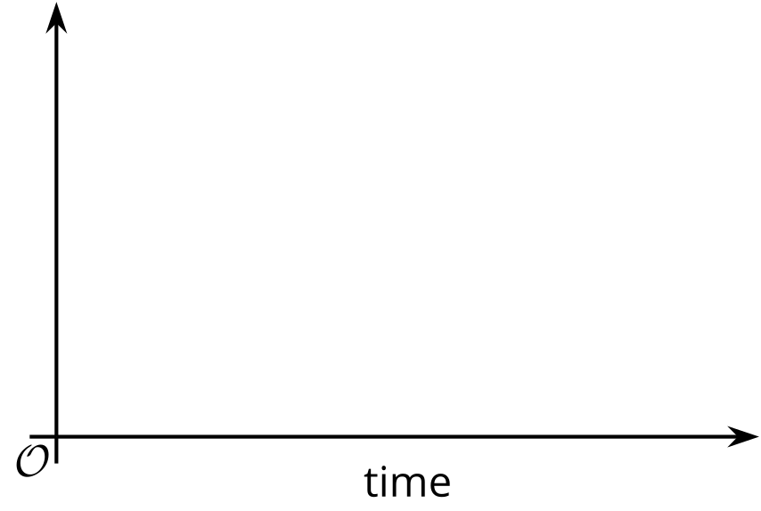
- Slide: The height of your shoes above ground as you walk to a slide, go up a ladder, and then go down a slide
- Merry-go-round: Your distance from the center of a merry-go-round as you ride the merry-go-round
- Merry-go-round, again: Your distance from your friend, who is standing next to the merry-go-round as you go around
- (From Unit 4, Lesson 8.)
- Lin charges $5.50 per hour to babysit. The amount of money earned, in dollars, is a function of the number of hours that she babysits.
- Which of the following inputs is impossible for this function?
  - -1
  - 2
  - 5
  - 8
- (From Unit 4, Lesson 10.)
- The instructions for cooking a steak with a pressure cooker can be represented with this set of rules, where $x$ represents the weight of a steak in ounces and $f\left(x\right)$ the cooking time in minutes.
- $f\left(x\right)=\left\{\begin{matrix}7, & 8≤x≤12 \\ 8, & 12<x≤13 \\ 9, & 13<x≤14 \\ 10, & 14<x≤15 \\ 11, & 15<x≤16\end{matrix}\right.$
  - Describe the instructions in words so that they can be followed by someone using the pressure cooker.
  - Graph function $f$.
  - 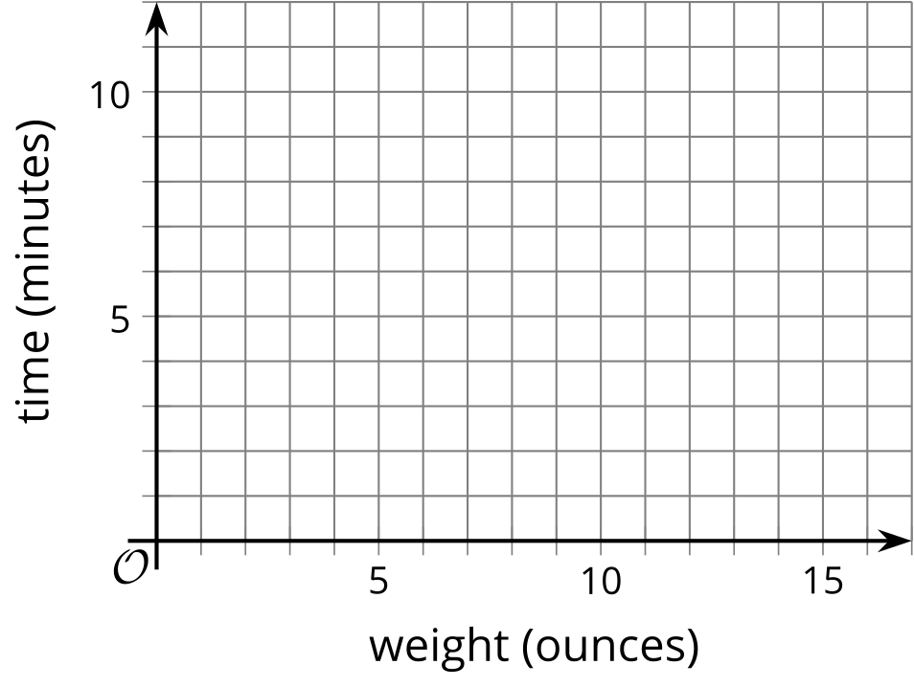
- (From Unit 4, Lesson 12.)
- The absolute value function $Q\left(x\right)=\left|x\right|$ gives the distance from 0 of the point $x$ on the number line.
- $Q$ can also be defined using piecewise notation: $Q\left(x\right)=\left\{\begin{matrix}x, & x≥0 \\ \text{-}x, & x<0\end{matrix}\right.$
- Determine if each point is on the graph of $Q$. For each point that you believe is not on the graph of $Q$, change the output coordinate so that the point is on the graph of $Q$.
  - $\left(\text{-}3,3\right)$
  - $\left(0,0\right)$
  - $\left(\text{-}5,\text{-}5\right)$
  - $\left(\text{-}72,72\right)$
  - $\left(\frac{4}{5},\text{-}\frac{4}{5}\right)$
- (From Unit 4, Lesson 14.)
© CC BY 2019 by Illustrative Mathematics®

