Lesson 5 Practice Problems
- A circle with an area of $8π$ square centimeters is dilated so that its image has an area of $32π$ square centimeters. What is the scale factor of the dilation?
  - 2
  - 4
  - 8
  - 16
- A trapezoid has an area of 100 square units. What scale factor would be required to dilate the trapezoid to have each area?
  - 6400 square units
  - 900 square units
  - 100 square units
  - 25 square units
  - 4 square units
- A triangle has an area of 6 square inches and a perimeter of 12 inches. Suppose it is dilated by some scale factor, and the area and perimeter of the image are calculated. Match each graph with the relationship it represents.

- Graph A
- 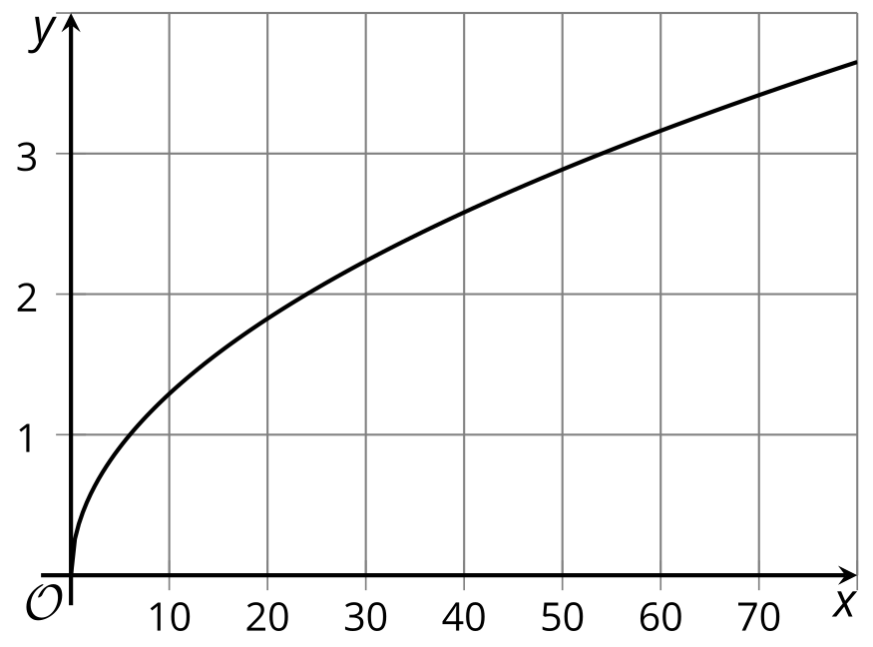

- Graph B
- 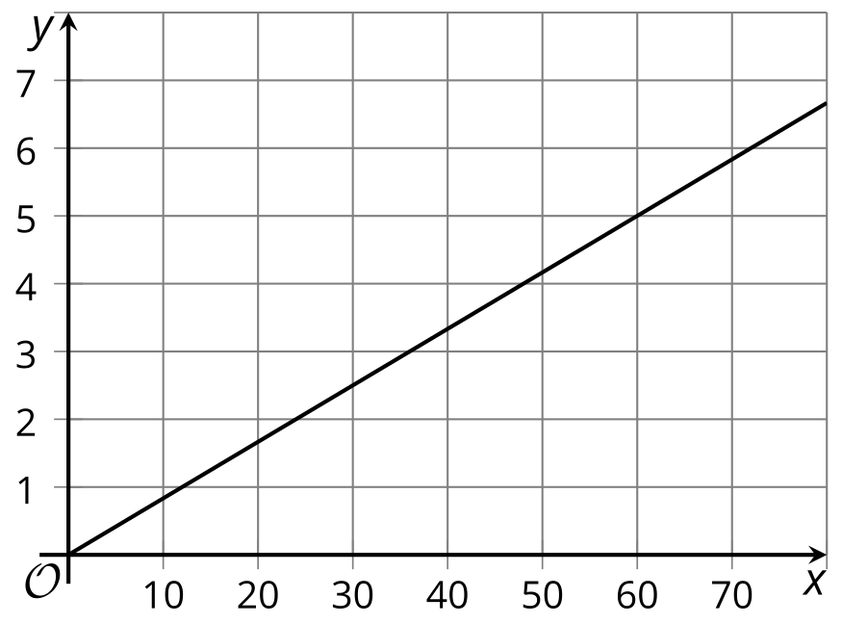

- Graph C
- 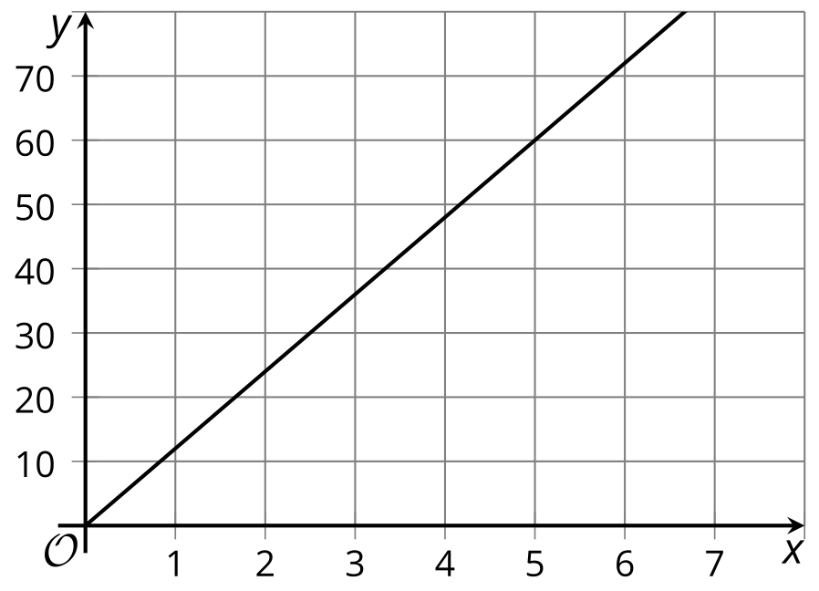

- Graph D
- 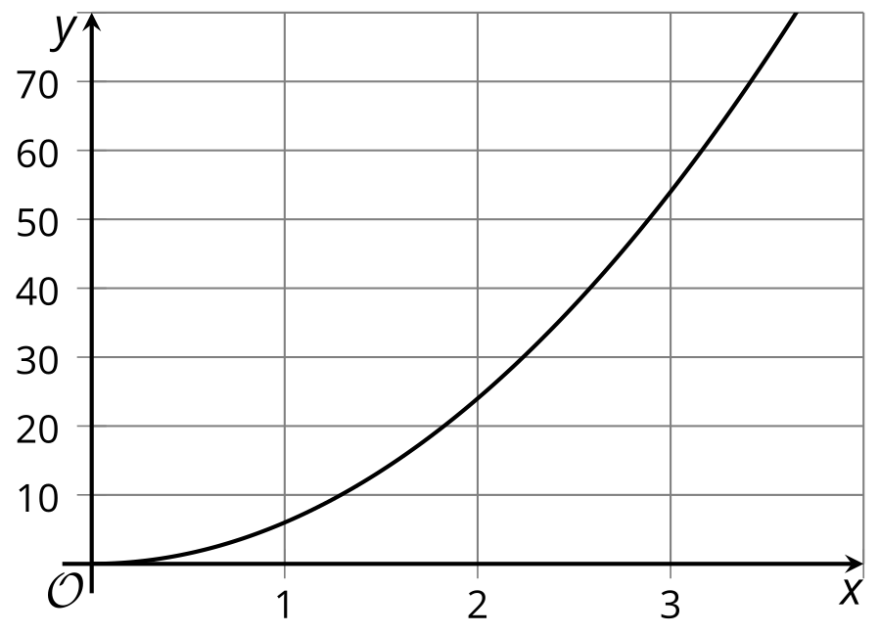
  - Graph A
  - Graph B
  - Graph C
  - Graph D
  - scale factor is the $x$-value; perimeter is the $y$-value
  - scale factor is the $x$-value; area is the $y$-value
  - perimeter is the $x$-value; scale factor is the $y$-value
  - area is the $x$-value; scale factor is the $y$-value
- A polygon with area 10 square units is dilated by a scale factor of $k$. Find the area of the image for each value of $k$.
  - $k=4$
  - $k=1.5$
  - $k=1$
  - $k=\frac{1}{3}$
- (From Unit 5, Lesson 4.)
- Parallelogram $AB^{′}C^{′}D^{′}$ was obtained by dilating parallelogram $ABCD$ using $A$ as the center of dilation.
- 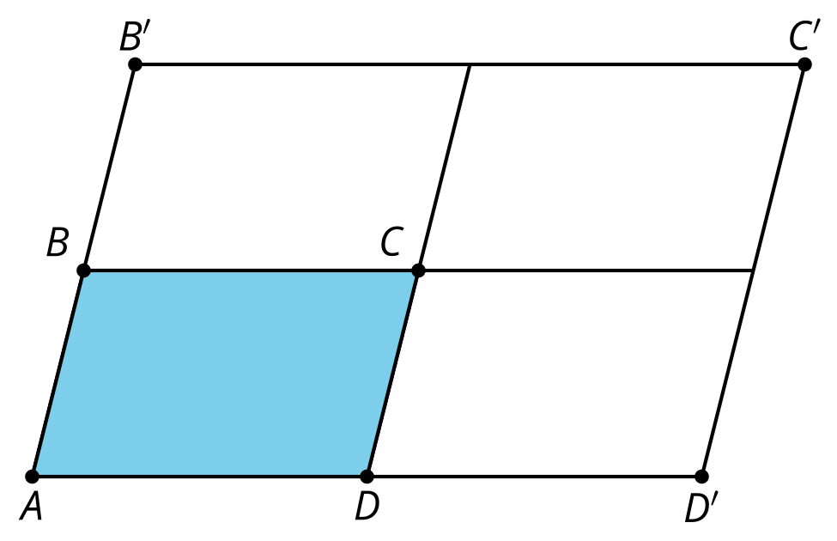
  - What was the scale factor of the dilation?
  - How many congruent copies of $ABCD$ have we fit inside $AB^{′}C^{′}D^{′}$?
  - How does the area of parallelogram $AB^{′}C^{′}D^{′}$ compare to parallelogram $ABCD$?
  - If parallelogram $ABCD$ has area 12 square units, what is the area of parallelogram $AB^{′}C^{′}D^{′}$?
- (From Unit 5, Lesson 4.)
- Select all solids whose cross sections are dilations of some two-dimensional shape using a point directly above the shape as a center and scale factors ranging from 0 to 1.
  - cylinder
  - cube
  - triangular prism
  - cone
  - triangular pyramid
- (From Unit 5, Lesson 3.)
- Select all expressions which give the measure of angle $A$.
- 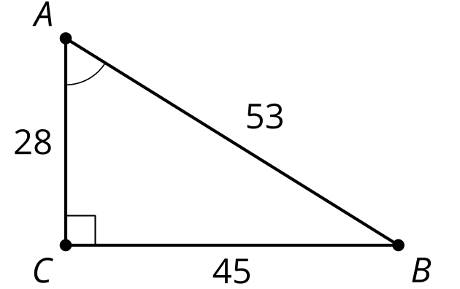
  - $arccos\left(\frac{28}{53}\right)$
  - $arccos\left(\frac{45}{53}\right)$
  - $arcsin\left(\frac{28}{53}\right)$
  - $arcsin\left(\frac{45}{53}\right)$
  - $arctan\left(\frac{28}{45}\right)$
  - $arctan\left(\frac{45}{28}\right)$
- (From Unit 4, Lesson 9.)
© CC BY 2019 by Illustrative Mathematics®

