Unit 3 Lesson 7: Equivalent Ratios Have the Same Unit Rates

1 Which One Doesn’t Belong: Comparing Speeds (Warm up)

Student Task Statement
Which one doesn’t belong? Be prepared to explain your reasoning.
5 miles in 15 minutes
3 minutes per mile
20 miles per hour
32 kilometers per hour

2 Price of Burritos

Student Task Statement
- Two burritos cost $14. Complete the table to show the cost for 4, 5, and 10 burritos at that rate. Next, find the cost for a single burrito in each case.
- number of burritos | - cost in dollars | - unit price  (dollars per burrito)
- 2 | - 14
- 4
- 5
- 10
- $b$
- What do you notice about the values in this table?
- Noah bought $b$ burritos and paid $c$ dollars. Lin bought twice as many burritos as Noah and paid twice the cost he did. How much did Lin pay per burrito?
 | - number of burritos | - cost in dollars | - unit price  (dollars per burrito)
- Noah | - $b$ | - $c$ | - $\frac{c}{b}$
- Lin | - $2⋅b$ | - $2⋅c$
- Explain why, if you can buy $b$ burritos for $c$ dollars, or buy $2⋅b$ burritos for $2⋅c$ dollars, the cost per item is the same in either case.

Activity Synthesis
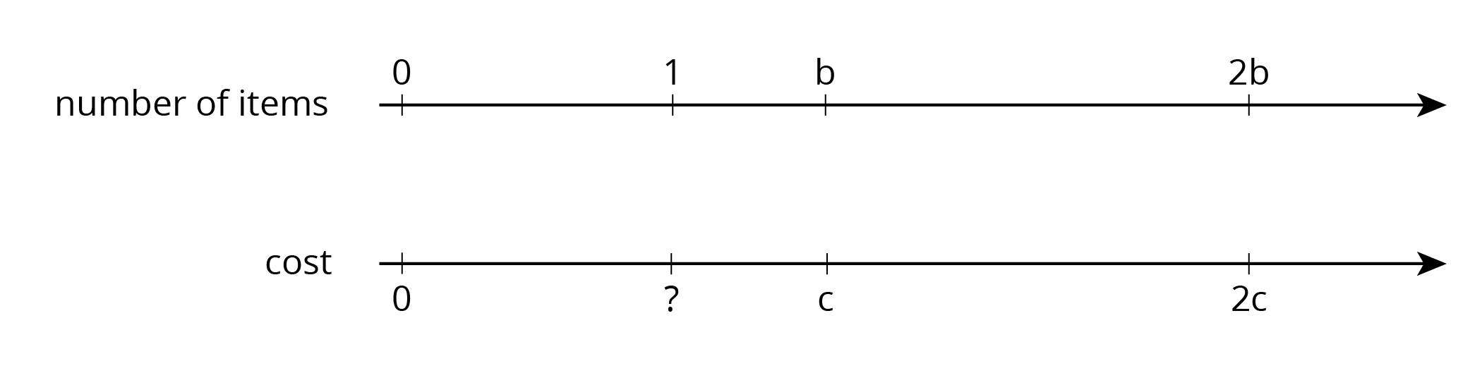

3 Making Bracelets

Student Task Statement
- Complete the table. Then, explain the strategy you used to do so.
- time in hours | - number of bracelets | - speed (bracelets per hour)
- 2 |  | - 6
- 5 |  | - 6
- 7 |  | - 6
 | - 66 | - 6
 | - 100 | - 6
- 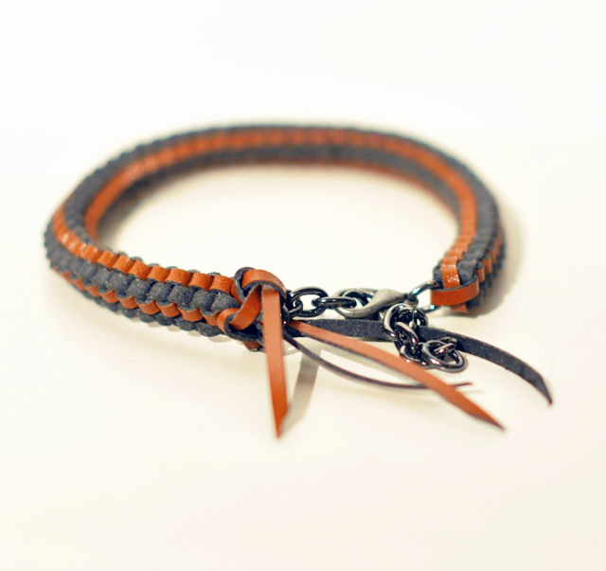
- Here is a partially filled table from an earlier activity. Use the same strategy you used for the bracelet problem to complete this table.
- number of  burritos | - cost in  dollars | - unit price  (dollars per burrito)
 | - 14 | - 7
 | - 28 | - 7
- 5 |  | - 7
- 10 |  | - 7
- Next, compare your results with those in the first table in the previous activity. Do they match? Explain why or why not.

4 How Much Applesauce? (Optional)

Student Task Statement
It takes 4 pounds of apples to make 6 cups of applesauce.
- At this rate, how much applesauce can you make with:
  - 7 pounds of apples?
  - 10 pounds of apples?
- How many pounds of apples would you need to make:
  - 9 cups of applesauce?
  - 20 cups of applesauce?
pounds of  apples | cups of  applesauce
4 | 6
7
10
 | 9
 | 20
© CC BY Open Up Resources. Adaptations CC BY IM.

