Lesson 12: Types of Angles

Standards Alignments
Building On | 4.NF.B.4.b
Addressing | 4.G.A.1, 4.MD.C.7

Teacher-facing Learning Goals
- Draw acute and obtuse angles.
- Identify acute, obtuse, right, and straight angles in two-dimensional figures.

Student-facing Learning Goals
- Let’s look at different types of angles.

Lesson Purpose
The purpose of this lesson is for students to classify angles as acute, obtuse, and straight, and to identify and draw acute and obtuse angles.
In previous lessons, students learned to measure angles and draw angles of given measurements. They saw that a ${90}^{∘}$ angle is called a right angle and is formed by two perpendicular lines. Students are also familiar with some benchmark angle measurements.
In this lesson, students classify angles by their size and identify angles as acute or obtuse in a variety of contexts. Students also learn that a ${180}^{∘}$ is called a straight angle.

Access for:

Students with Disabilities
- Representation (Activity 1)

Instructional Routines
MLR2 Collect and Display (Activity 1), Number Talk (Warm-up)

Materials to Gather
- Materials from a previous lesson: Activity 1
- Pattern blocks: Activity 3
- Protractors: Activity 2, Activity 3

Lesson Timeline
Warm-up | 10 min
Activity 1 | 10 min
Activity 2 | 10 min
Activity 3 | 15 min
Lesson Synthesis | 10 min
Cool-down | 5 min

Teacher Reflection Question
Before this point, students have had experiences of sorting mathematical objects relative to some benchmarks. In this lesson, angles are categorized by their size and relative to two benchmarks: ${90}^{∘}$ and ${180}^{∘}$. How readily did students conceptualize angles this way? Which past experiences of classifying objects would help to make this idea more intuitive?

Cool-down
(to be completed at the end of the lesson) 5min
Obtuse, Acute, and Straight Angles

Standards Alignments
Addressing | 4.G.A.1, 4.MD.C.7

Student-facing Task Statement
- Here is a ray. Draw another ray from point $P$ to make an acute angle.
- 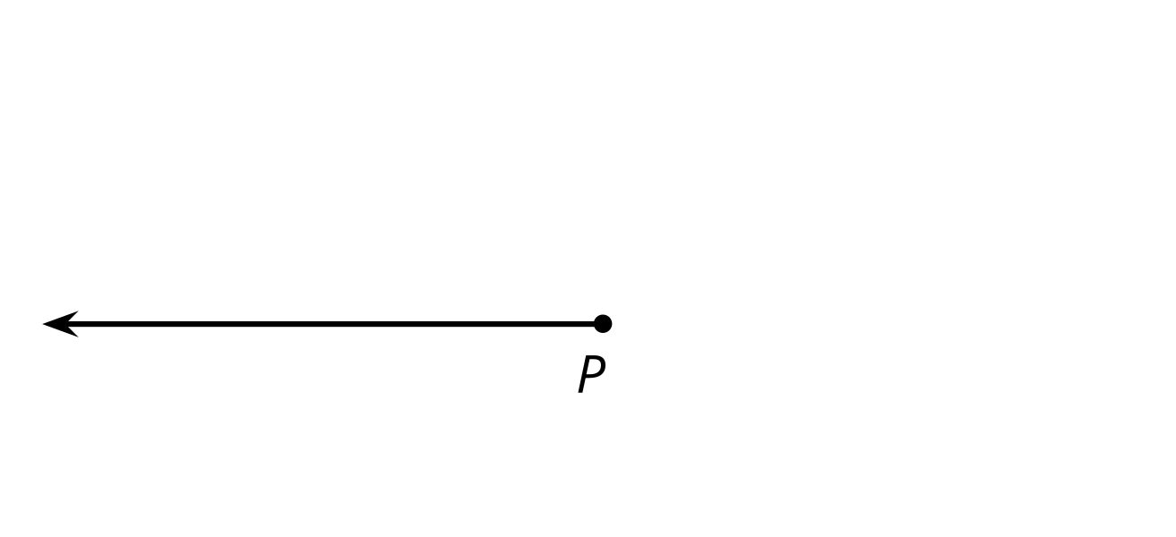
- Here are some labeled angles. Identify all angles that are obtuse.
- 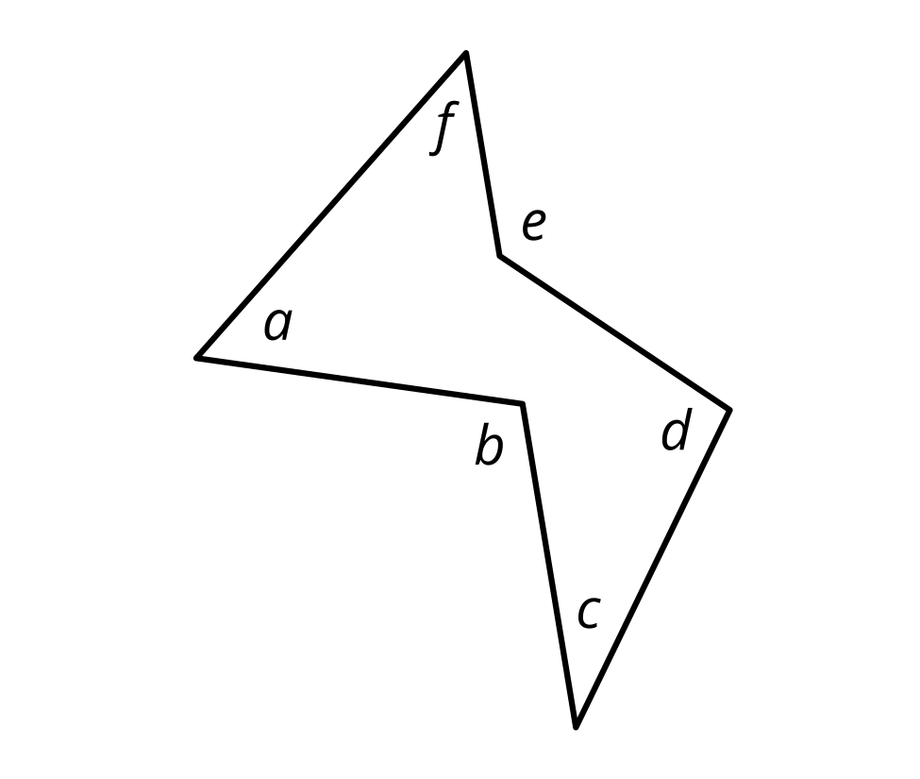
- An angle is formed by four ${35}^{∘}$ angles. Is that angle a straight angle? Explain how you know.

Student Responses
- Sample response:
- 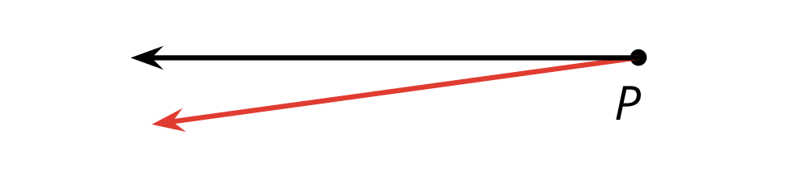
- Angles $b$, $e$, and $d$
- No. Sample response: A straight angle is ${180}^{∘}$. Four ${35}^{∘}$ angles make ${140}^{∘}$ ($4×35=140$).

