Lesson 2: Circular Grid
Let’s dilate figures on circular grids.

2.1: Notice and Wonder: Concentric Circles
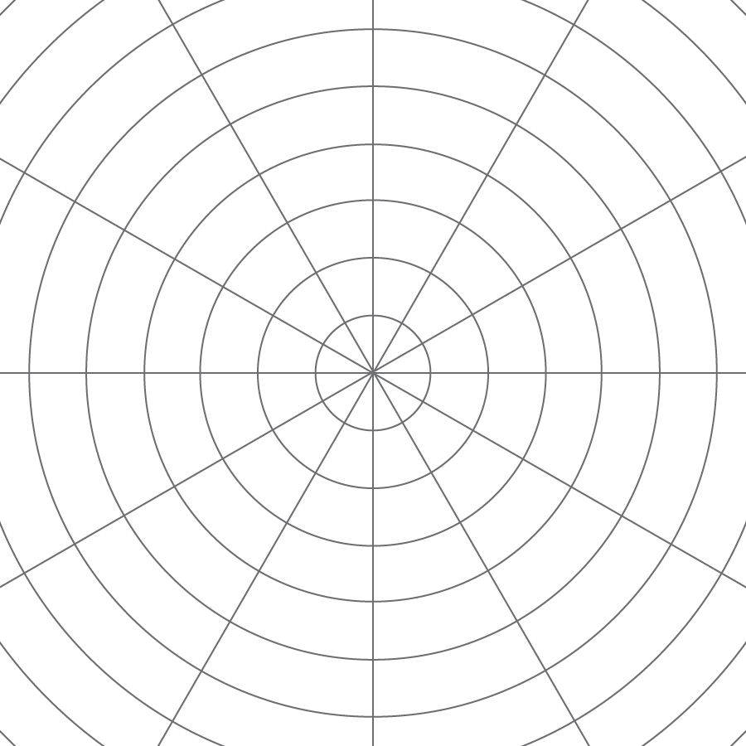
What do you notice? What do you wonder?

2.2: A Droplet on the Surface
The larger Circle d is a dilation of the smaller Circle c. $P$ is the center of dilation.
- Draw four points on the smaller circle (not inside the circle!), and label them $E$, $F$, $G$, and $H$.
- Draw the rays from $P$ through each of those four points.
- Label the points where the rays meet the larger circle $E^{′}$, $F^{′}$, $G^{′}$, and $H^{′}$.
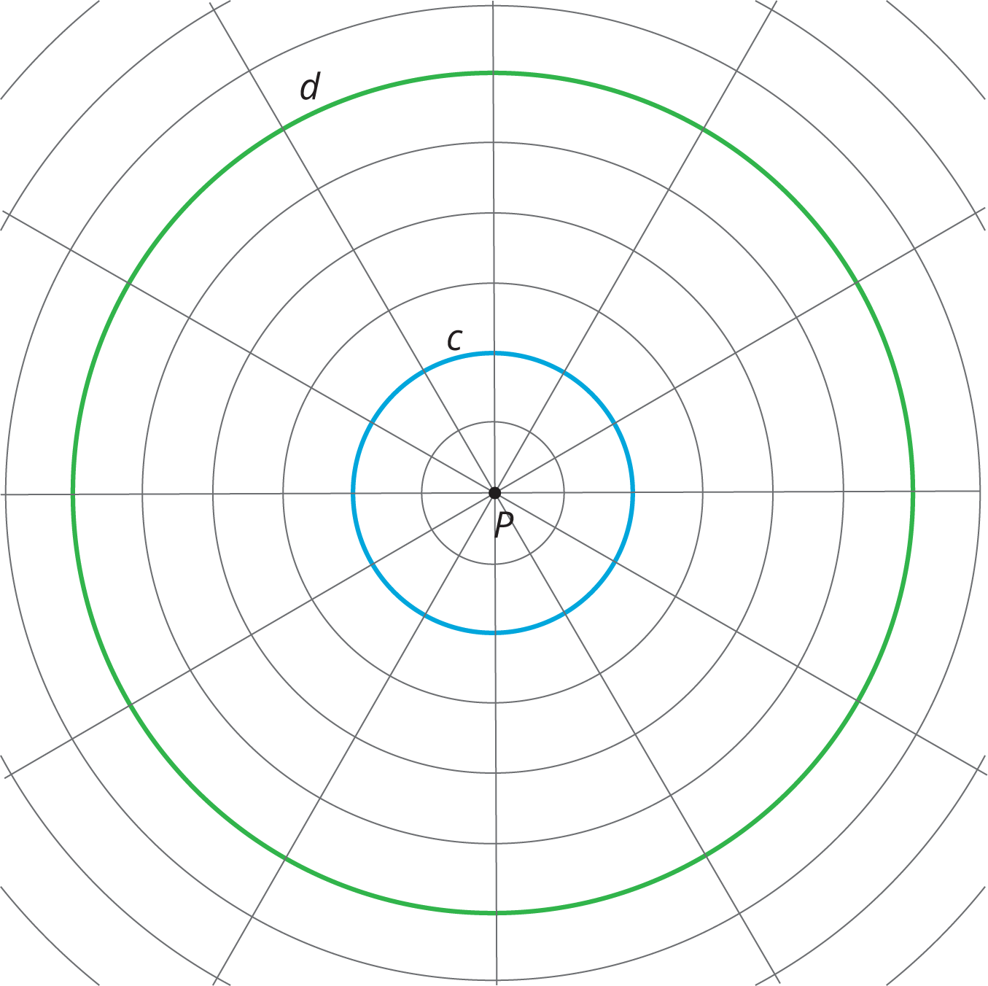
4. Complete the table. In the row labeled c, write the distance between $P$ and the point on the smaller circle in grid units. In the row labeled d, write the distance between $P$ and the corresponding point on the larger circle in grid units.
 | $E$ | $F$ | $G$ | $H$
c
d
5. The center of dilation is point $P$. What is the scale factor that takes the smaller circle to the larger circle? Explain your reasoning.

2.3: Quadrilateral on a Circular Grid
Here is a polygon $ABCD$.
- Dilate each vertex of polygon $ABCD$ using $P$ as the center of dilation and a scale factor of 2. Label the image of $A$ as $A^{′}$, and label the images of the remaining three vertices as $B^{′}$, $C^{′}$, and $D^{′}$.
- Draw segments between the dilated points to create polygon $A^{′}B^{′}C^{′}D^{′}$.
- What are some things you notice about the new polygon?
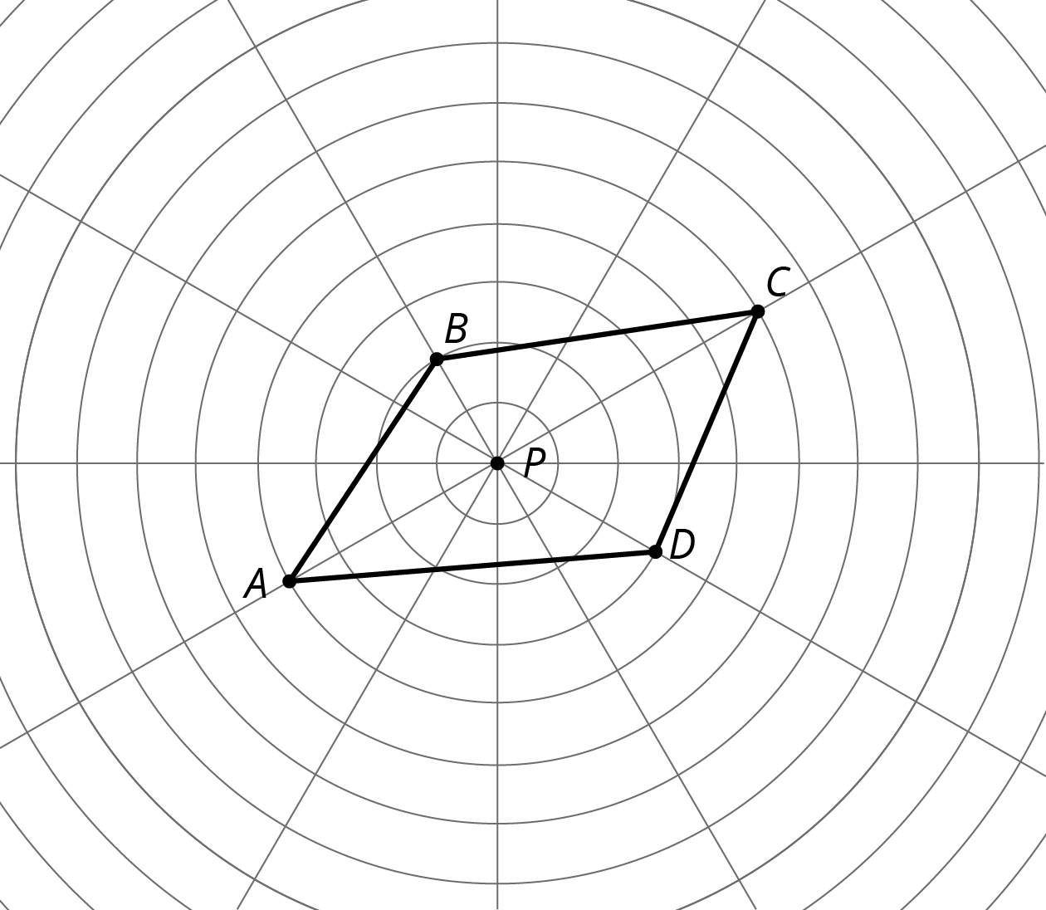
4. Choose a few more points on the sides of the original polygon and transform them using the same dilation. What do you notice?
5. Dilate each vertex of polygon $ABCD$ using $P$ as the center of dilation and a scale factor of $\frac{1}{2}$. Label the image of $A$ as $E$, the image of $B$ as $F$, the image of $C$ as $G$ and the image of $D$ as $H$.
6. What do you notice about polygon $EFGH$?

Are you ready for more?
Suppose $P$ is a point not on line segment $\overset{¯}{WX}$. Let $\overset{¯}{YZ}$ be the dilation of line segment $\overset{¯}{WX}$ using $P$ as the center with scale factor 2. Experiment using a circular grid to make predictions about whether each of the following statements must be true, might be true, or must be false.
- $\overset{¯}{YZ}$ is twice as long $\overset{¯}{WX}$.
- $\overset{¯}{YZ}$ is five units longer than $\overset{¯}{WX}$.
- The point $P$ is on $\overset{¯}{YZ}$.
- $\overset{¯}{YZ}$ and $\overset{¯}{WX}$ intersect.

2.4: A Quadrilateral and Concentric Circles
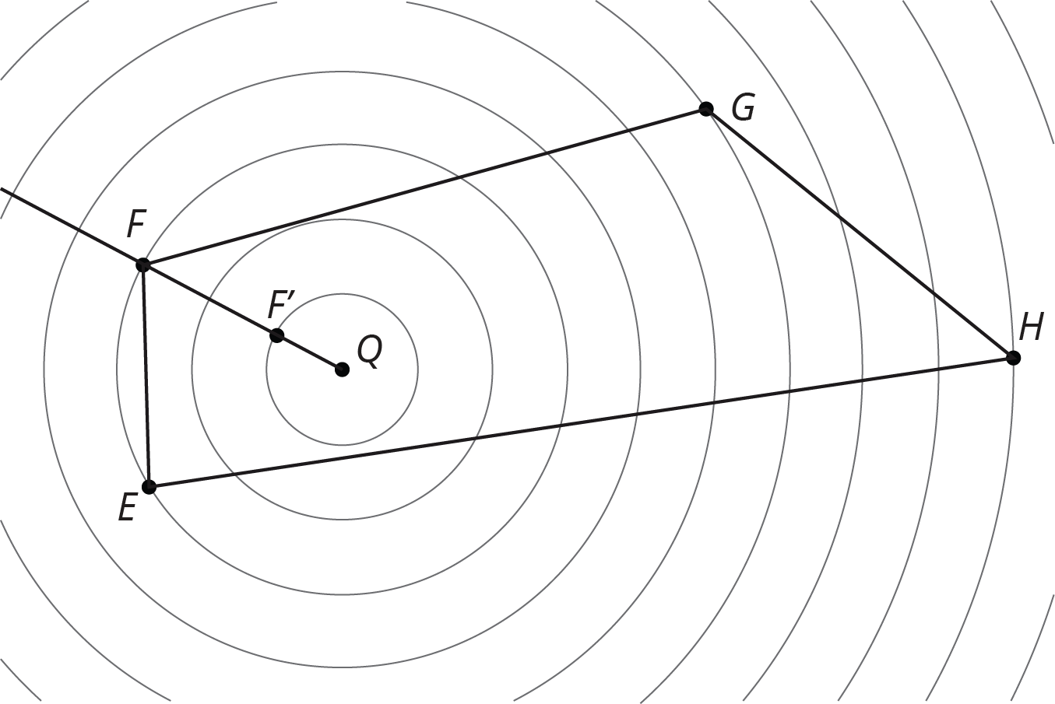
Dilate polygon $EFGH$ using $Q$ as the center of dilation and a scale factor of $\frac{1}{3}$. The image of $F$ is already shown on the diagram. (You may need to draw more rays from $Q$ in order to find the images of other points.)

Lesson 2 Summary
A circular grid like this one can be helpful for performing dilations.
The radius of the smallest circle is one unit, and the radius of each successive circle is one unit more than the previous one.
To perform a dilation, we need a center of dilation, a scale factor, and a point to dilate. In the picture, $P$ is the center of dilation. With a scale factor of 2, each point stays on the same ray from $P$, but its distance from $P$ doubles:
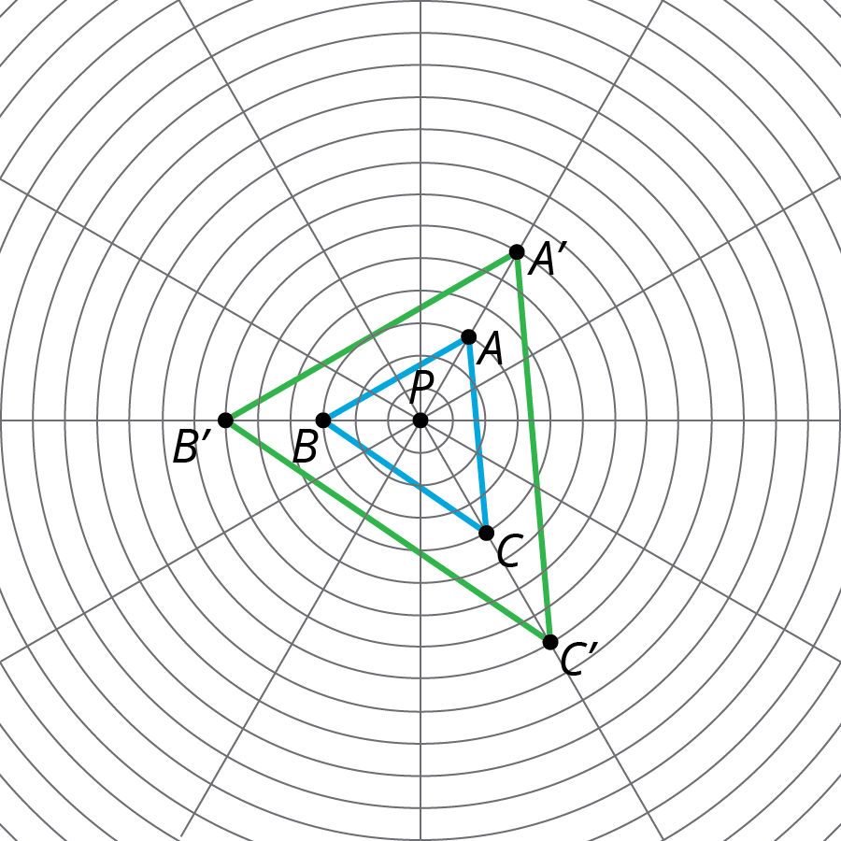
Since the circles on the grid are the same distance apart, segment $PA^{′}$ has twice the length of segment $PA$, and the same holds for the other points.
© CC BY Open Up Resources. Adaptations CC BY IM.

