Unit 1 Lesson 12: Alternate Interior Angles

1 Angle Pairs (Warm up)

Student Task Statement
- Find the measure of angle $JGH$. Explain or show your reasoning.
- 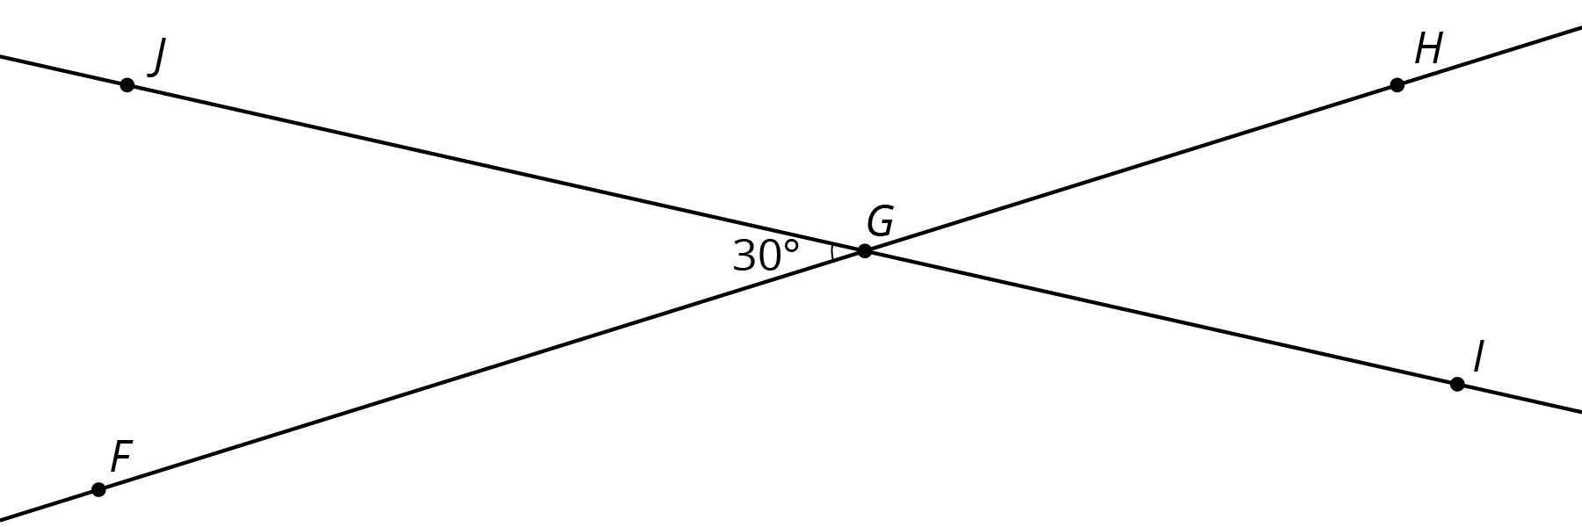
- Find and label a second ${30}^{∘}$ angle in the diagram. Find and label an angle congruent to angle $JGH$.
- Angle $BAC$ is a right angle. Find the measure of angle $CAD$.
- 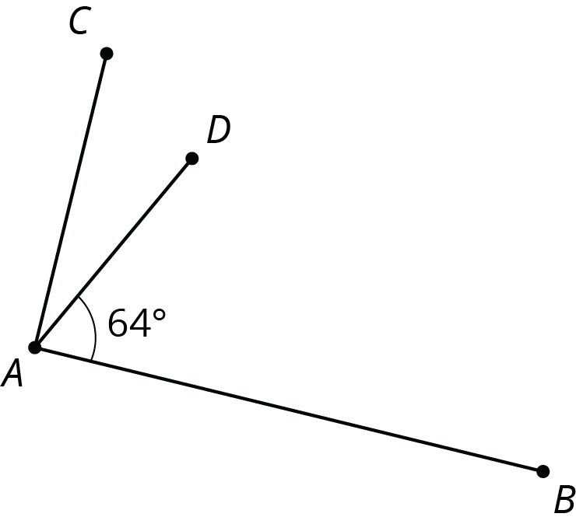
- ​​​​​

2 Cutting Parallel Lines with a Transversal

Images for Launch
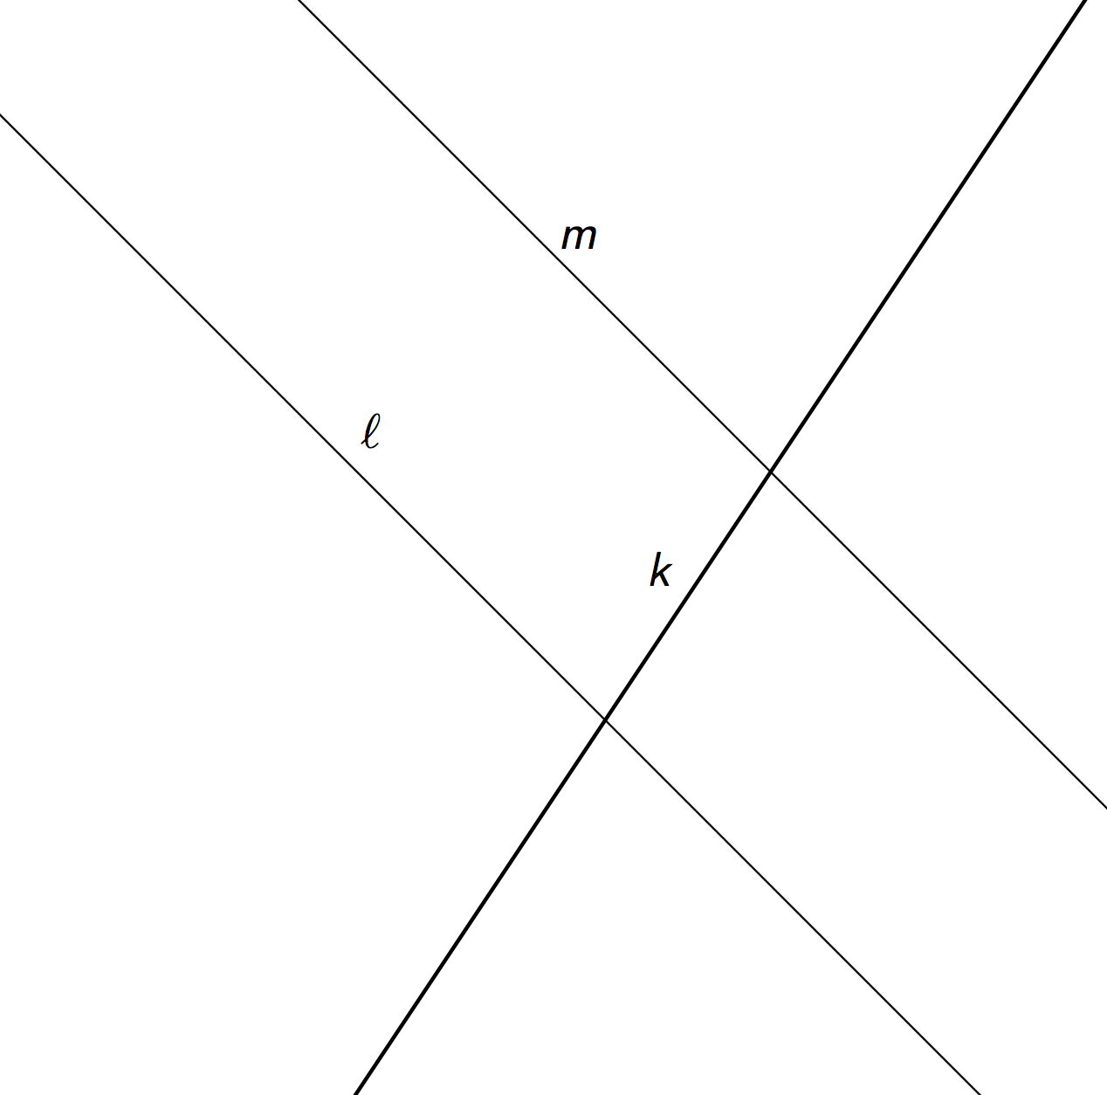

Student Task Statement
Lines $AC$ and $DF$ are parallel. They are cut by transversal $HJ$.
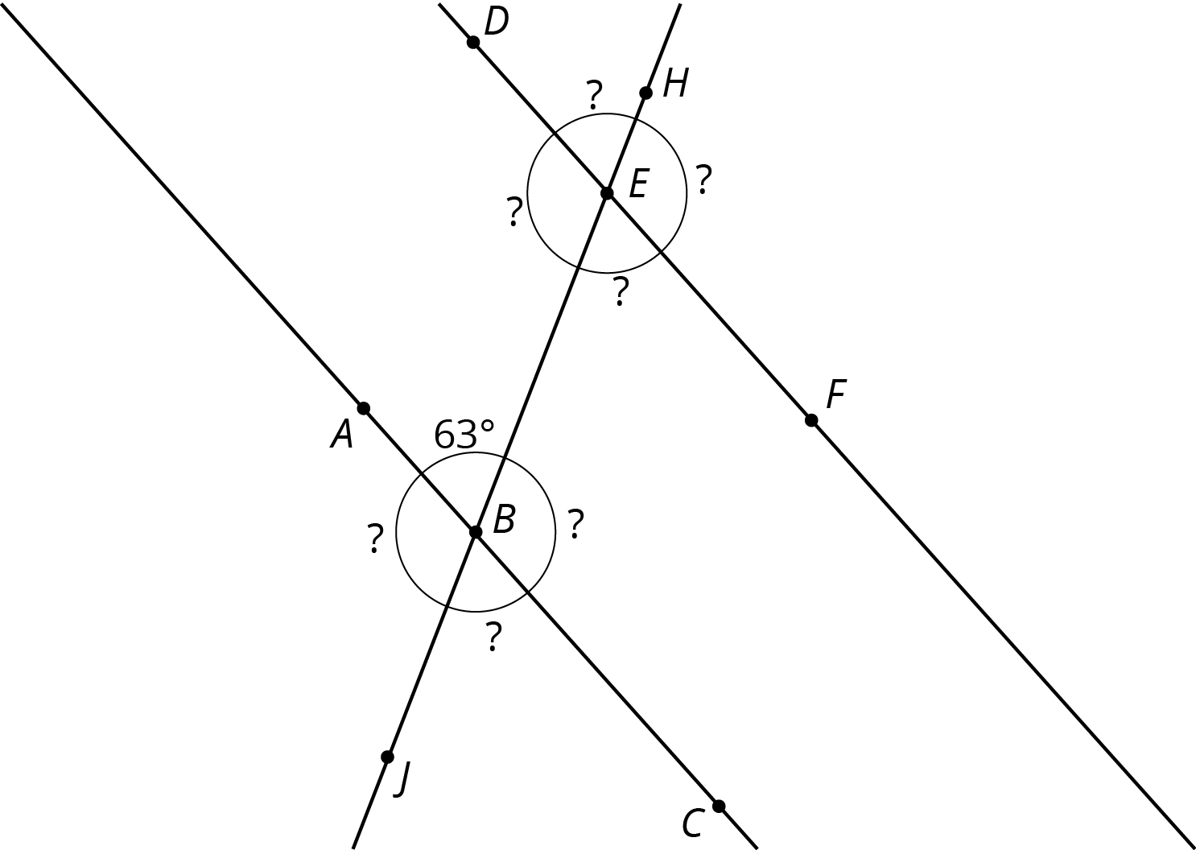
- With your partner, find the seven unknown angle measures in the diagram. Explain your reasoning.
- What do you notice about the angles with vertex $B$ and the angles with vertex $E$?
- Using what you noticed, find the measures of the four angles at point $B$ in the second diagram. Lines $AC$ and $DF$ are parallel.
- 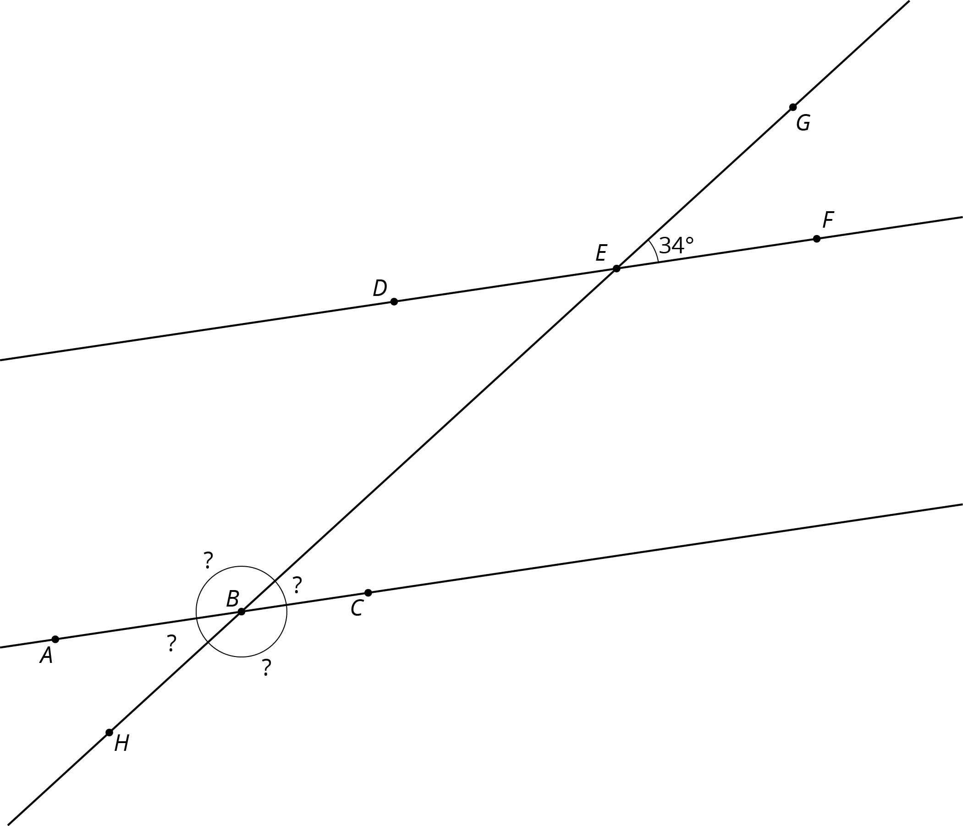
- The next diagram resembles the first one, but the lines form slightly different angles. Work with your partner to find the six unknown angles with vertices at points $B$ and $E$.
- 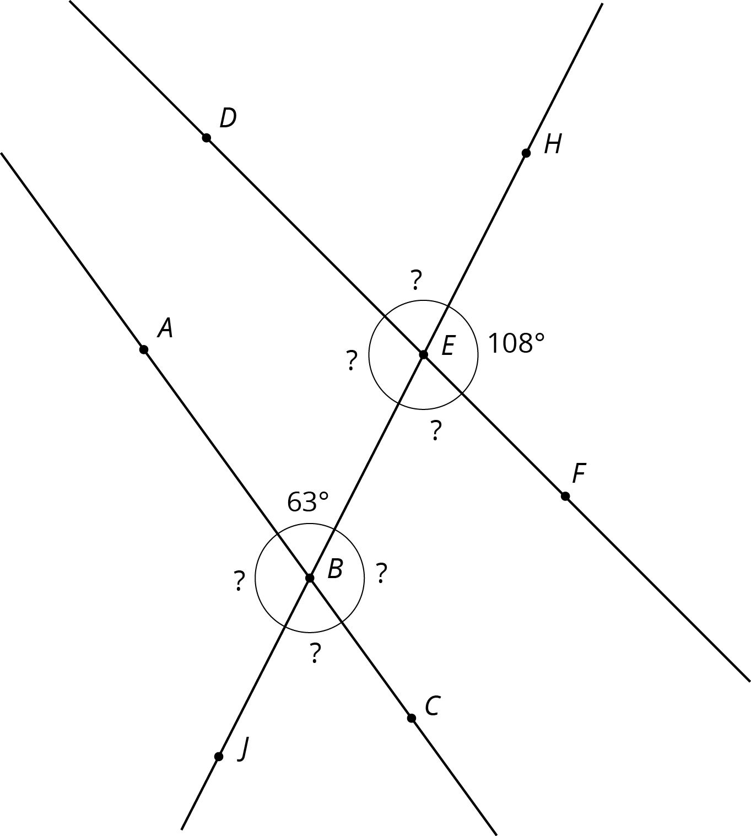
- What do you notice about the angles in this diagram as compared to the earlier diagram? How are the two diagrams different? How are they the same?

3 Alternate Interior Angles Are Congruent

Student Task Statement
- Lines $ℓ$ and $k$ are parallel and $t$ is a transversal. Point $M$ is the midpoint of segment $PQ$.
- 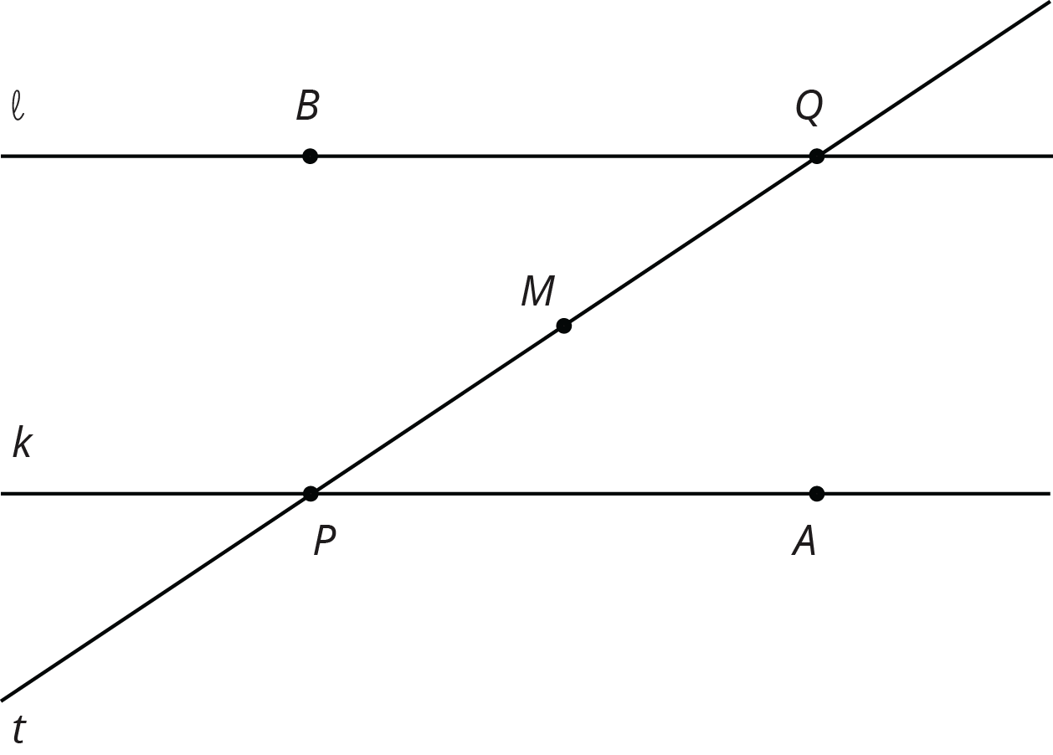
- Find a rigid transformation showing that angles $MPA$ and $MQB$ are congruent.
- In this picture, lines $ℓ$ and $k$ are no longer parallel. $M$ is still the midpoint of segment $PQ$.
- 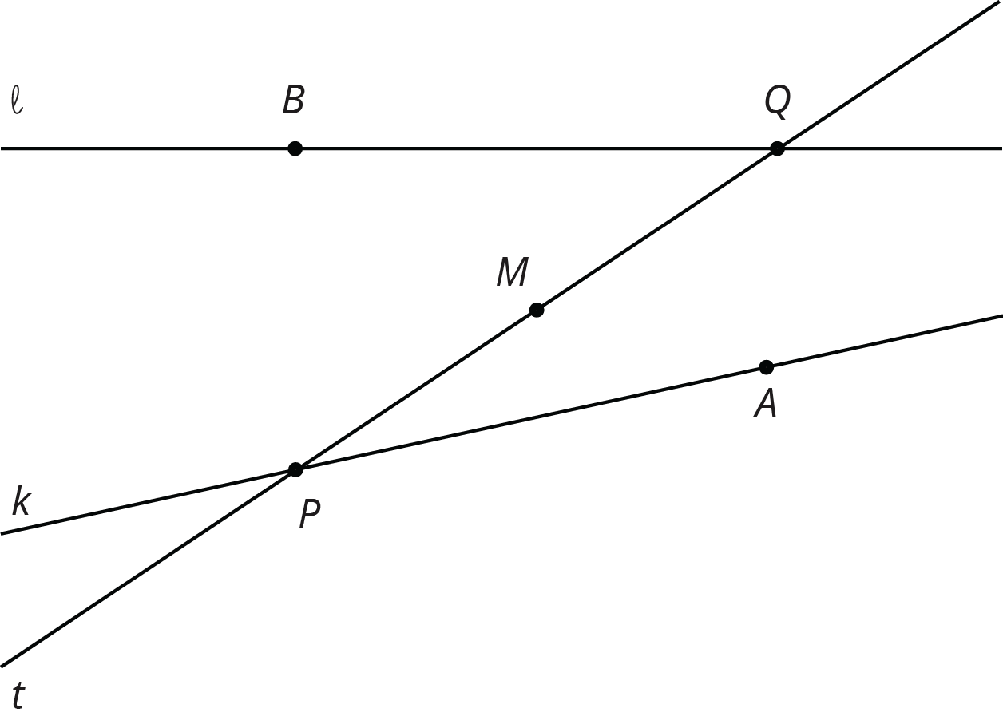
- Does your argument in the earlier problem apply in this situation? Explain.

4 Info Gap: Angle Finding

Student Task Statement
Your teacher will give you either a problem card or a data card. Do not show or read your card to your partner.
If your teacher gives you the problem card:
- Silently read your card and think about what information you need to be able to answer the question.
- Ask your partner for the specific information that you need.
- Explain how you are using the information to solve the problem.
- Continue to ask questions until you have enough information to solve the problem.
- Share the problem card and solve the problem independently.
- Read the data card and discuss your reasoning.
If your teacher gives you the data card:
- Silently read your card.
- Ask your partner “What specific information do you need?” and wait for them to ask for information.
- If your partner asks for information that is not on the card, do not do the calculations for them. Tell them you don’t have that information.
- Before sharing the information, ask “Why do you need that information?” Listen to your partner’s reasoning and ask clarifying questions.
- Read the problem card and solve the problem independently.
- Share the data card and discuss your reasoning.
Pause here so your teacher can review your work. Ask your teacher for a new set of cards and repeat the activity, trading roles with your partner.

Images for Activity Synthesis
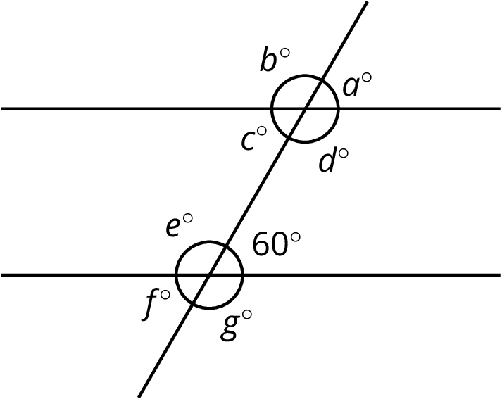
© CC BY Open Up Resources. Adaptations CC BY IM.

