Lesson 8: Reasoning about Solving Equations (Part 2)
Let’s use hangers to understand two different ways of solving equations with parentheses.

8.1: Equivalent to $2\left(x+3\right)$
Select all the expressions equivalent to $2\left(x+3\right)$.
- $2⋅\left(x+3\right)$
- $\left(x+3\right)2$
- $2⋅x+2⋅3$
- $2⋅x+3$
- $\left(2⋅x\right)+3$
- $\left(2+x\right)3$

8.2: Either Or
- Explain why either of these equations could represent this hanger:
- 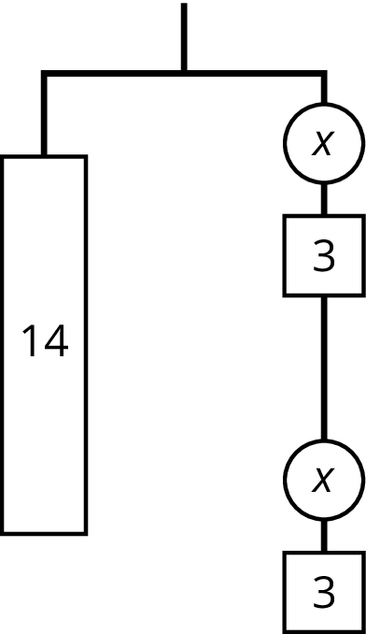
- $14=2\left(x+3\right)$ or $14=2x+6$
- Find the weight of one circle. Be prepared to explain your reasoning.

8.3: Use Hangers to Understand Equation Solving, Again
Here are some balanced hangers. Each piece is labeled with its weight.
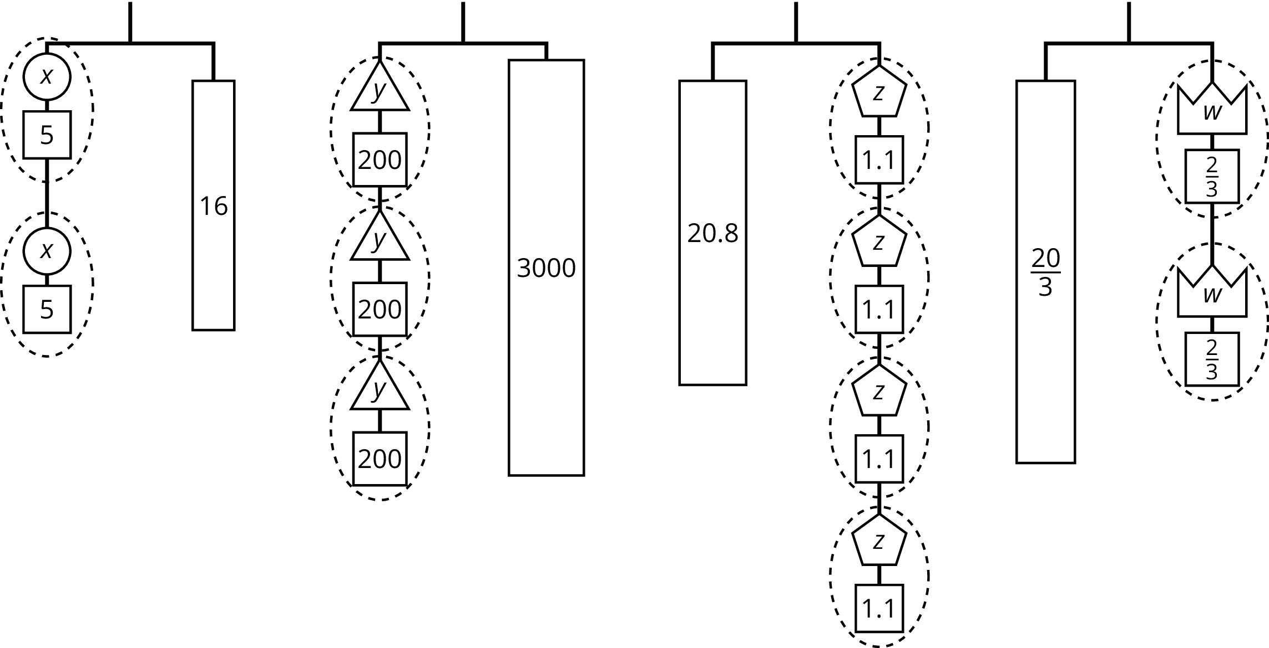
For each diagram:
- Assign one of these equations to each hanger:
- $2\left(x+5\right)=16$
- $3\left(y+200\right)=3​,000$
- $20.8=4\left(z+1.1\right)$
- $\frac{20}{3}=2\left(w+\frac{2}{3}\right)$
- Explain how to figure out the weight of a piece labeled with a letter by reasoning about the diagram.
- Explain how to figure out the weight of a piece labeled with a letter by reasoning about the equation.

Lesson 8 Summary
The balanced hanger shows 3 equal, unknown weights and 3 2-unit weights on the left and an 18-unit weight on the right.
There are 3 unknown weights plus 6 units of weight on the left. We could represent this balanced hanger with an equation and solve the equation the same way we did before.
$\begin{matrix}3x+6 & =18 \\ 3x & =12 \\ x & =4\end{matrix}$
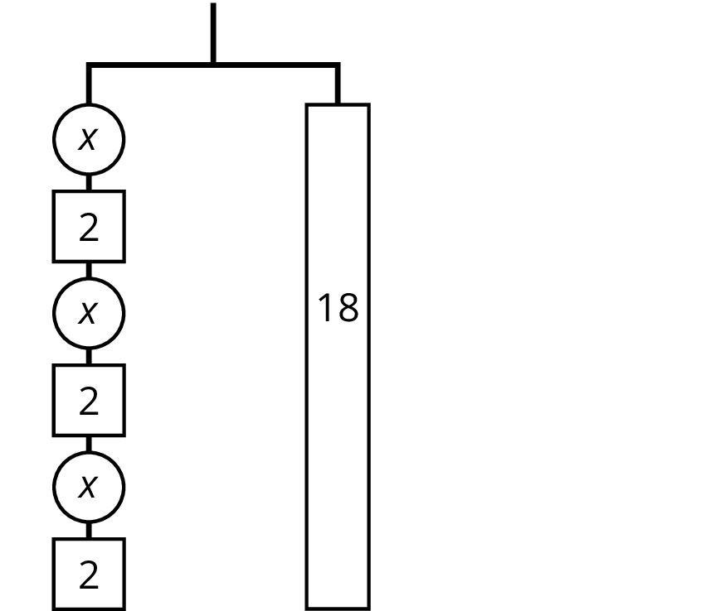
Since there are 3 groups of $x+2$ on the left, we could represent this hanger with a different equation: $3\left(x+2\right)=18$.
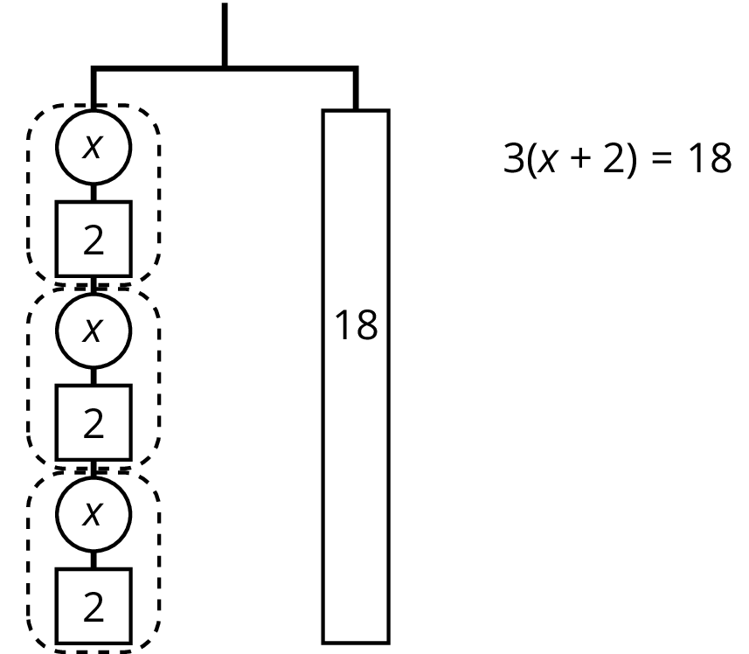
The two sides of the hanger balance with these weights: 3 groups of $x+2$ on one side, and 18, or 3 groups of 6, on the other side.
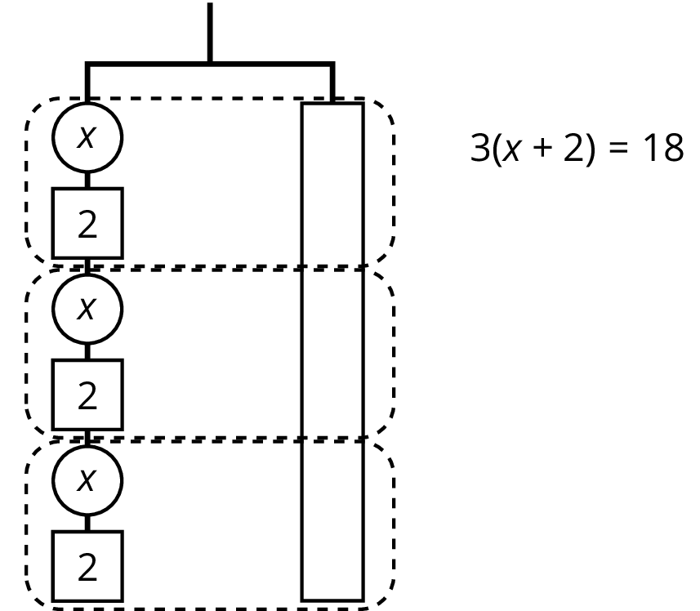
The two sides of the hanger will balance with $\frac{1}{3}$ of the weight on each side: $\frac{1}{3}⋅3\left(x+2\right)=\frac{1}{3}⋅18$.
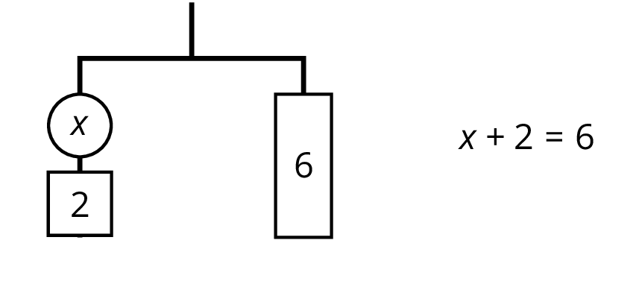
We can remove 2 units of weight from each side, and the hanger will stay balanced. This is the same as subtracting 2 from each side of the equation.
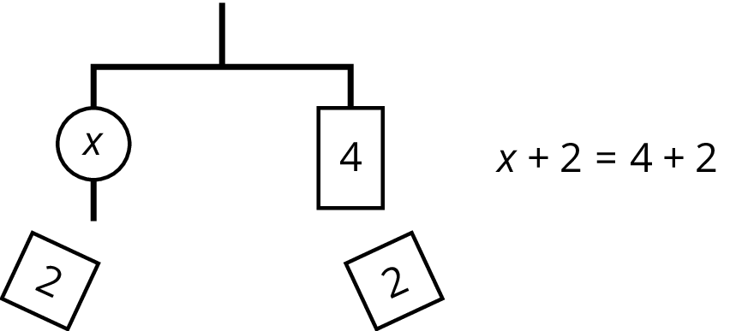
An equation for the new balanced hanger is $x=4$. This gives the solution to the original equation.
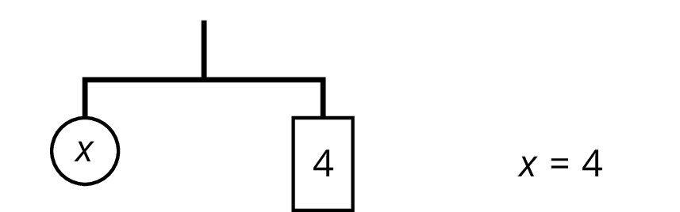
Here is a concise way to write the steps above:
$\begin{matrix}3\left(x+2\right) & =18 & \\ x+2 & =6 & \text{after multiplying each side by }\frac{1}{3} \\ x & =4 & \text{after subtracting 2 from each side}\end{matrix}$
© CC BY Open Up Resources. Adaptations CC BY IM.

