Unit 4 Lesson 13: Exponential Functions with Base $e$

1 $e$ on a Calculator (Warm up)

Student Task Statement
The other day, you learned that $e$ is a mathematical constant whose value is approximately 2.718. When working on problems that involve $e$, we often rely on calculators to estimate values.
- Find the $e$ button on your calculator. Experiment with it to understand how it works. (For example, see how the value of $2e$ or $e^{2}$ can be calculated.)
- Evaluate each expression. Make sure your calculator gives the indicated value. If it doesn’t, check in with your partner to compare how you entered the expression.
  - $10⋅e^{\left(1.1\right)}$ should give approximately 30.04166
  - $5⋅e^{\left(1.1\right)\left(7\right)}$ should give approximately 11,041.73996
  - $e^{\frac{9}{23}}+7$ should give approximately 8.47891

2 Same Situation, Different Equations

Student Task Statement
The population of a colony of insects is 9 thousand when it was first being studied. Here are two functions that could be used to model the growth of the colony $t$ months after the study began.
$P\left(t\right)=9⋅{\left(1.02\right)}^{t}$
$Q\left(t\right)=9⋅e^{\left(0.02t\right)}$
- Use technology to find the population of the colony at different times after the beginning of the study and complete the table.
- $t$ (time in months) | - $P\left(t\right)$ (population in thousands) | - $Q\left(t\right)$ (population in thousands)
- 6
- 12
- 24
- 48
- 100
- What do you notice about the populations in the two models?
- Here are pairs of equations representing the populations, in thousands, of four other insect colonies in a research lab. The initial population of each colony is 10 thousand and they are growing exponentially. $t$ is time, in months, since the study began.
- $\text{Colony 1}f\left(t\right)=10⋅{\left(1.05\right)}^{t}g\left(t\right)=10⋅e^{\left(0.05t\right)}$
- $\text{Colony 2}k\left(t\right)=10⋅{\left(1.03\right)}^{t}l\left(t\right)=10⋅e^{\left(0.03t\right)}$
- $\text{Colony 3}p\left(t\right)=10⋅{\left(1.01\right)}^{t}q\left(t\right)=10⋅e^{\left(0.01t\right)}$
- $\text{Colony 4}v\left(t\right)=10⋅{\left(1.005\right)}^{t}w\left(t\right)=10⋅e^{\left(0.005t\right)}$
  - Graph each pair of functions on the same coordinate plane. Adjust the graphing window to the following boundaries to start: $0<x<50$ and $0<y<80$.
  - What do you notice about the graph of the equation written using $e$ and the counterpart written without $e$? Make a couple of observations.

3 $e$ in Exponential Models

Student Task Statement
Exponential models that use $e$ often use the format shown in this example:
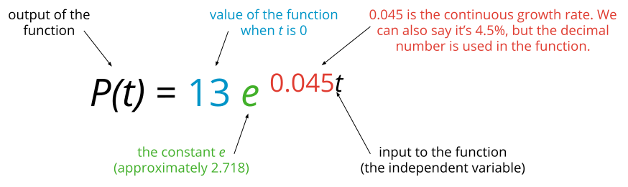
Here are some situations in which a percent change is considered to be happening continuously. For each function, identify the missing information and the missing growth rate (expressed as a percentage).
- At time $t=0$, measured in hours, a scientist puts 50 bacteria into a gel on a dish. The bacteria are growing and the population is expected to show exponential growth.
  - function: $b\left(t\right)=50⋅e^{\left(0.25t\right)}$
  - continuous growth rate per hour:
- In 1964, the population of the United States was growing at a rate of 1.4% annually. That year, the population was approximately 192 million. The model predicts the population, in millions, $t$ years after 1964.
  - function: $p\left(t\right)=\underset{_}{}⋅e^{\underset{_}{​}t}$
  - continuous growth rate per year: 1.4%
- In 1955, the world population was about 2.5 billion and growing. The model predicts the population, in billions, $t$ years after 1955.
  - function: ​​$q\left(t\right)=\underset{_}{}⋅e^{\left(0.0168t\right)}$
  - continuous growth rate per year:

4 Graphing Exponential Functions with Base $e$ (Optional)

Student Task Statement
- Use graphing technology to graph the function defined by $f\left(t\right)=50⋅e^{\left(0.25t\right)}$. Adjust the graphing window as needed to answer these questions:
  - The function $f$ models the population of bacteria in $t$ hours after it was initially measured. About how many bacteria were in the dish 10 hours after the scientist put the initial 50 bacteria in the dish?
  - About how many hours did it take for the number of bacteria in the dish to double? Explain or show your reasoning.
- Use graphing technology to graph the function defined by $p\left(t\right)=192⋅e^{\left(0.014t\right)}$. Adjust the graphing window as needed to answer these questions:
  - The equation models the population, in millions, in the U.S. $t$ years after 1964. What does the model predict for the population of the U.S. in 1974?
  - In which year does the model predict the population will reach 300 million?
© CC BY 2019 by Illustrative Mathematics®

