Lesson 16 Practice Problems
- Tickets to a family concert cost $10 for adults and $3 for children. The concert organizers collected a total of $900 from ticket sales.
  - In this situation, what is the meaning of each variable in the equation $10A+3C=900$?
  - If 42 adults were at the concert, how many children attended?
  - If 140 children were at the concert , how many adults attended?
  - Write an equation to represent $C$ as a function of $A$. Explain what this function tells us about the situation.
  - Write an equation to represent $A$ as a function of $C$. Explain what this function tell us about the situation.
- A school group has $600 to spend on T-shirts. The group is buying from a store that gives them a $5 discount off the regular price per shirt.
- $n=\frac{600}{p−5}$ gives the number of shirts, $n$, that can be purchased at a regular price, $p$.
- $p=\frac{600}{n}+5$ gives the regular price, $p$, of a shirt when $n$ shirts are bought.
  - What is $n$ when $p$ is 20?
  - What is $p$ when $n$ is 40?
  - Is one function an inverse of the other? Explain how you know.
- Functions $f$ and $g$ are inverses, and $f\left(\text{-}2\right)=3$. Is the point $\left(3,\text{-}2\right)$ on the graph of $f$, on the graph of $g$, or neither?
- Here are two equations that relate two quantities, $p$ and $Q$:
- $Q=7p+1,​999$
- $p=\frac{Q−1,999}{7}$
- Select all statements that are true about $p$ and $Q$.
  - $Q=7p+1,​999$ could represent a function, but $p=\frac{Q−1,999}{7}$ could not.
  - Each equation could represent a function.
  - $p=\frac{Q−1,999}{7}$ could represent a function, but $Q=7p+1,​999$ could not.
  - The two equations represent two functions that are inverses of one another.
  - If $Q=7p+1,​999$ represents a function, then the inverse function can be defined by $p=7Q−1,​999$.
- Elena plays the piano for 30 minutes each practice day. The total number of minutes $p$ that Elena practiced last week is a function of $n$, the number of practice days.
- Find the domain and range for this function.
- (From Unit 4, Lesson 10.)
- The graph shows the attendance at a sports game as a function of time in minutes.
  - Describe how attendance changed over time.
  - 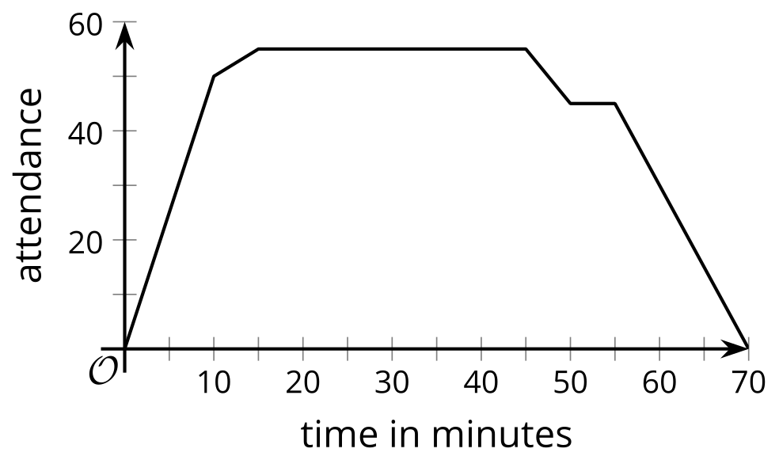
  - Describe the domain.
  - Describe the range.
- (From Unit 4, Lesson 11.)
- Two children set up a lemonade stand in their front yard. They charge $1 for every cup. They sell a total of 15 cups of lemonade. The amount of money the children earned, $R$ dollars, is a function of the number of cups of lemonade they sold, $n$.
  - Is 20 part of the domain of this function? Explain your reasoning.
  - What does the range of this function represent?
  - Describe the set of values in the range of $R$.
  - Is the graph of this function discrete or continuous? Explain your reasoning.
- (From Unit 4, Lesson 11.)
- Here is the graph of function $f$, which represents Andre's distance from his bicycle as he walked in a park.
- 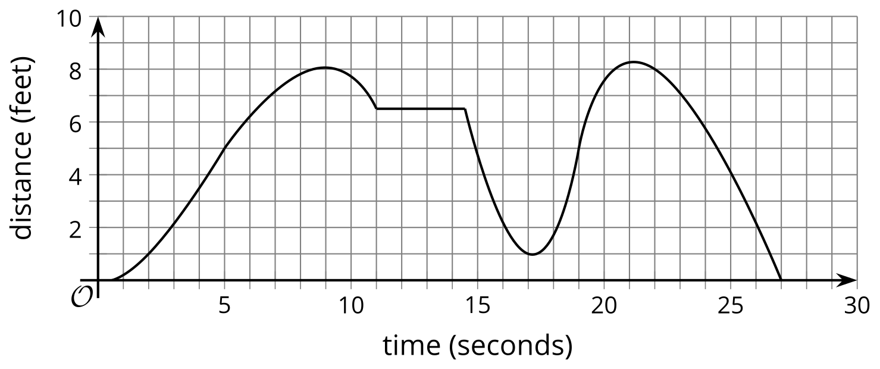
  - Estimate $f\left(5\right)$.
  - Estimate $f\left(17\right)$.
  - For what values of $t$ does $f\left(t\right)=8$?
  - For what values of $t$ does $f\left(t\right)=6.5$?
  - For what values of $t$ does $f\left(t\right)=10$?
- (From Unit 4, Lesson 6.)
© CC BY 2019 by Illustrative Mathematics®

