## Unit 2 Lesson 9: Side Length Quotients in Similar Triangles

### 1 Two-three-four and Four-five-six (Warm up)

#### Student Task Statement

Triangle has side lengths 2, 3, and 4. Triangle has side lengths 4, 5, and 6. Is Triangle similar to Triangle ?

#### Activity Synthesis

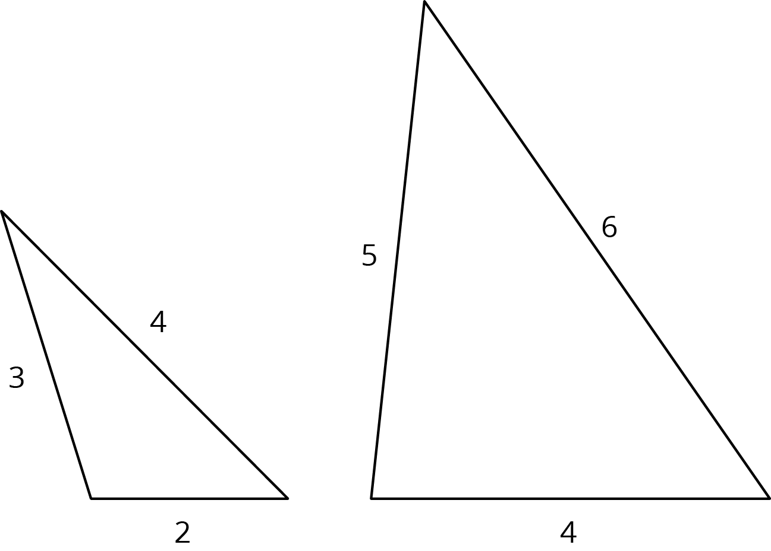

### 2 Quotients of Sides Within Similar Triangles

#### Student Task Statement

Triangle  is similar to triangles , , and . The scale factors for the dilations that show triangle is similar to each triangle are in the table.

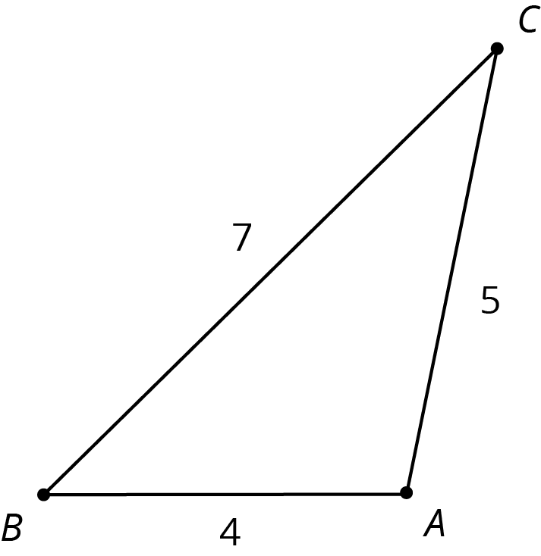

1. Find the side lengths of triangles , , and . Record them in the table.

|  |  |  |  |  |
| --- | --- | --- | --- | --- |
| * triangle | * scale factor | * length of short side | * length of medium side | * length of long side |
|  | * 1 | * 4 | * 5 | * 7 |
|  | * 2 |  |  |  |
|  | * 3 |  |  |  |
|  |  |  |  |  |

1. Your teacher will assign you one of the three columns. For all four triangles, find the quotient of the triangle side lengths assigned to you and record it in the table. What do you notice about the quotients?

|  |  |  |  |
| --- | --- | --- | --- |
| * triangle | * (long side) (short side) | * (long side) (medium side) | * (medium side) (short side) |
|  | * or 1.75 |  |  |
|  |  |  |  |
|  |  |  |  |
|  |  |  |  |

1. Compare your results with your partners’ and complete your table.

### 3 Using Side Quotients to Find Side Lengths of Similar Triangles

#### Student Task Statement

Triangles , , and are all similar. The side lengths of the triangles all have the same units. Find the unknown side lengths.

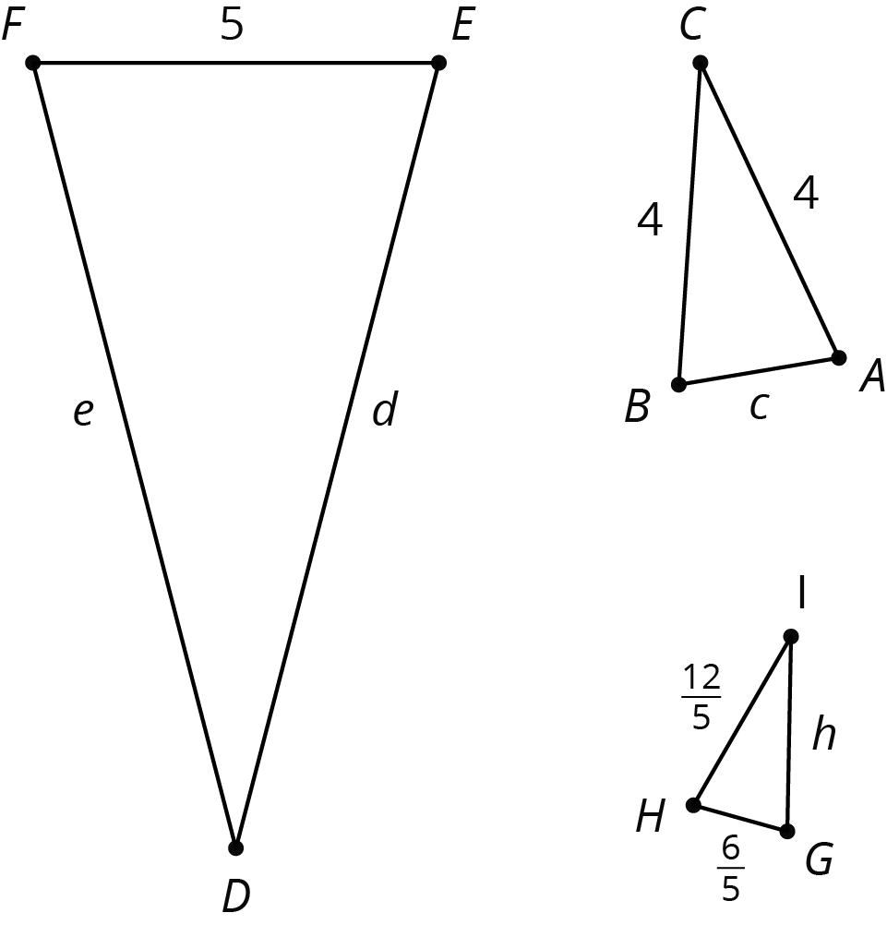

#### Images for Activity Synthesis

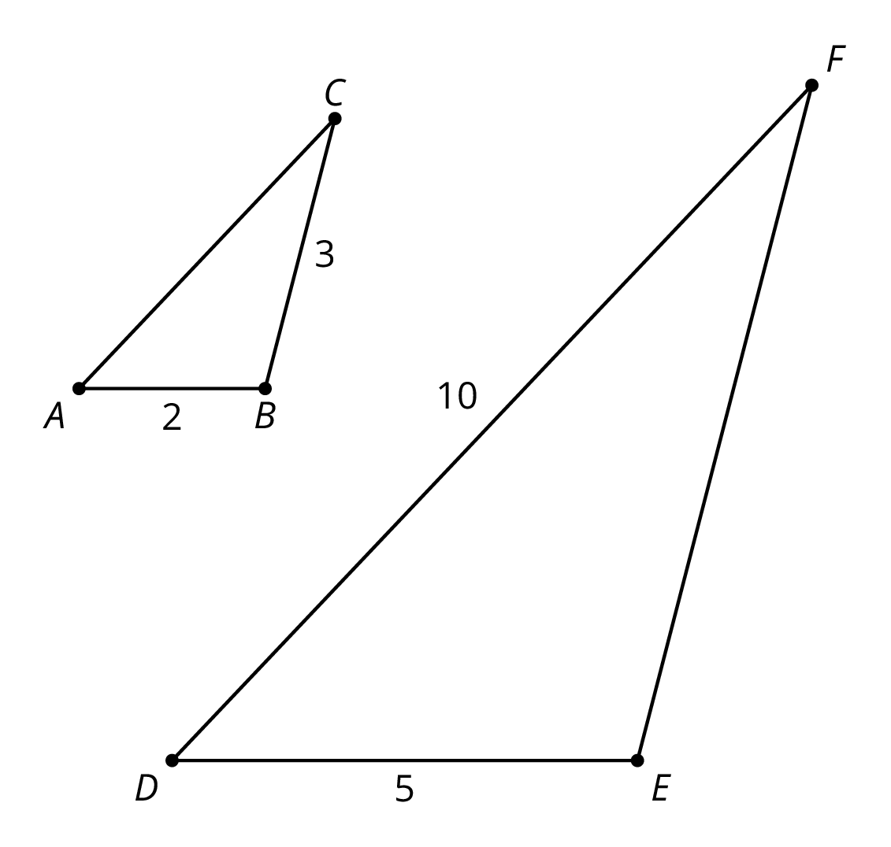



© CC BY Open Up Resources. Adaptations CC BY IM.