Lesson 16: Estimate Products
- Let’s estimate products of a whole number and a fraction.

Warm-up: Notice and Wonder: Garden Size
What do you notice? What do you wonder?
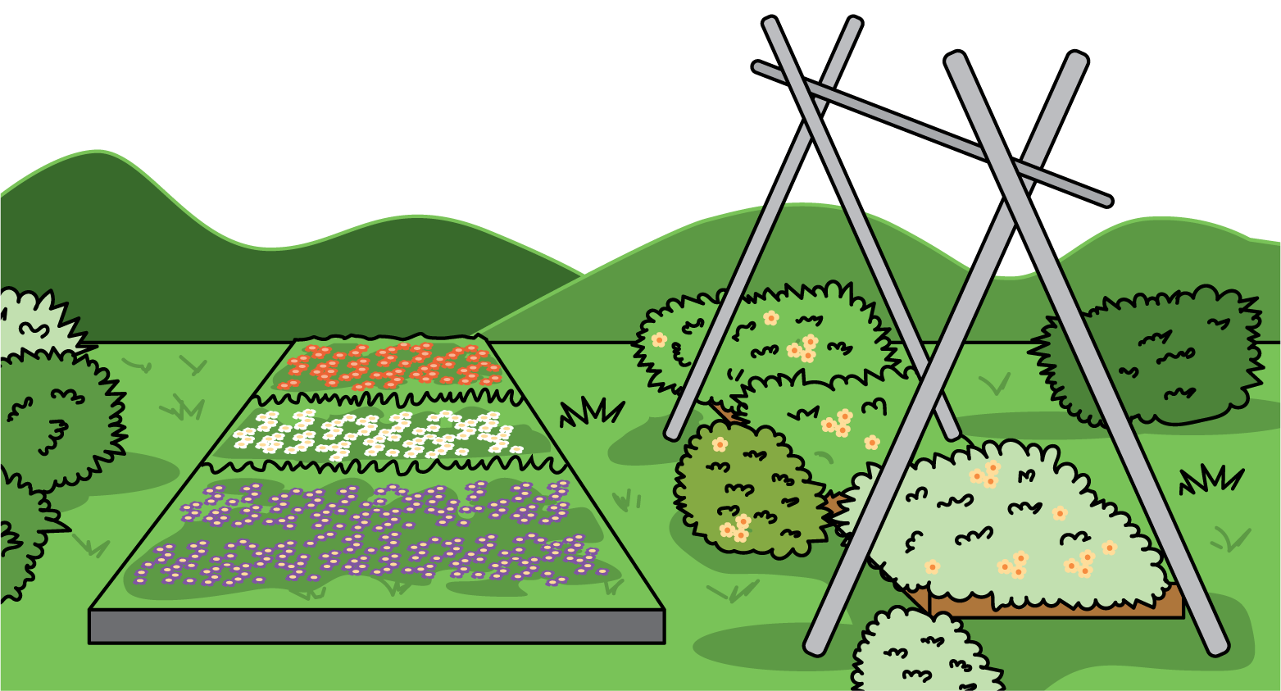

16.1: Priya’s Garden
Priya has enough materials to build a garden that is 36 square feet.
Choose all the side lengths that are reasonable for her garden. Be prepared to explain your thinking to your partner.
- 9 feet by $4\frac{2}{3}$ feet
- 9 feet by $3\frac{8}{9}$ feet
- 12 feet by $2\frac{11}{12}$ feet
- 9 feet by $2\frac{2}{3}$ feet

16.2: Too High, Too Low, Just About Right
- Write a whole number product that is slightly less than, slightly greater than, or about equal to the value of $7×12\frac{8}{9}$.
  - slightly less:
  - slightly greater:
  - just right:
- Write a whole number product that is slightly less than, slightly greater than, or about equal to the value of $9×4\frac{2}{29}$.
  - slightly less:
  - slightly greater:
  - just right:
- Without calculating, use the numbers 2, 3, 5, 6, and 7, to complete the expression with a value close to 20.
_× _aaaiaaaiaaaiaaai
- Explain how you know your expression represents a value close to 20.

Section Summary
Section Summary
In this section, we learned how to find the area of a rectangle with a fractional side length. The shaded region has an area of $4×\frac{2}{3}$ because there are 4 groups of $\frac{2}{3}$ of a square unit shaded. The area is $\frac{8}{3}$ or $2\frac{2}{3}$ because there are 8 shaded parts and each one is $\frac{1}{3}$ of a square unit.
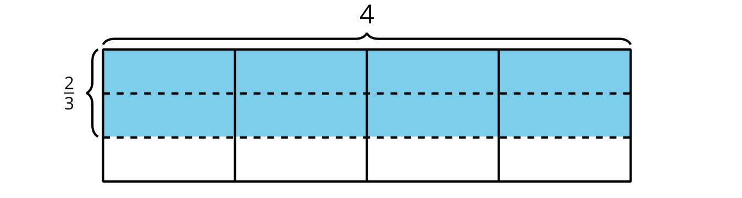
We also learned to multiply a mixed number by a whole number. We used area diagrams and expressions to see why our strategies work. For example, to solve $3\frac{3}{4}×2$, we can use the expression $\left(3×2\right)+\left(\frac{3}{4}×2\right)$. We can see both of these expressions in the diagram.
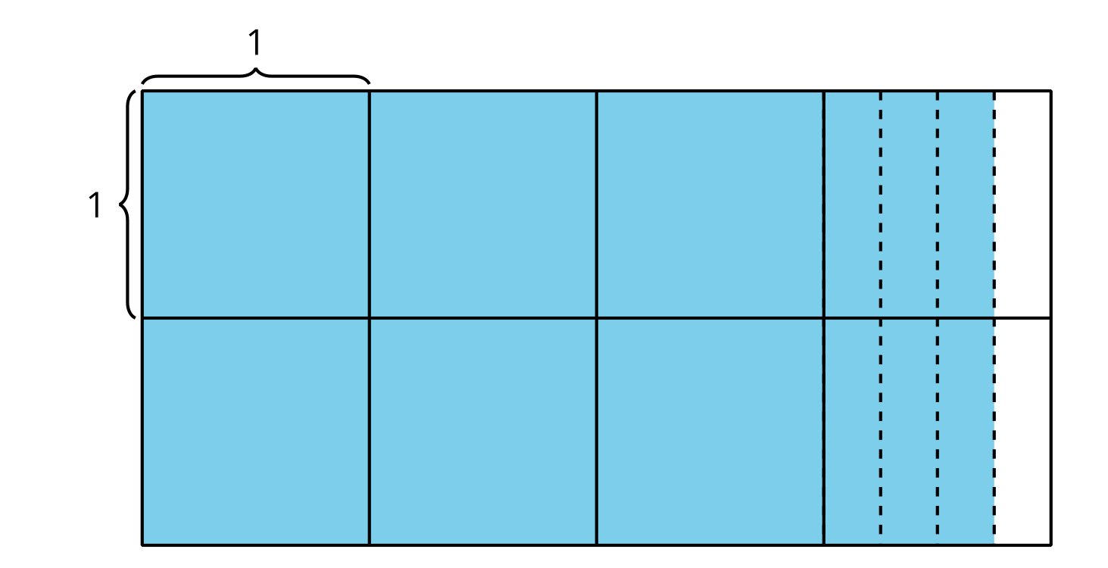
© CC BY 2021 Illustrative Mathematics®

