Lesson 9: Add and Subtract Within 100
- Let’s find the difference in our own way.

Warm-up: Which One Doesn’t Belong: Tens and Ones
Which one doesn’t belong?
A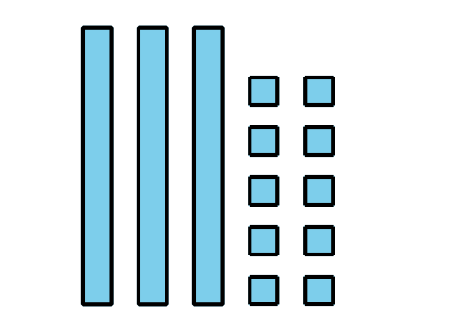
B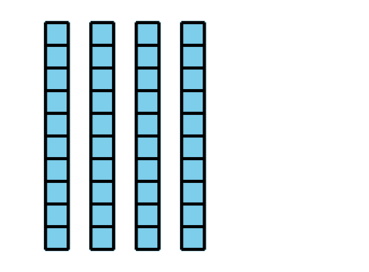
C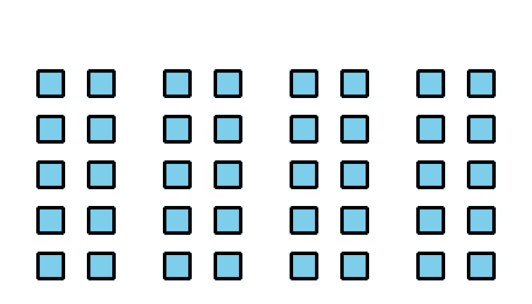
D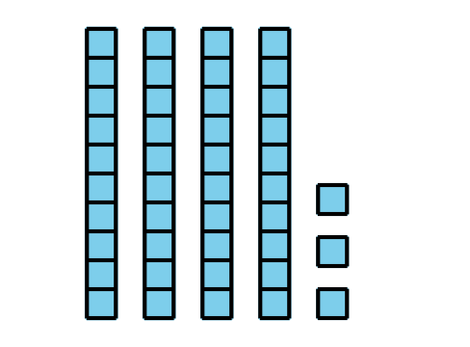

9.1: Sort and Find the Value
- Match each expression to a base-ten diagram.
- Choose 1 addition expression and find the value of the sum.
- Choose 1 subtraction expression and find value of the difference.

9.2: Add or Subtract
Find the value of each expression. Show your thinking. Use blocks if it helps.
- $27+47$
- $55−27$
- $36+38$
- $82−39$

Section Summary
Section Summary
In this section, we practiced subtracting two-digit numbers. We learned that when there are not enough ones to subtract by place, you can decompose 1 ten for 10 ones. We used base-ten blocks and base-ten diagrams to show our thinking.
$63−18$
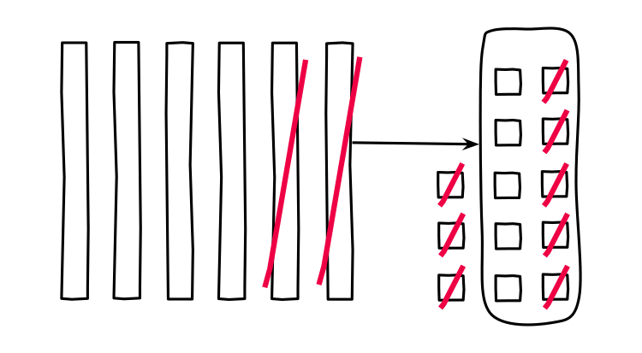
© CC BY 2021 Illustrative Mathematics®

