Unit 7 Lesson 13: Decompose Tens or Hundreds

WU Which One Doesn’t Belong: Blocks and Blocks (Warm up)

Student Task Statement
Which one doesn’t belong?
A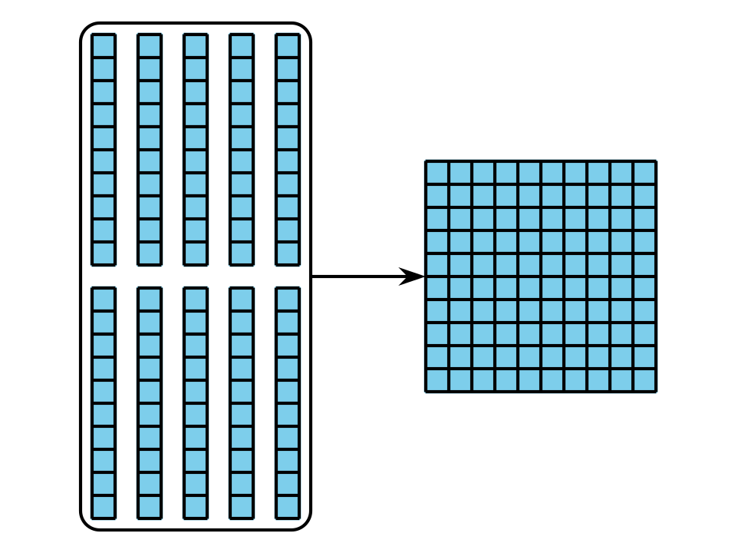
B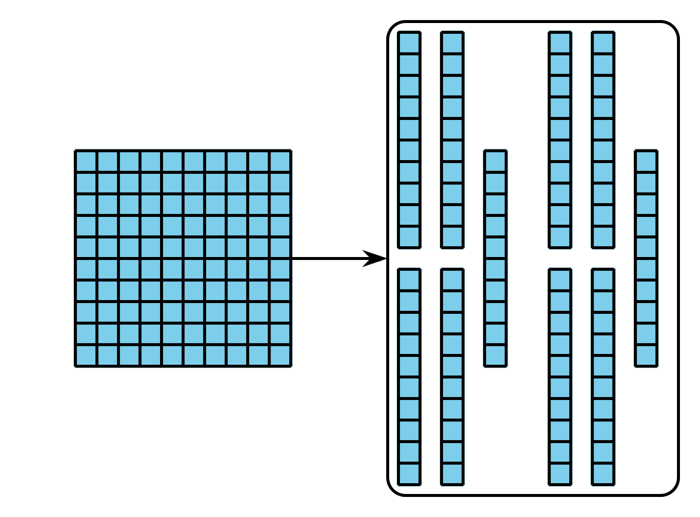
C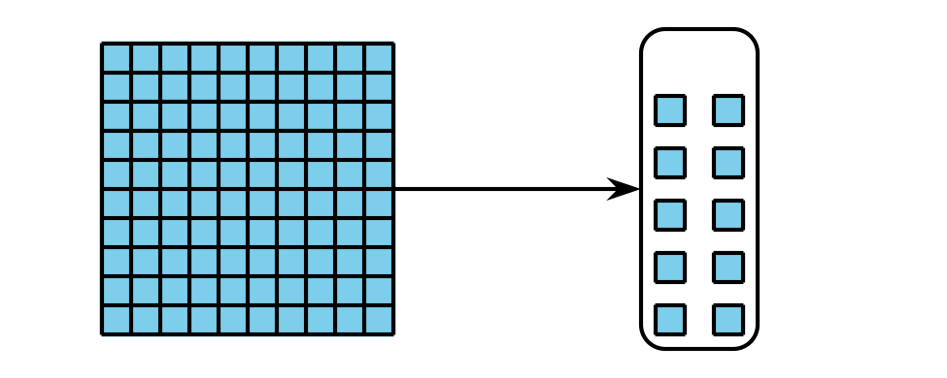
D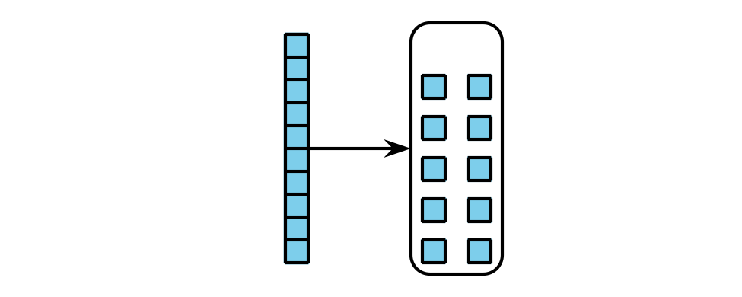

1 Subtract with Base-ten Diagrams

Student Task Statement
Mai used base-ten blocks to find the value of $336−52$. Then, she started making a diagram to show her work.
Explain what Mai did in Step 2. Show what Mai should do next to find the difference.
Step 1
Step 2
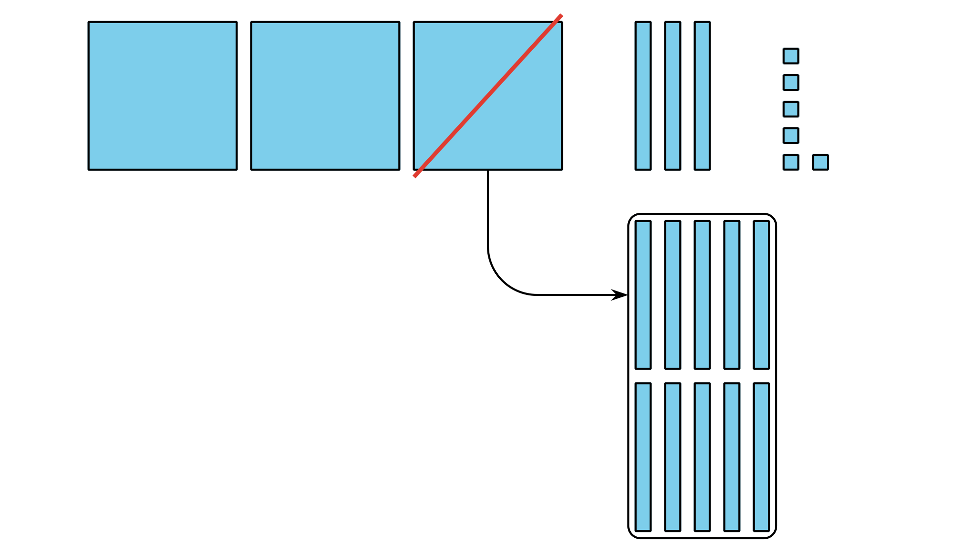
- Write each expression next to the matching diagram. Then find the value of each difference.
- $244−28$
- $256−64$
- $244−64$

  - 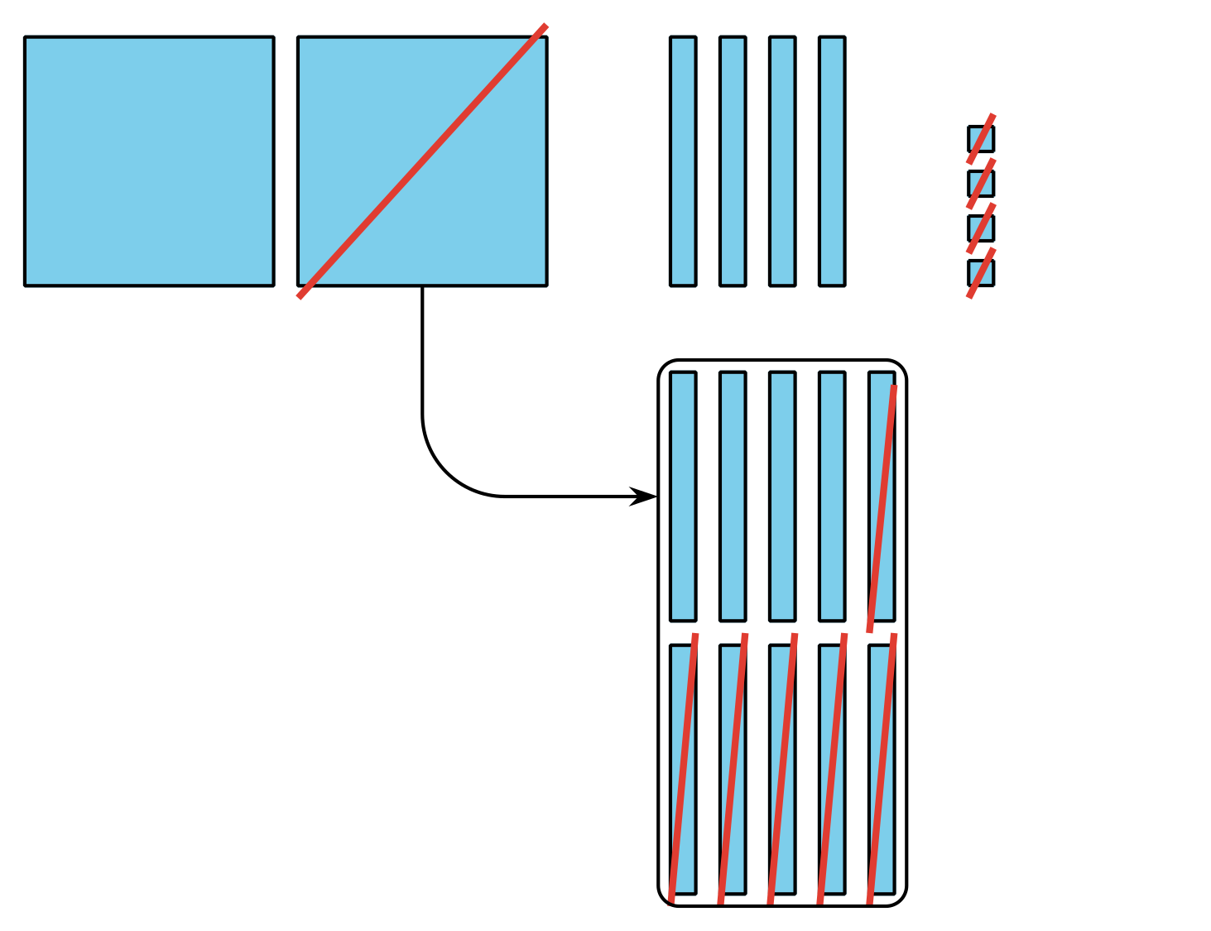

  - 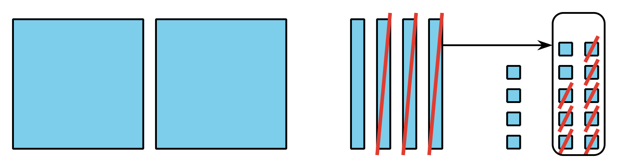

  - 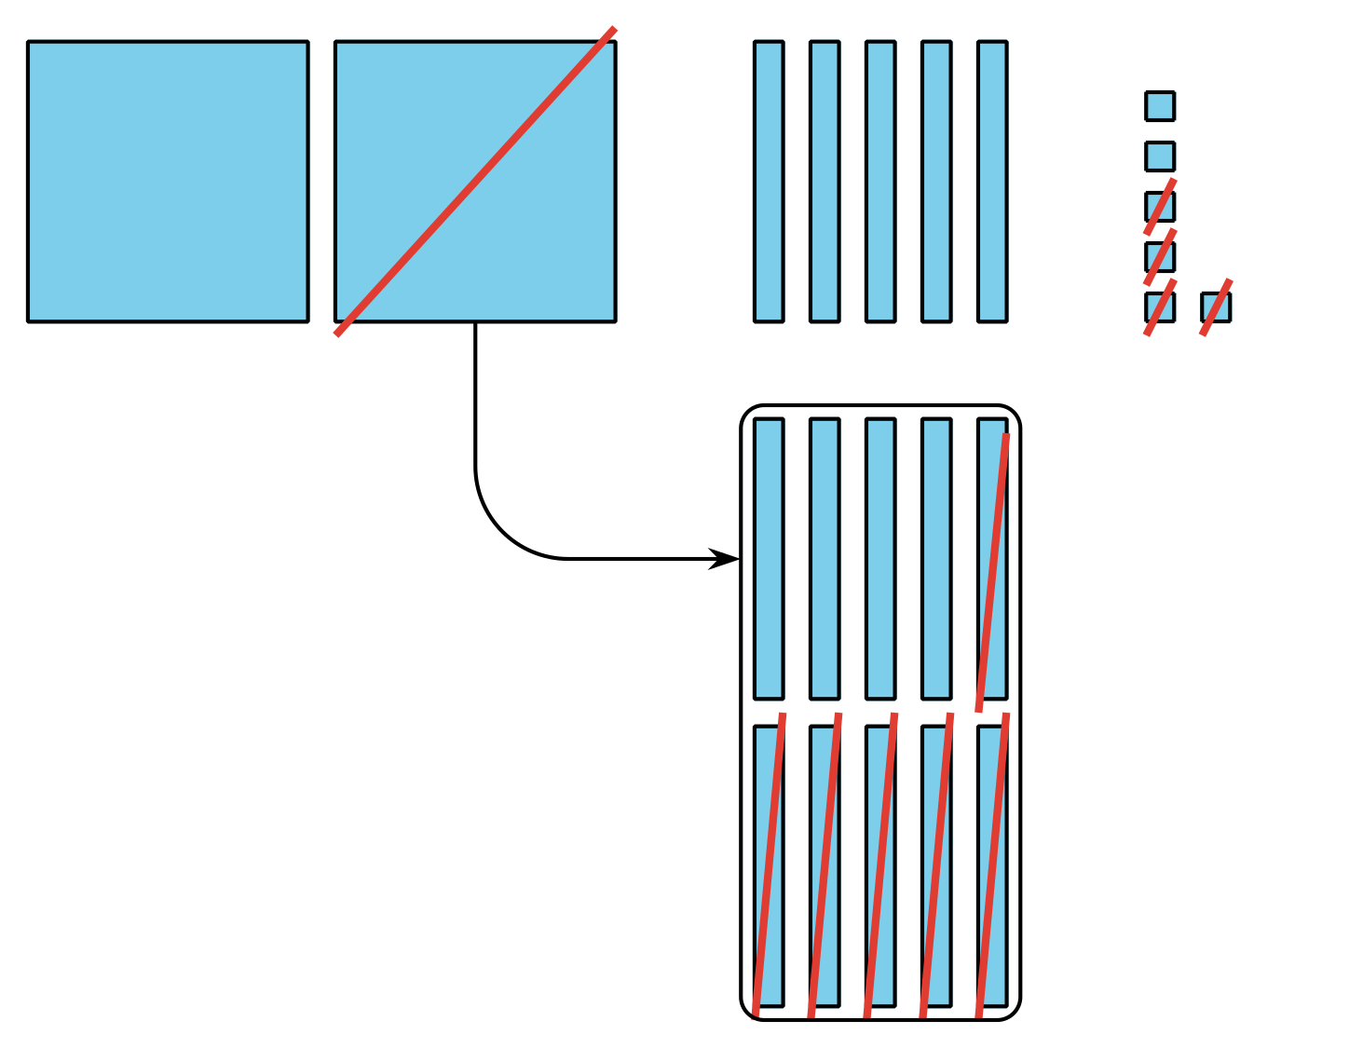

2 Decompose a Ten or Hundred

Student Task Statement
Find the value of each difference. Show your thinking. Try Mai's way for one expression.
- $245−28$
- $352−71$
- $364−182$
- $293−147$
- Share how you found the value of one of the expressions to your partner. Use the sentence frames to help explain:
  - “First, I . . .”
  - “Next, I . . .”
  - “Then, I . . .”
  - “Last , I . . .”
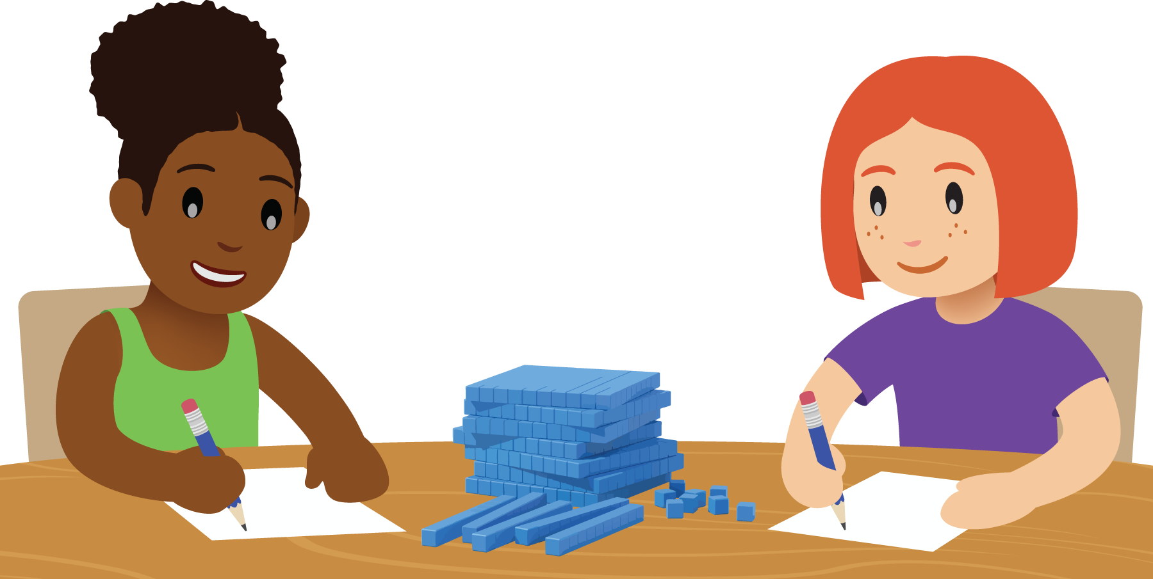
© CC BY 2021 Illustrative Mathematics®

