Lesson 17: Using Box Plots

17.1: Hours of Slumber
Ten sixth-grade students were asked how much sleep, in hours, they usually get on a school night. Here is the five-number summary of their responses.
- Minimum: 5 hours
- First quartile: 7 hours
- Median: 7.5 hours
- Third quartile: 8 hours
- Maximum: 9 hours
- On the grid, draw a box plot for this five-number summary.
- 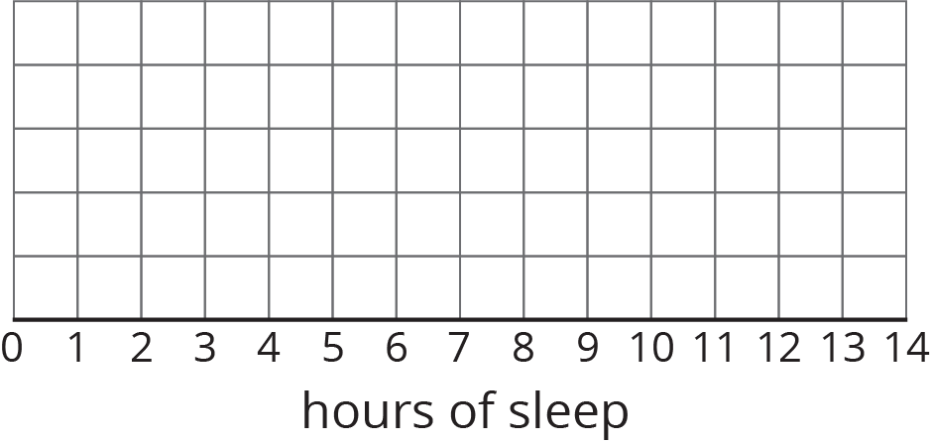
- What questions could be answered by looking at this box plot?

17.2: Info Gap: Sea Turtles
Your teacher will give you either a Problem Card or a Data Card about sea turtles that nest on the Outer Banks of North Carolina. Do not show or read your card to your partner.
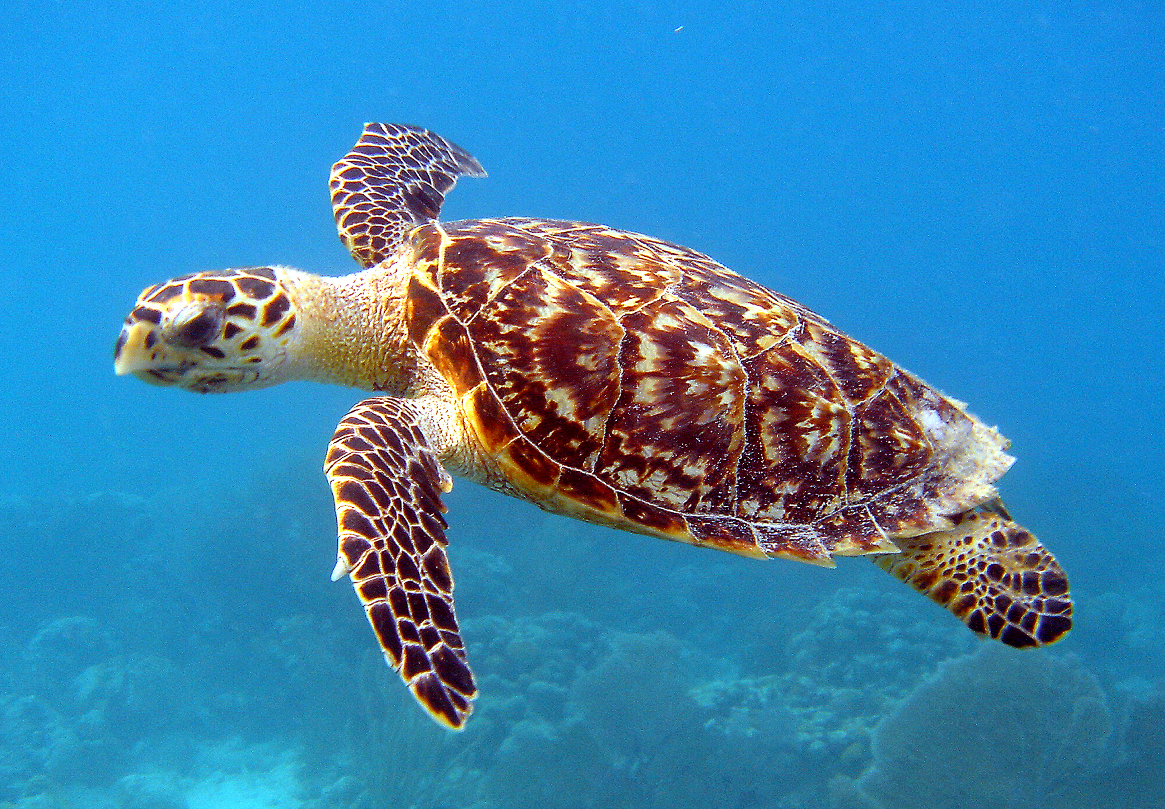
If your teacher gives you the problem card:
- Silently read your card and think about what information you need to be able to answer the question.
- Ask your partner for the specific information that you need.
- Explain how you are using the information to solve the problem.
- Continue to ask questions until you have enough information to solve the problem.
- Share the problem card and solve the problem independently.
- Read the data card and discuss your reasoning.
If your teacher gives you the data card:
- Silently read your card.
- Ask your partner “What specific information do you need?” and wait for them to ask for information.
- If your partner asks for information that is not on the card, do not do the calculations for them. Tell them you don’t have that information.
- Before sharing the information, ask “Why do you need that information?” Listen to your partner’s reasoning and ask clarifying questions.
- Read the problem card and solve the problem independently.
- Share the data card and discuss your reasoning.
Pause here so your teacher can review your work. Ask your teacher for a new set of cards and repeat the activity, trading roles with your partner.

17.3: Paper Planes
Andre, Lin, and Noah each designed and built a paper airplane. They launched each plane several times and recorded the distance of each flight in yards.
Andre

25
26
27
27
27
28
28
28
29
30
30
Lin

20
20
21
24
26
28
28
29
29
30
32
Noah

13
14
15
18
19
20
21
23
23
24
25
Work with your group to summarize the data sets with numbers and box plots.
- Write the five-number summary for the data for each airplane. Then, calculate the interquartile range for each data set.
- min | - Q1 | - median | - Q3 | - max | - IQR
- Draw three box plots, one for each paper airplane. Label the box plots clearly.
- 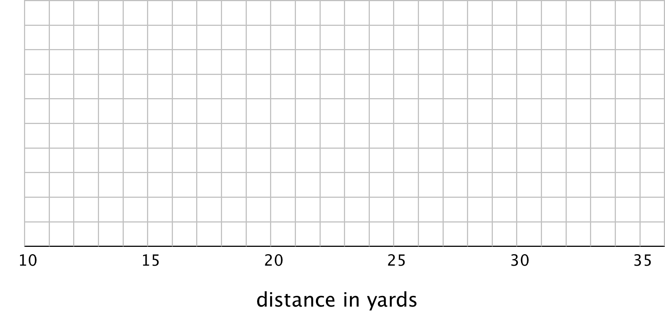
- How are the results for Andre and Lin’s planes the same? How are they different?
- How are the results for Lin and Noah’s planes the same? How are they different?

Are you ready for more?
Priya joined in the paper-plane experiments. She launched her plane eleven times and recorded the lengths of each flight. She found that her maximum and minimum were equal to Lin’s. Her IQR was equal to Andre’s.
Draw a box plot that could represent Priya’s data.
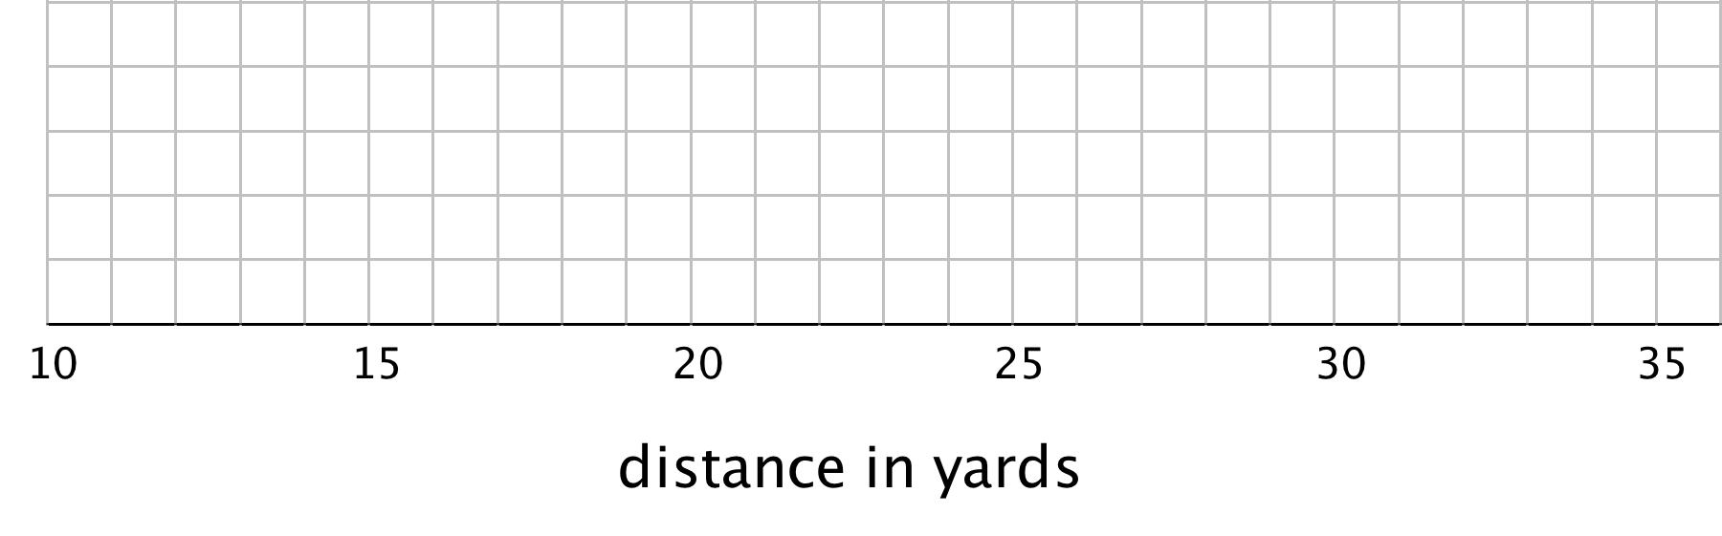
With the information given, can you estimate the median for Priya’s data? Explain your reasoning.

Lesson 17 Summary
Box plots are useful for comparing different groups. Here are two sets of plots that show the weights of some berries and some grapes.
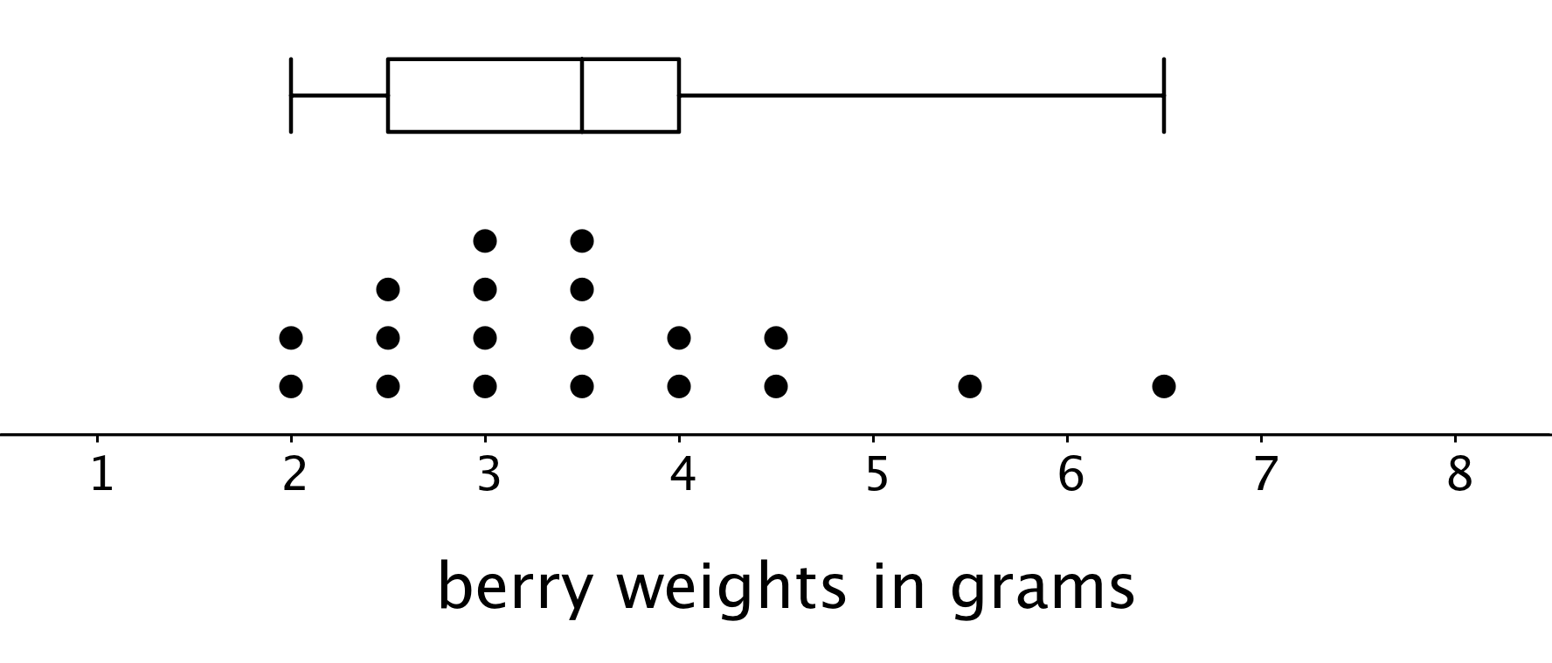
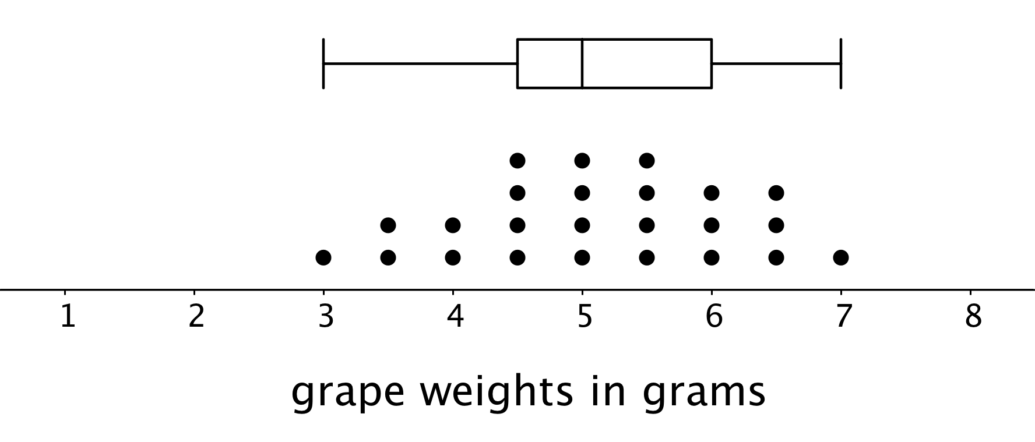
Notice that the median berry weight is 3.5 grams and the median grape weight is 5 grams. In both cases, the IQR is 1.5 grams. Because the grapes in this group have a higher median weight than the berries, we can say a grape in the group is typically heavier than a berry. Because both groups have the same IQR, we can say that they have a similar variability in their weights.
These box plots represent the length data for a collection ladybugs and a collection of beetles.
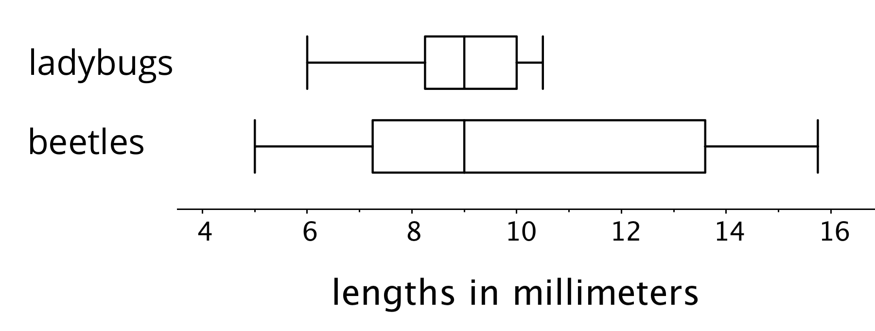
The medians of the two collections are the same, but the IQR of the ladybugs is much smaller. This tells us that a typical ladybug length is similar to a typical beetle length, but the ladybugs are more alike in their length than the beetles are in their length.
© CC BY Open Up Resources. Adaptations CC BY IM.

