Lesson 7: Simulating Multi-step Experiments
Let’s simulate more complicated events.

7.1: Notice and Wonder: Ski Business
What do you notice? What do you wonder?
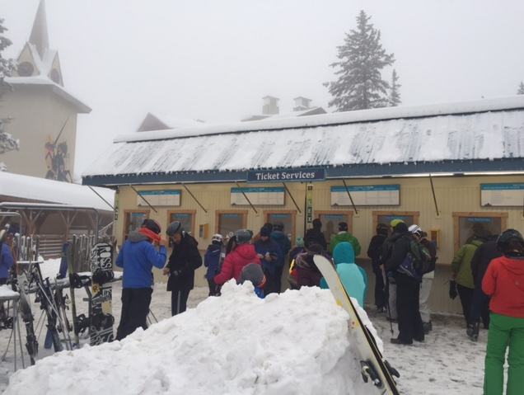
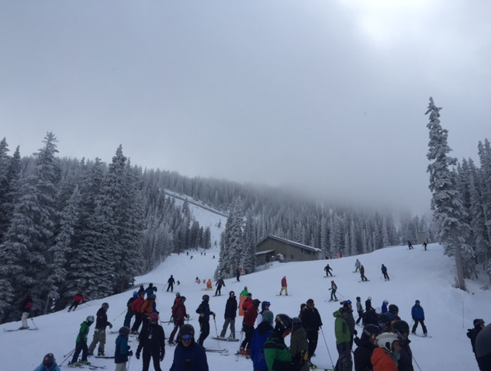

7.2: Alpine Zoom
Alpine Zoom is a ski business. To make money over spring break, they need it to snow at least 4 out of the 10 days. The weather forecast says there is a $\frac{1}{3}$ chance it will snow each day during the break.
- Describe a chance experiment that you could use to simulate whether it will snow on the first day of spring break.
- How could this chance experiment be used to determine whether Alpine Zoom will make money?
- Pause here so your teacher can give you the supplies for a simulation.
- Simulate the weather for 10 days to see if Alpine Zoom will make money over spring break. Record your results in the first row of the table.
 | - day 1 | - day 2 | - day 3 | - day 4 | - day 5 | - day 6 | - day 7 | - day 8 | - day 9 | - day 10 | - Did they make money?
- simulation 1
- simulation 2
- simulation 3
- simulation 4
- simulation 5
- Repeat the previous step 4 more times. Record your results in the other rows of the table.
- Based on your group’s simulations, estimate the probability that Alpine Zoom will make money.

7.3: Kiran’s Game
Kiran invents a game that uses a board with alternating black and white squares. A playing piece starts on a white square and must advance 4 squares to the other side of the board within 5 turns to win the game.
For each turn, the player draws a block from a bag containing 2 black blocks and 2 white blocks. If the block color matches the color of the next square on the board, the playing piece moves onto it. If it does not match, the playing piece stays on its current square.
- Take turns playing the game until each person in your group has played the game twice.
- Use the results from all the games your group played to estimate the probability of winning Kiran’s game.
- Do you think your estimate of the probability of winning is a good estimate? How could it be improved?

Are you ready for more?
How would each of these changes, on its own, affect the probability of winning the game?
- Change the rules so that the playing piece must move 7 spaces within 8 moves.
- Change the board so that all the spaces are black.
- Change the blocks in the bag to 3 black blocks and 1 white block.

7.4: Simulation Nation
Match each situation to a simulation.
Situations:
- In a small lake, 25% of the fish are female. You capture a fish, record whether it is male or female, and toss the fish back into the lake. If you repeat this process 5 times, what is the probability that at least 3 of the 5 fish are female?
- Elena makes about 80% of her free throws. Based on her past successes with free throws, what is the probability that she will make exactly 4 out of 5 free throws in her next basketball game?
- On a game show, a contestant must pick one of three doors. In the first round, the winning door has a vacation. In the second round, the winning door has a car. What is the probability of winning a vacation and a car?
- Your choir is singing in 4 concerts. You and one of your classmates both learned the solo. Before each concert, there is an equal chance the choir director will select you or the other student to sing the solo. What is the probability that you will be selected to sing the solo in exactly 3 of the 4 concerts?
Simulations:
- Toss a standard number cube 2 times and record the outcomes. Repeat this process many times and find the proportion of the simulations in which a 1 or 2 appeared both times to estimate the probability.
- Make a spinner with four equal sections labeled 1, 2, 3, and 4. Spin the spinner 5 times and record the outcomes. Repeat this process many times and find the proportion of the simulations in which a 4 appears 3 or more times to estimate the probability.
- Toss a fair coin 4 times and record the outcomes. Repeat this process many times, and find the proportion of the simulations in which exactly 3 heads appear to estimate the probability.
- Place 8 blue chips and 2 red chips in a bag. Shake the bag, select a chip, record its color, and then return the chip to the bag. Repeat the process 4 more times to obtain a simulated outcome. Then repeat this process many times and find the proportion of the simulations in which exactly 4 blues are selected to estimate the probability.

Lesson 7 Summary
The more complex a situation is, the harder it can be to estimate the probability of a particular event happening. Well-designed simulations are a way to estimate a probability in a complex situation, especially when it would be difficult or impossible to determine the probability from reasoning alone.
To design a good simulation, we need to know something about the situation. For example, if we want to estimate the probability that it will rain every day for the next three days, we could look up the weather forecast for the next three days. Here is a table showing a weather forecast:
 | today  (Tuesday) | Wednesday | Thursday | Friday
probability of rain | 0.2 | 0.4 | 0.5 | 0.9
We can set up a simulation to estimate the probability of rain each day with three bags.
- In the first bag, we put 4 slips of paper that say “rain” and 6 that say “no rain.”
- In the second bag, we put 5 slips of paper that say “rain” and 5 that say “no rain.”
- In the third bag, we put 9 slips of paper that say “rain” and 1 that says “no rain.”
Then we can select one slip of paper from each bag and record whether or not there was rain on all three days. If we repeat this experiment many times, we can estimate the probability that there will be rain on all three days by dividing the number of times all three slips said “rain” by the total number of times we performed the simulation.
© CC BY Open Up Resources. Adaptations CC BY IM.

