Lesson 7: Building Quadratic Functions to Describe Situations (Part 3)

7.1: Which One Doesn’t Belong: Graphs of Four Functions
Which one doesn’t belong?

A
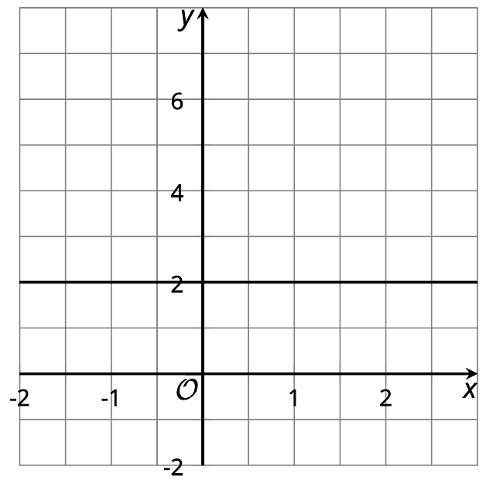

B
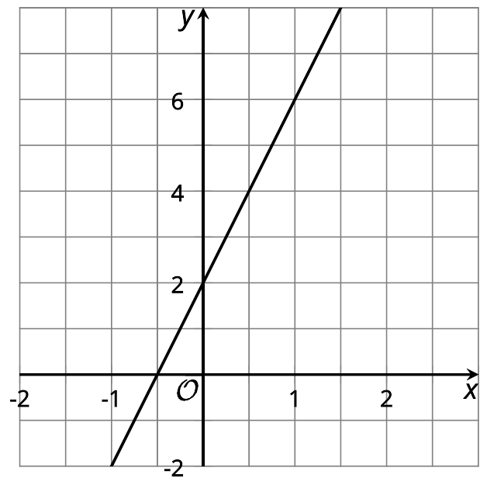

C
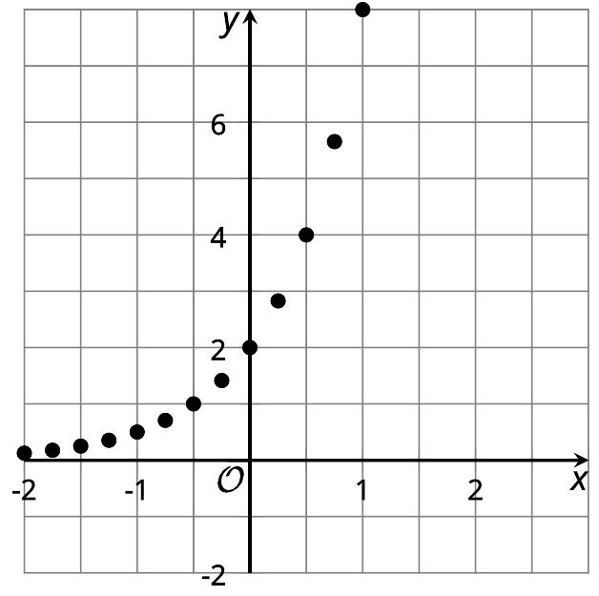

D
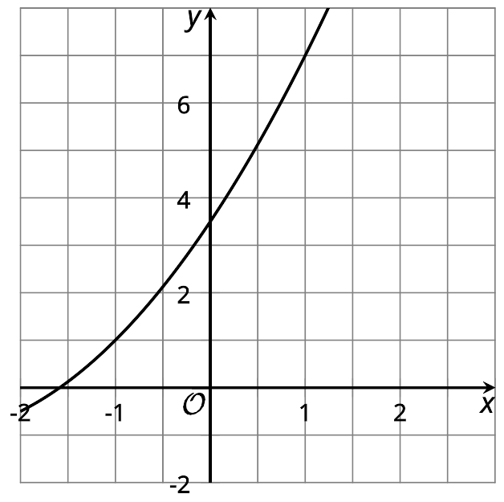

7.2: What Price to Charge?
A company that sells movies online is deciding how much to charge customers to download a new movie. Based on data from previous sales, the company predicts that if they charge $x$ dollars for each download, then the number of downloads, in thousands, is $18−x$.
- Complete the table to show the predicted number of downloads at each listed price. Then, find the revenue at each price. The first row has been completed for you.
- price (dollars per download) | - number of downloads (thousands) | - revenue (thousands of dollars)
- 3 | - 15 | - 45
- 5
- 10
- 12
- 15
- 18
- $x$
- Is the relationship between the price of the movie and the revenue (in thousands of dollars) quadratic? Explain how you know.
- Plot the points that represent the revenue, $r$, as a function of the price of one download in dollars, $x$.
- 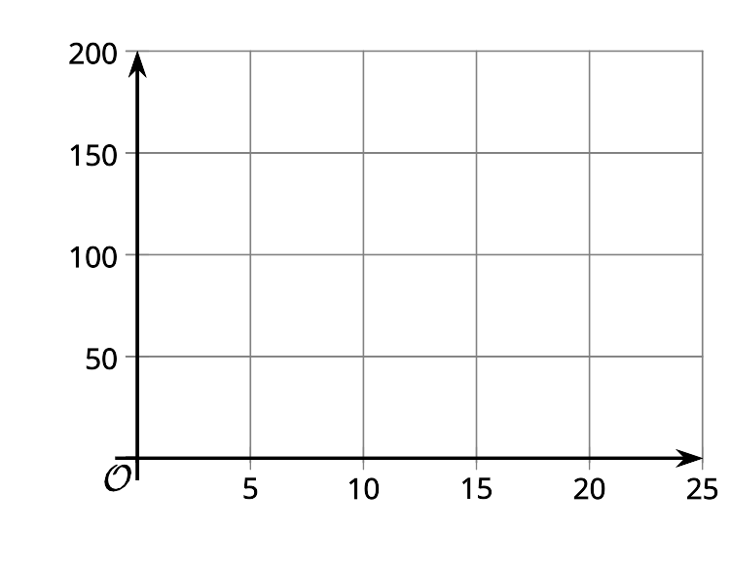
- What price would you recommend the company charge for a new movie? Explain your reasoning.

Are you ready for more?
The function that uses the price (in dollars per download) $x$ to determine the number of downloads (in thousands) $18−x$ is an example of a demand function and its graph is known. Economists are interested in factors that can affect the demand function and therefore the price suppliers wish to set.
- What are some things that could increase the number of downloads predicted for the same given prices?
- If the demand shifted so that we predicted $20−x$ thousand downloads at a price of $x$ dollars per download, what do you think will happen to the price that gives the maximum revenue? Check what actually happens.

7.3: Domain, Vertex, and Zeros
Here are 4 sets of descriptions and equations that represent some familiar quadratic functions. The graphs show what a graphing technology may produce when the equations are graphed. For each function:
- Describe a domain that is appropriate for the situation. Think about any upper or lower limits for the input, as well as whether all numbers make sense as the input. Then, describe how the graph should be modified to show the domain that makes sense.
- Identify or estimate the vertex on the graph. Describe what it means in the situation.
- Identify or estimate the zeros of the function. Describe what it means in the situation.
1. The area of rectangle with a perimeter of 25 meters and a side length $x$: $A(x)=x⋅\frac{(25−2x)}{2}$
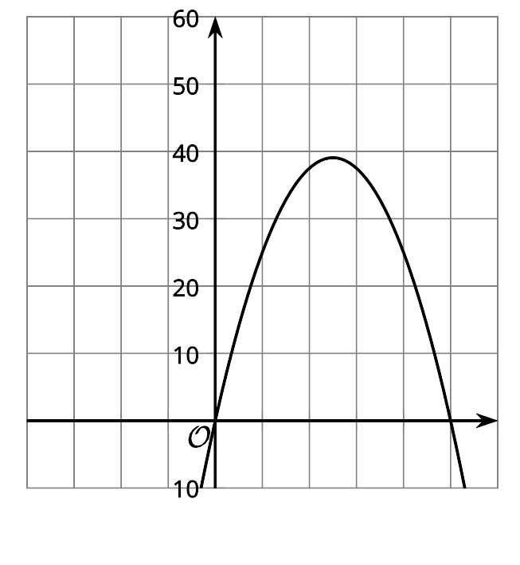
- Domain:
- Vertex:
- Zeros:
2. The number of squares as a function of step number $n$: $f(n)=n^{2}+4$
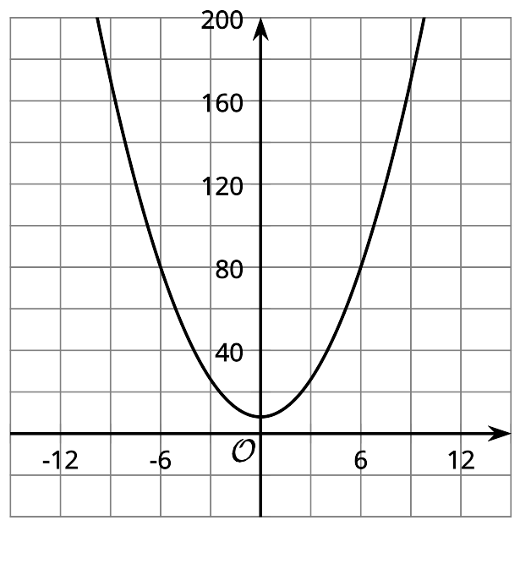
- Domain:
- Vertex:
- Zeros:​​​
3. The distance in feet that an object has fallen $t$ seconds after being dropped: $g(t)=16t^{2}$
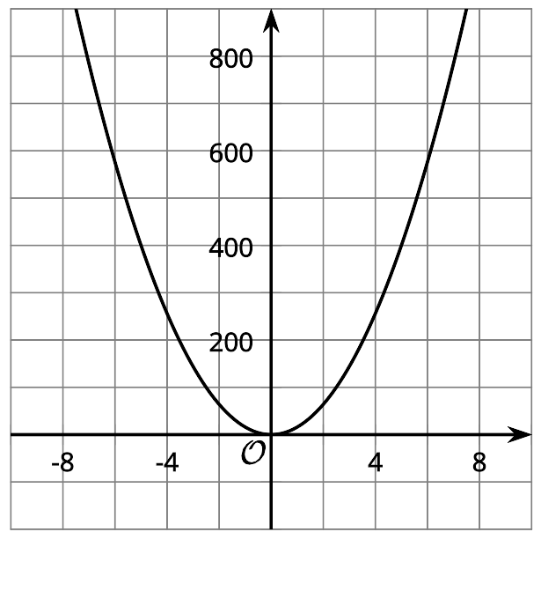
- Domain:
- Vertex:
- Zeros:
4. The height in feet of an object $t$ seconds after being dropped: $h(t)=576−16t^{2}$
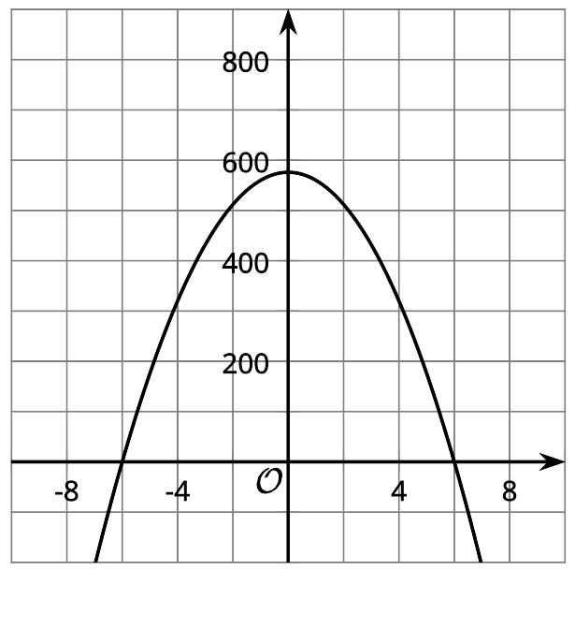
- Domain:
- Vertex:
- Zeros:

Lesson 7 Summary
Quadratic functions often come up when studying revenue. (Revenue means the money collected when someone sells something.)
Suppose we are selling raffle tickets and deciding how much to charge for each ticket. When the price of the tickets is higher, typically fewer tickets will be sold.
Let’s say that with a price of $d$ dollars, it is possible to sell $600−75d$ tickets. We can find the revenue by multiplying the price by the number of tickets expected to be sold. A function that models the revenue $r$ collected is $r(d)=d(600−75d)$. Here is a graph that represents the function.
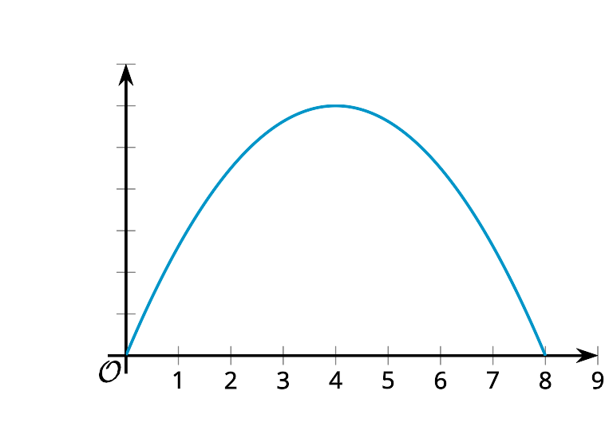
It makes sense that the revenue goes down after a certain point, since if the price is too high nobody will buy a ticket. From the graph, we can tell that the greatest revenue, $1,200, comes from selling the tickets for $4 each.
We can also see that the domain of the function $r$ is between 0 and 8. This makes sense because the cost of the tickets can’t be negative, and if the price were more than $8, the model does not work, as the revenue collected cannot be negative. (A negative revenue would mean the number of tickets sold is negative, which is not possible.)
© CC BY 2019 by Illustrative Mathematics

