Lesson 5: ¿Qué es un ángulo?

Standards Alignments
Addressing | 4.G.A.1, 4.MD.C.5
Building Towards | 4.MD.C.5

Teacher-facing Learning Goals
- Identify angles in two-dimensional figures.
- Recognize angles as geometric figures that are formed wherever two rays share a common endpoint.

Student-facing Learning Goals
- Busquemos ángulos y encontremos maneras de describirlos.

Lesson Purpose
The purpose of this lesson is to introduce angles and to motivate a need for vocabulary to describe what they are and their size.
In this lesson, students are introduced to angles. They learn that an angle can be defined in terms of the geometric parts they have been working with in this unit.
In previous grades, students have used “square corners” to describe right angles within two-dimensional shapes. They may have considered an angle as the space within a square corner or the “pointy” corner itself. Here, students learn that an angle is a geometric figure made up of two rays that share the same endpoint, which we refer to as the vertex of the angle.
Throughout the lesson, students use the vocabulary they have developed to describe other geometric figures to identify and describe angles. Monitor for the ways students reason about how to describe the size of angles. Students will compare and measure angles in future lessons.
This lesson has a Student Section Summary.

Access for:

Students with Disabilities
- Engagement (Activity 1)

Instructional Routines
MLR1 Stronger and Clearer Each Time (Activity 2), MLR2 Collect and Display (Activity 1), Notice and Wonder (Warm-up)

Materials to Gather
- Rulers or straightedges: Activity 1, Activity 3

Materials to Copy
- Tricky Figures, Spanish (groups of 8): Activity 1

Required Preparation

Lesson Timeline
Warm-up | 5 min
Activity 1 | 15 min
Activity 2 | 15 min
Activity 3 | 10 min
Lesson Synthesis | 10 min
Cool-down | 5 min

Teacher Reflection Question
What was the best question you asked students today? Why would you consider it the best one based on what students said or did?

Cool-down
(to be completed at the end of the lesson) 5min
Encuentra los ángulos

Standards Alignments
Addressing | 4.G.A.1, 4.MD.C.5

Student-facing Task Statement
- Jada dice que la figura A muestra un ángulo, pero que la figura B no. ¿Estás de acuerdo? Explica tu razonamiento. ​​​​​
- 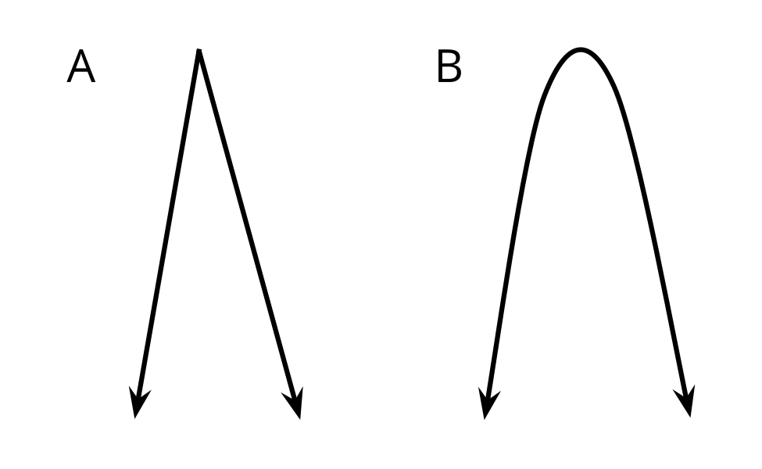
- Identifica los ángulos de cada letra y dibuja los rayos para mostrar cada ángulo.

Student Responses
- Yes. Sample reasoning: Figure A is made up of two rays with the same endpoint. Figure B is a continuous curve, so it doesn’t count as an angle.
- Sample response:
