Unit 1 Lesson 1: Moving in the Plane

1 Which One Doesn’t Belong: Diagrams (Warm up)

Student Task Statement
Which one doesn’t belong?
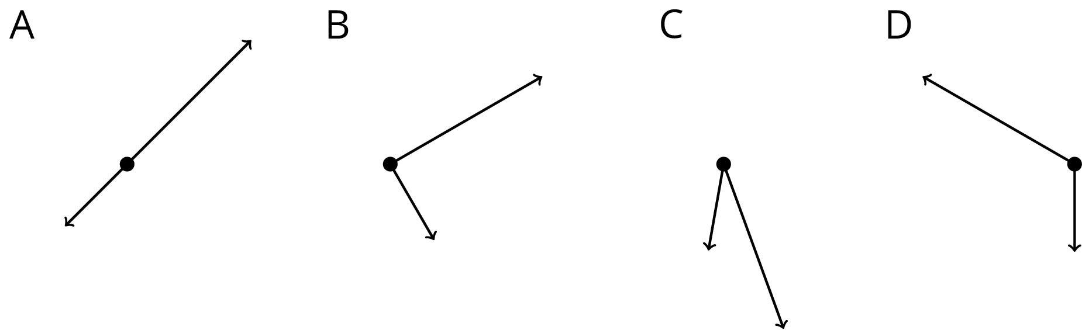

2 Triangle Square Dance

Student Task Statement
Your teacher will give you three pictures. Each shows a different set of dance moves.
- Arrange the three pictures so you and your partner can both see them right way up. Choose who will start the game.
  - The starting player mentally chooses A, B, or C and describes the dance to the other player.
  - The other player identifies which dance is being talked about: A, B, or C.
- After one round, trade roles. When you have described all three dances, come to an agreement on the words you use to describe the moves in each dance.
- With your partner, write a description of the moves in each dance.

Images for Activity Synthesis
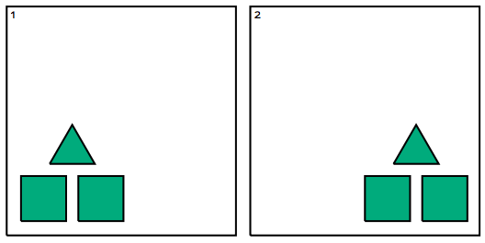
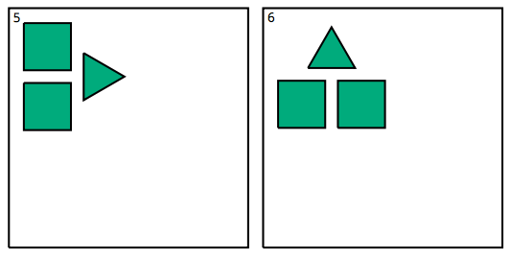
© CC BY Open Up Resources. Adaptations CC BY IM.

