Unit 4 Lesson 2: Representations of Growth and Decay

1 One Fourth at a Time (Warm up)

Student Task Statement
Priya borrowed $160 from her grandmother. Each month, she pays off one fourth of the remaining balance that she owes.
- What amount will Priya pay her grandmother in the third month?
- Discuss with a partner why the expression $160⋅{\left(\frac{3}{4}\right)}^{3}$ represents the balance Priya owes her grandmother at the end of the third month.

2 Climbing Cost (Optional)

Student Task Statement
The tuition at a college was $30,000 in 2012, $31,200 in 2013, and $32,448 in 2014. The tuition has been increasing by the same percentage since the year 2000.
- The equation $c\left(t\right)=30,​000⋅{\left(1.04\right)}^{t}$ represents the cost of tuition, in dollars, as a function of $t$, the number of years since 2012. Explain what the 30,000 and 1.04 tell us about this situation.
- What is the percent increase in tuition from year to year?
- What does $c\left(3\right)$ mean in this situation? Find its value and show your reasoning.

  - Write an expression to represent the cost of tuition in 2007.
  - How much did tuition cost that year?

3 Two Vans and Their Values (Optional)

Student Task Statement
A small business bought a van for $40,000 in 2008. The van depreciates by 15% every year after its purchase.
- Which graph correctly represents the value of the van as a function of years since its purchase? Be prepared to explain why each of the other graphs could not represent the function.

- Graph A
- 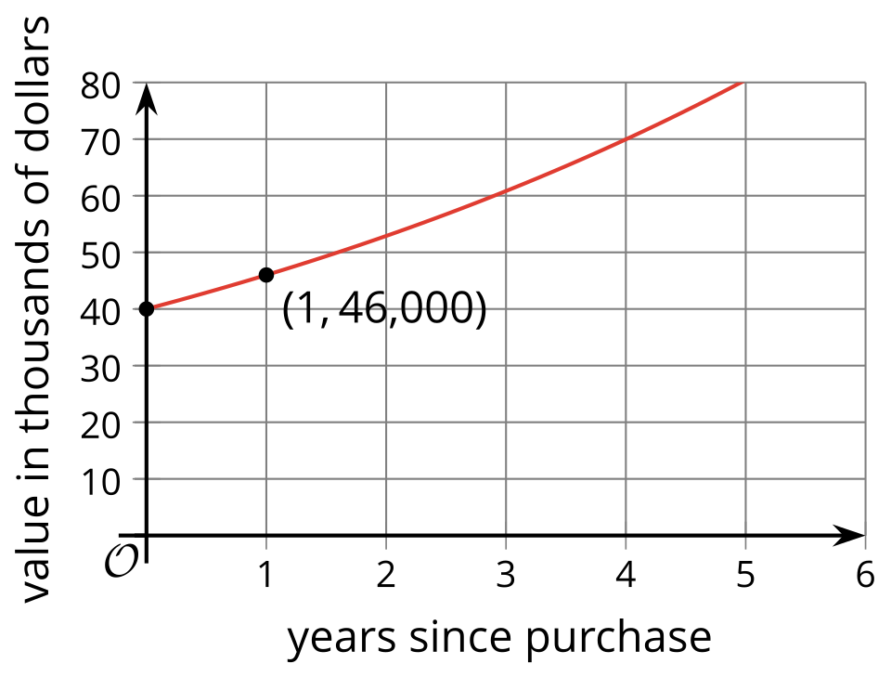

- Graph B
- 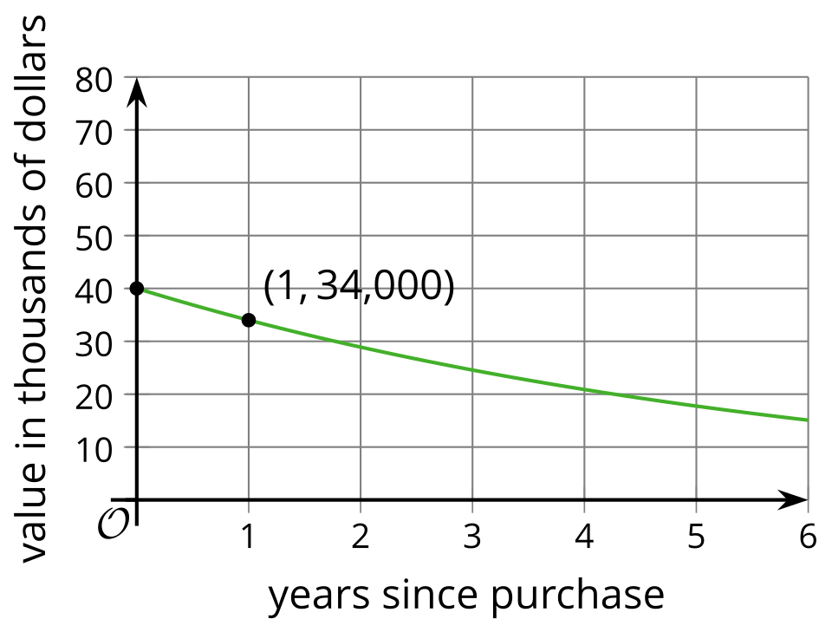

- Graph C
- 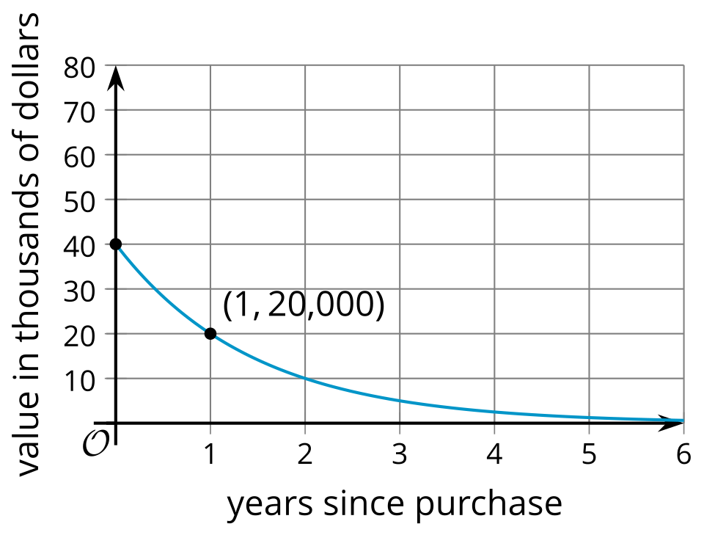

- Graph D
- 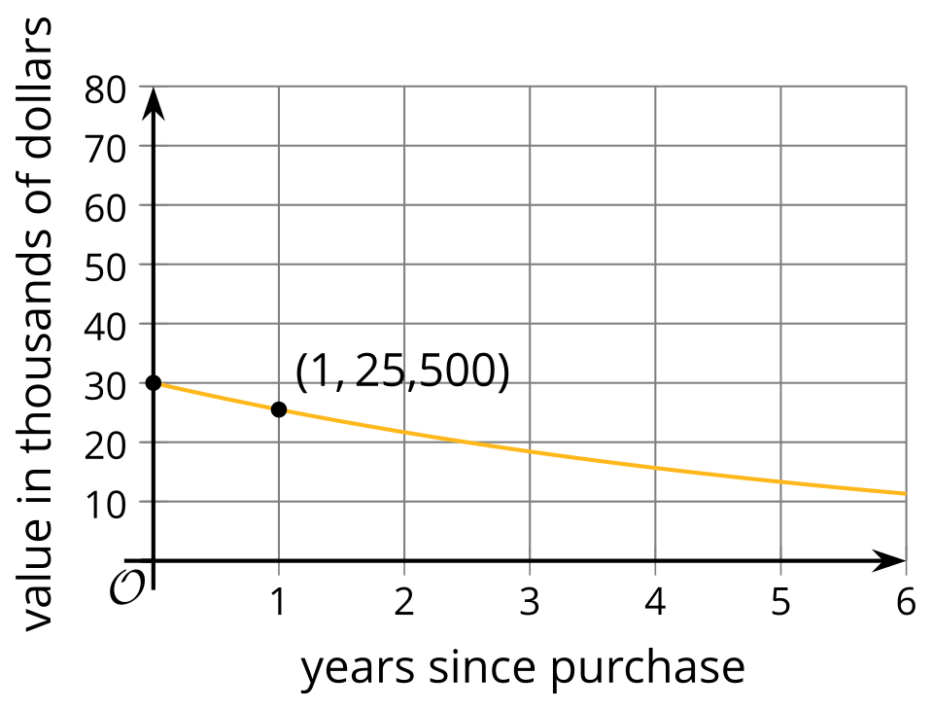
- Find the value of the van 8 years after its purchase. Show your reasoning.
- In the same year (2008), the business bought a second van that cost $10,000 less than the first van and depreciates at 10% per year. Would the second van be worth more or less than the first van 8 years after the purchase? Explain or show your reasoning.
- On the same coordinate plane as the graph you chose in the first question, sketch a graph that shows the value of the second van, in dollars, as a function of years since its purchase.
© CC BY 2019 by Illustrative Mathematics®

