Lesson 2: Puntos, rectas, rayos y segmentos

Standards Alignments
Addressing | 4.G.A.1, 4.NBT.B.4, 4.NBT.B.5

Teacher-facing Learning Goals
- Draw points, lines, rays, and segments.
- Identify points, lines, rays, and segments in geometric drawings.

Student-facing Learning Goals
- Dibujemos puntos, rectas, segmentos de recta y rayos.

Lesson Purpose
The purpose of this lesson is for students to identify and draw lines, segments, and rays.
In the previous lesson, students created drawings and used informal language to describe their drawings. They began to see segments as pieces contained within lines.
In this lesson, students begin to connect points, lines, and line segments with formal definitions. They also encounter rays and learn that a ray is different from a line segment, but, like a segment, it is also a part of a line. The first activity, a Card Sort, encourages students to look for these distinctions.
In the second activity, students draw segments and rays that form other shapes and figures. An isometric dot paper is used for drawing to reinforce the idea of segments and rays having endpoints.
To support students with the vocabulary in this unit, consider making time for them to build a personal illustrated “word wall” at the end of each lesson in which new terms are introduced. Allow a few minutes for students to add new terms, illustrations, and definitions in their own words to an organizer as shown in the blackline master.

Access for:

Students with Disabilities
- Engagement (Activity 1)

English Learners
- MLR8 (Activity 1)

Instructional Routines
MLR7 Compare and Connect (Activity 2), Number Talk (Warm-up)

Materials to Gather
- Rulers or straightedges: Activity 1, Activity 2

Materials to Copy
- Card Sort: Who Am I?, Spanish (groups of 2): Activity 1

Required Preparation

Lesson Timeline
Warm-up | 10 min
Activity 1 | 20 min
Activity 2 | 15 min
Lesson Synthesis | 10 min
Cool-down | 5 min

Teacher Reflection Question
Who participated in math class today? Who did not participate and why might this be? How can you leverage each of your student’s ideas to support them in being seen and heard in tomorrow’s class?

Cool-down
(to be completed at the end of the lesson) 5min
Verdadero o falso: ¿Cuál es el punto?

Standards Alignments
Addressing | 4.G.A.1

Student-facing Task Statement
Decide si cada afirmación es verdadera o falsa. Si es falsa, corrígela.
- Un punto marca un lugar.
- Este es el dibujo de un rayo.
- 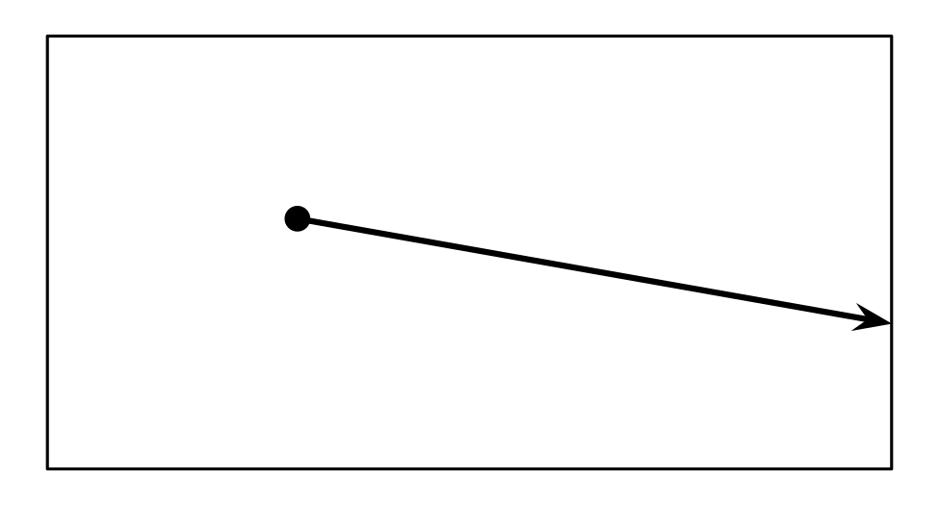
- Una recta puede ser curva.
- Este es un dibujo de un segmento.
- 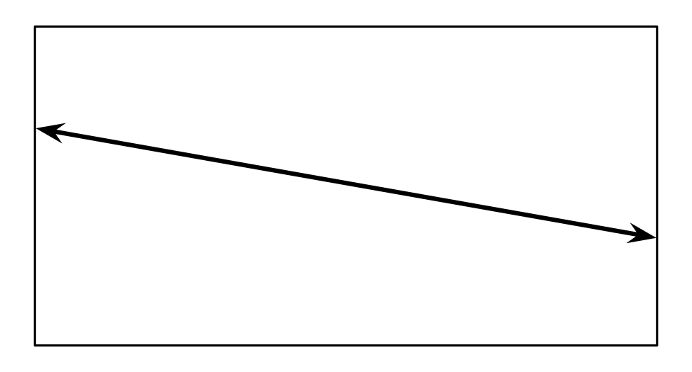
- La longitud de un rayo se puede medir.

Student Responses
- True
- True
- False. A line is always straight.
- False. Sample corrections:
  - A line segment is a part of a line and has two endpoints.
  - The drawing shows a line or two rays pointing in opposite directions.
  - This is a drawing of a segment:
- false. A ray goes on forever in one direction so the length cannot be measured.

