Unit 8 Lesson 6: Create Number Books (Part 1)

Notice and Wonder: All Hands On (Warm up)

Student Task Statement
What do you notice?
What do you wonder?

1 Explore Number Books

Student Task Statement

2 School Walk

Student Task Statement

3 Centers: Choice Time

Student Task Statement
Choose a center.
Find the Pair
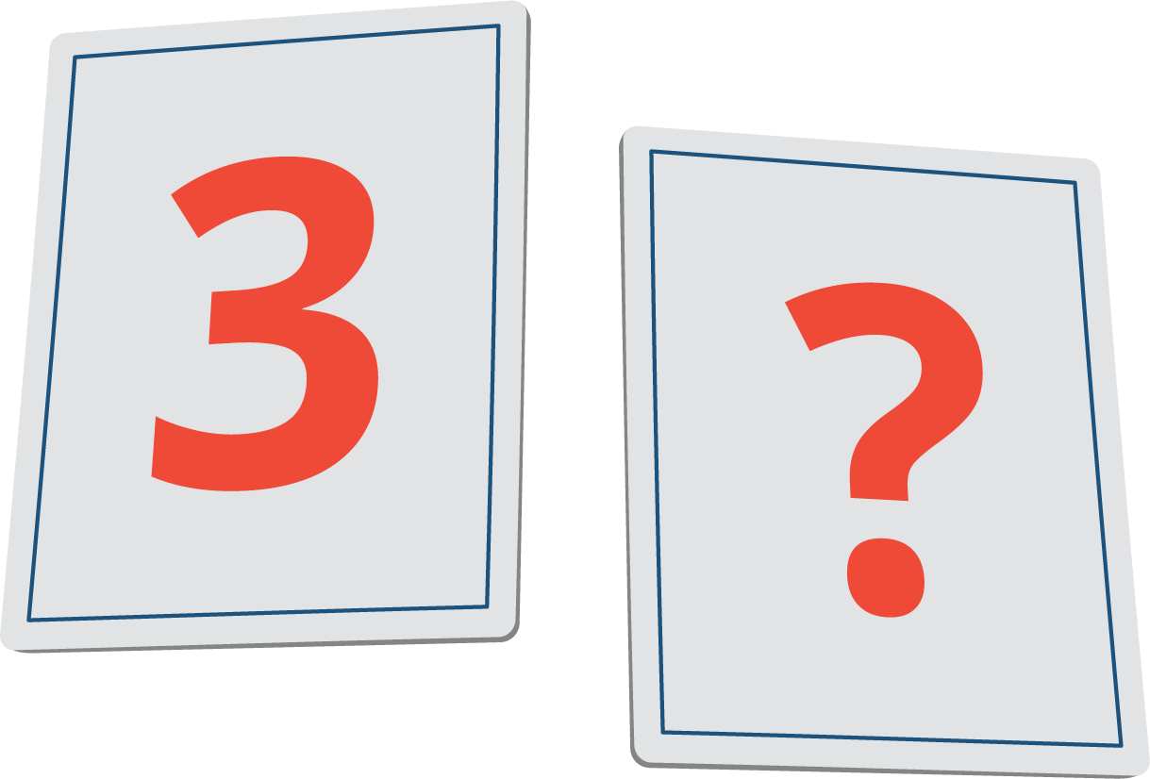
Math Stories
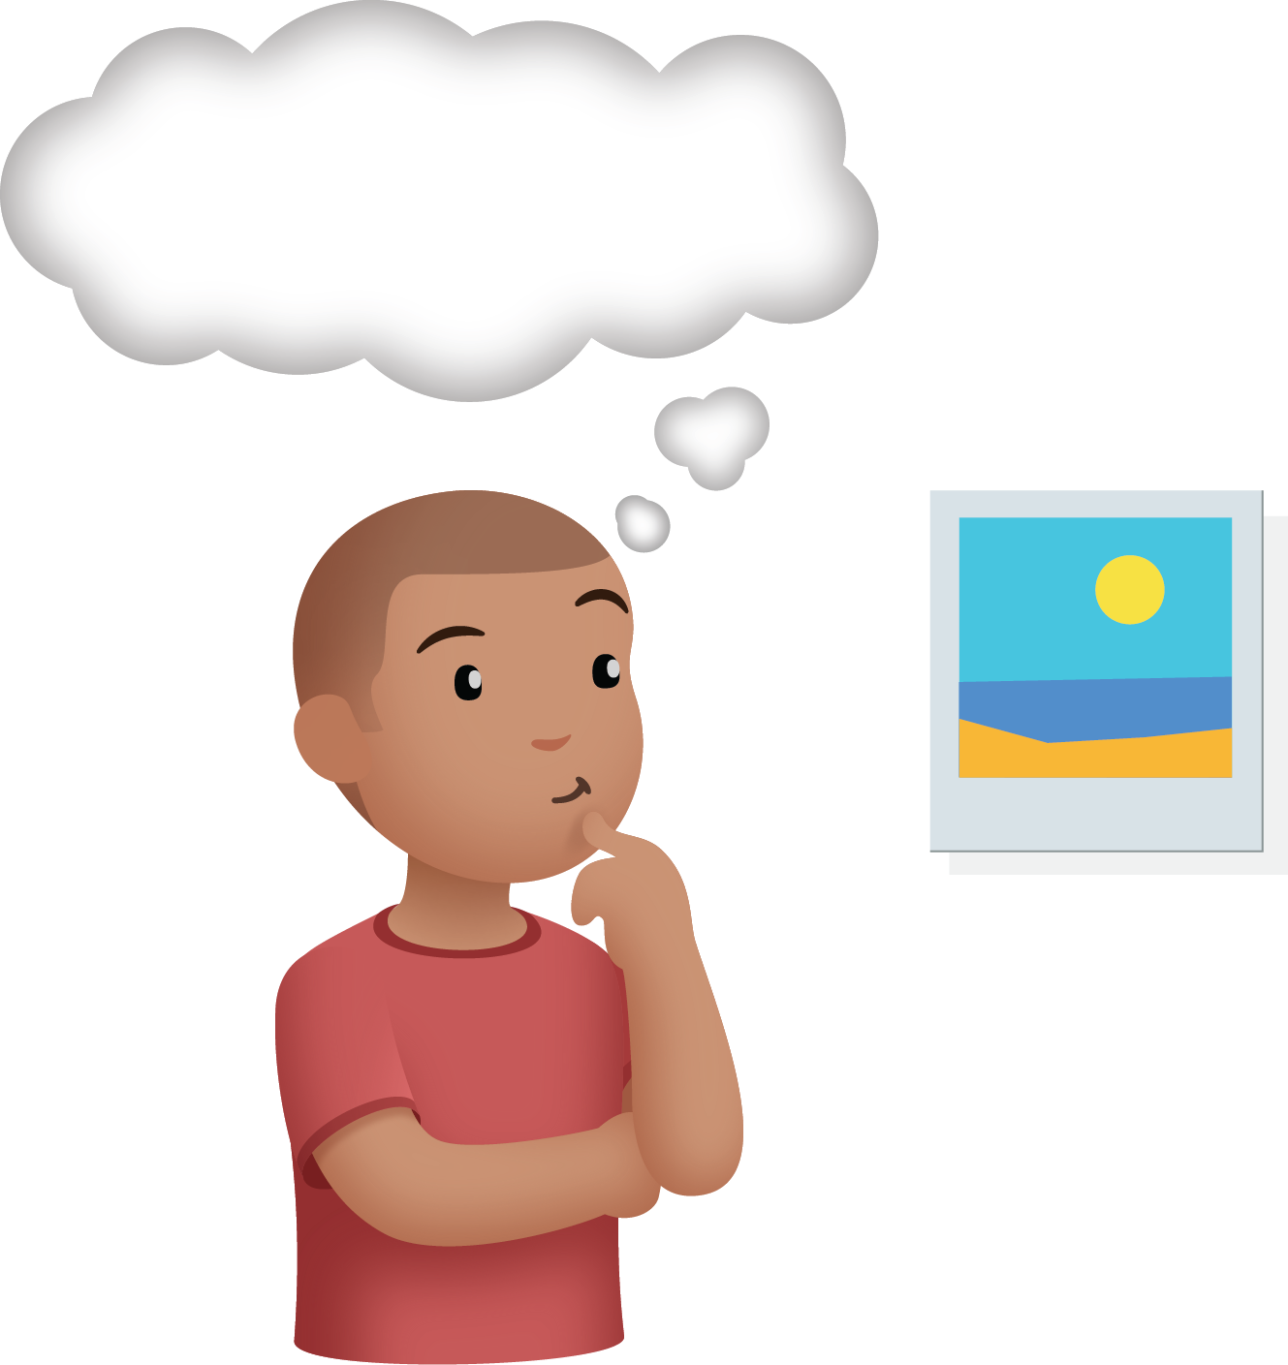
Build Shapes
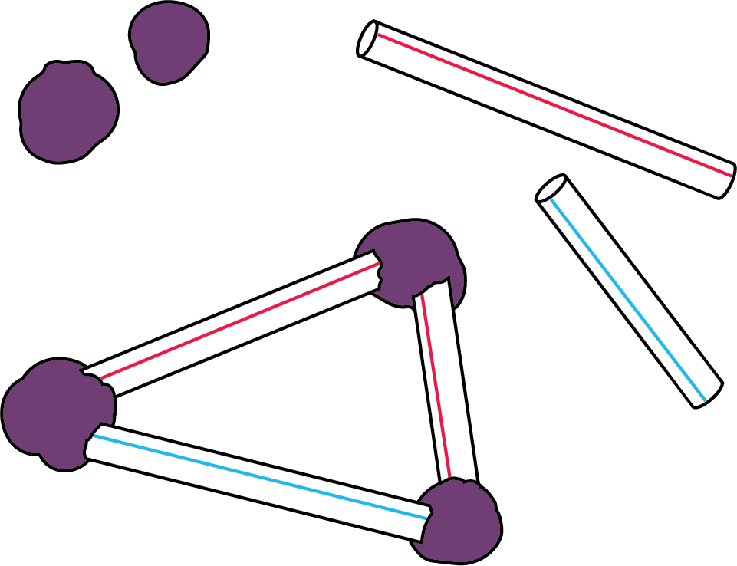
Make or Break Apart Numbers
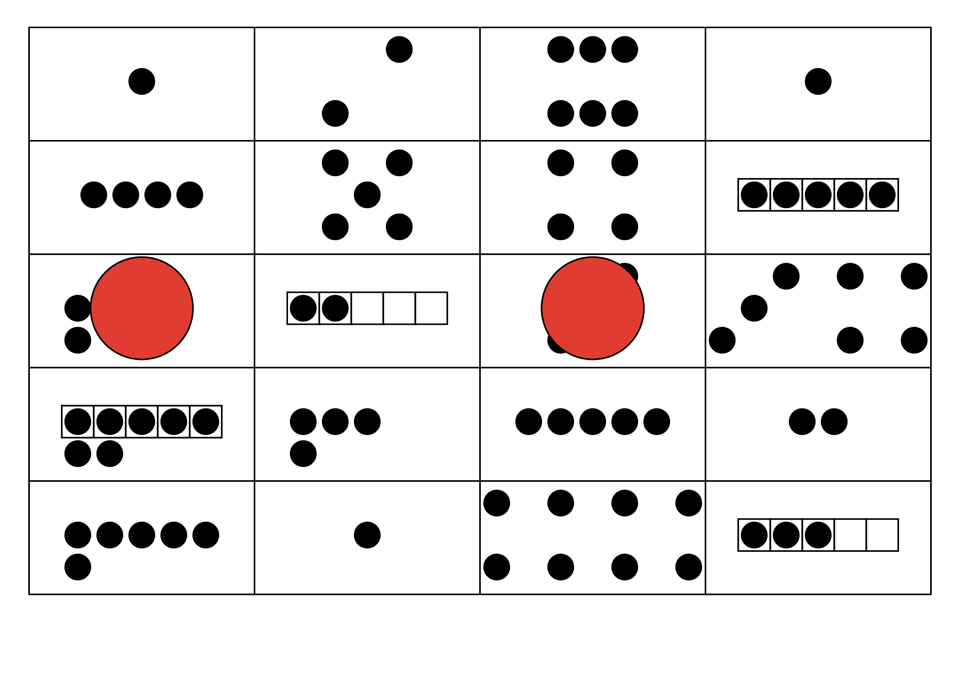
Picture Books
© CC BY 2021 Illustrative Mathematics®

