Lesson 12: Count Images (Part 2)

Standards Alignments
Addressing | K.CC.B.4.a, K.CC.B.4.b, K.CC.B.5, K.OA.A.4

Teacher-facing Learning Goals
- Keep track of images that have been counted.
- Write a number to answer “how many” questions about groups of up to 20 images.

Student-facing Learning Goals
- Let’s figure out how many shapes there are.

Lesson Purpose
The purpose of this lesson is for students to count to answer “how many” questions about groups of up to 20 images and keep track of images that have been counted.
In previous lessons, students counted groups of up to 20 objects and groups of up to 19 images arranged in lines, arrays, and on 10-frames. In this lesson, students count groups of up to 20 images arranged in lines, arrays, circles, and on 10-frames. Students use methods of keeping track of images that they have developed in previous lessons and units and may develop new methods, especially when counting images in circles. Students practice writing numbers 11–20 to represent quantities.
This lesson has a Student Section Summary.

Access for:

Students with Disabilities
- Action and Expression (Activity 2)

English Learners
- MLR8 (Activity 1)

Instructional Routines
Which One Doesn’t Belong? (Warm-up)

Materials to Gather
- 10-frames: Activity 3
- Connecting cubes or counters: Activity 3
- Connecting cubes: Activity 2
- Materials from previous centers: Activity 3
- Number cards 0–10: Activity 3

Materials to Copy
- Find the Pair Stage 2 Recording Sheet (groups of 1): Activity 3

Lesson Timeline
Warm-up | 10 min
Activity 1 | 10 min
Activity 2 | 10 min
Activity 3 | 15 min
Lesson Synthesis | 10 min
Cool-down | 5 min

Teacher Reflection Question
As you finish up this unit, reflect on the norms and activities that have supported each student in learning math. List ways you have seen each student grow as a young mathematician throughout this work. List ways you have seen yourself grow as a teacher. What will you continue to do and what will you improve upon in the next unit?

Cool-down
(to be completed at the end of the lesson) 5min
How Many Triangles?

Standards Alignments
Addressing | K.CC.B.5

Student-facing Task Statement
How many triangles are there?
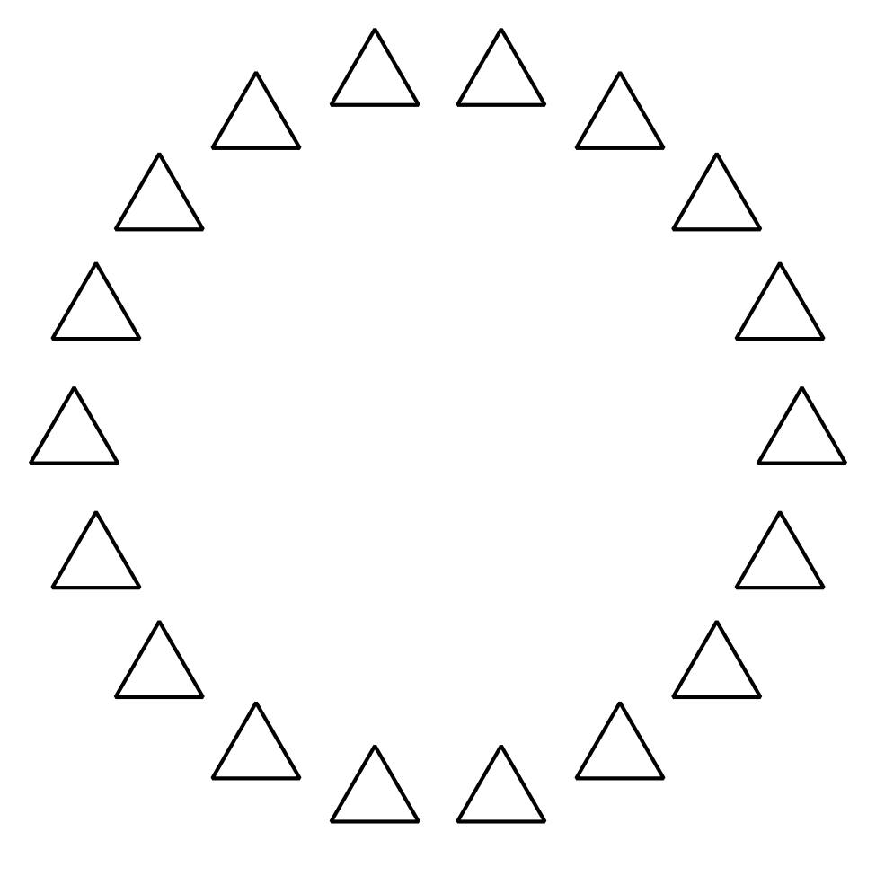
There are _______________ triangles.

Student Responses
18

