Lesson 2: Partial Products in Diagrams

Standards Alignments
Addressing | 5.NBT.B
Building Towards | 5.NBT.B.5

Teacher-facing Learning Goals
- Interpret partial products diagrams.
- Multiply a three-digit number and a two-digit number.

Student-facing Learning Goals
- Let's interpret diagrams that can help us find products.

Lesson Purpose
The purpose of this lesson is for students to multiply multi-digit whole numbers using strategies based on place value and the properties of operations.
This lesson builds on the partial products representation students saw in grade 4 to help organize calculations of whole number products. This becomes even more important for the product of a two-digit and three-digit number as the number of partial products is larger, depending on the diagram that is used. Part of the value of the standard algorithm which students will also see in later lessons is that it condenses the calculations and the number of partial products.

Access for:

Students with Disabilities
- Engagement (Activity 2)

English Learners
- MLR8 (Activity 1)

Instructional Routines
Which One Doesn’t Belong? (Warm-up)

Lesson Timeline
Warm-up | 10 min
Activity 1 | 15 min
Activity 2 | 20 min
Lesson Synthesis | 10 min
Cool-down | 5 min

Teacher Reflection Question
Think about which students haven’t shared their strategies in class lately. Were there missed opportunities to highlight their thinking during recent lessons? How can you take advantage of those opportunities when they arise?

Cool-down
(to be completed at the end of the lesson) 5min
$222×14$

Standards Alignments
Building Towards | 5.NBT.B.5

Student-facing Task Statement
Here is a diagram that represents $222×14$.
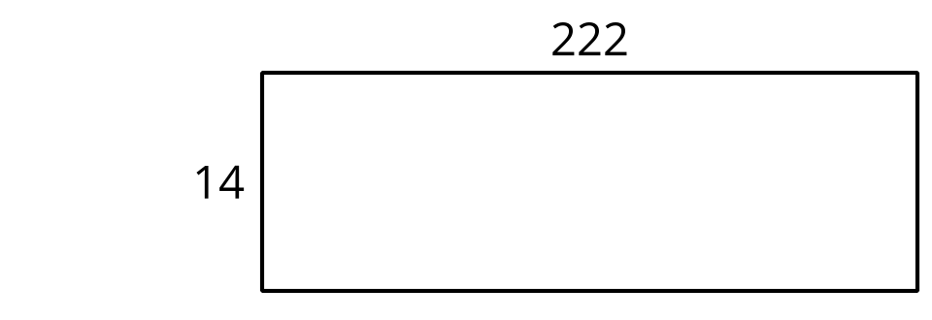
Find the value of $222×14$. Use the diagram if it is helpful. Explain or show your reasoning.

Student Responses
3,108. Sample response: I broke 222 down into hundreds, tens, and ones, and multiplied each by 14.
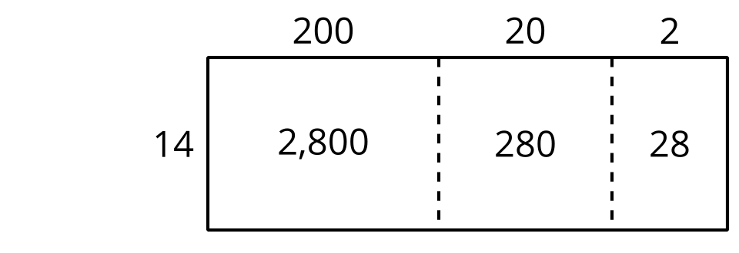
The product is $2,​800+280+28$, which is $3,​108$.

