Lesson 5: Center Day 1
- Let’s play games to practice adding and subtracting.

Warm-up: Notice and Wonder: Math Picture
What do you notice?
What do you wonder?

5.2: Centers: Choice Time
Choose a center.
Sort and Display
Math Stories
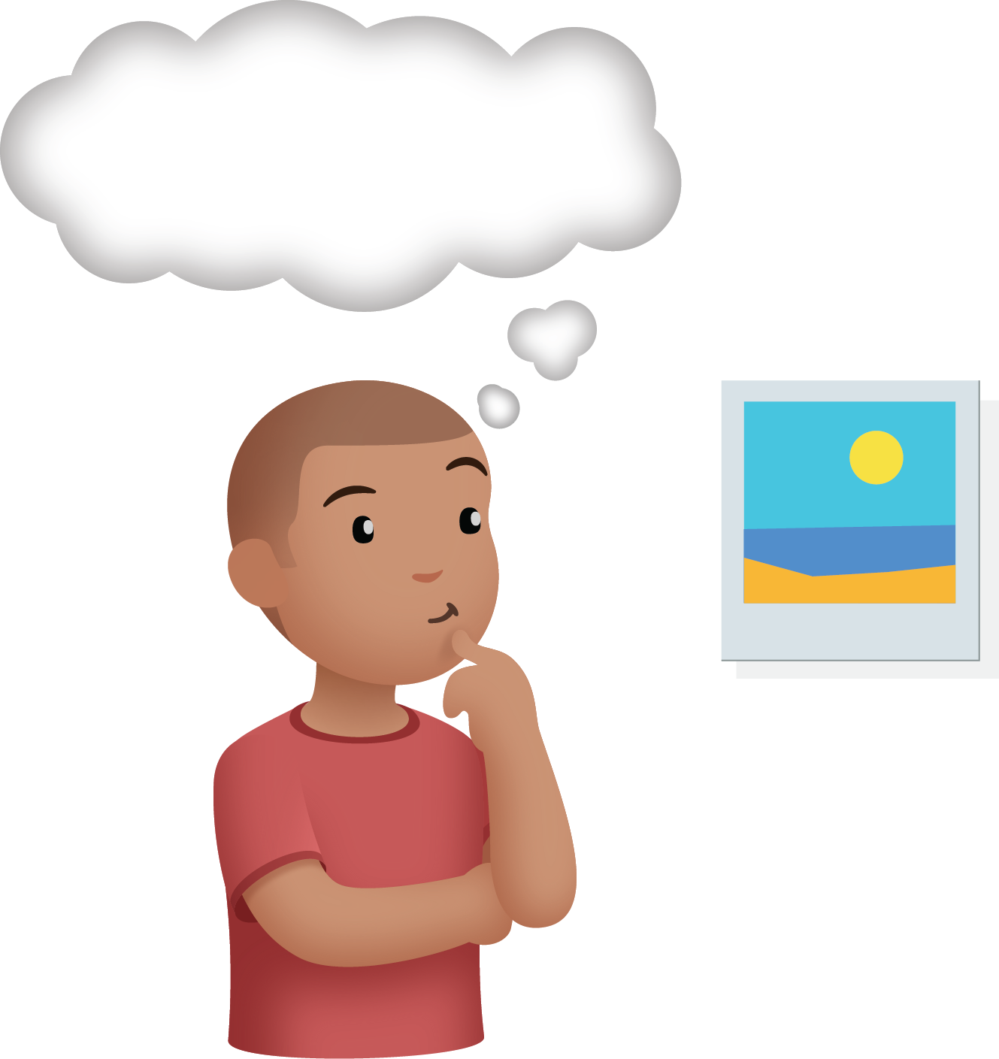
Find the Pair
© CC BY 2021 Illustrative Mathematics®

