Lesson 4: Interpret Measurement Data on Line Plots

Standards Alignments
Building On | 2.MD.D.9
Addressing | 3.MD.B.4
Building Towards | 3.MD.B.4

Teacher-facing Learning Goals
- Interpret line plots that display measurement data in fractions of an inch.

Student-facing Learning Goals
- Let’s make sense of line plots with lengths in half inches and quarter inches.

Lesson Purpose
The purpose of this lesson is for students to make sense of line plots that represent measurements to the nearest half or fourth of an inch.
In grade 2, students made line plots to show measurements to the nearest whole unit. In previous lessons, they measured objects with rulers marked with halves and fourths of an inch. In this lesson, students interpret line plots that show lengths in half inches and quarter inches and ask and answer questions about the data.

Access for:

Students with Disabilities
- Engagement (Activity 2)

English Learners
- MLR6 (Activity 2)

Instructional Routines
Notice and Wonder (Warm-up)

Lesson Timeline
Warm-up | 10 min
Activity 1 | 20 min
Activity 2 | 15 min
Lesson Synthesis | 10 min
Cool-down | 5 min

Teacher Reflection Question
What part of the lesson went really well today in terms of students’ learning? What did you do that made that part go well?

Cool-down
(to be completed at the end of the lesson) 5min
Interpret and Choose

Standards Alignments
Addressing | 3.MD.B.4

Student-facing Task Statement
Select all the statements that are true about the measurements in the line plot.
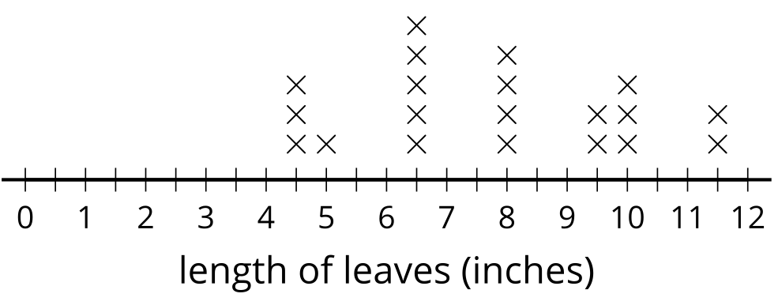
- Five leaves had a length of $6\frac{1}{2}$ inches.
- Six leaves had a length of $9\frac{1}{2}$ inches.
- There were 12 leaves measured.
- There were 20 leaves measured.
- The shortest leaf was 5 inches.
- The shortest leaf was $4\frac{1}{2}$ inches.

Student Responses
A, D, F

