Lesson 12: Connections between Graphs and Equations
- Let’s examine some situations, equations, and graphs.

12.1: Math Talk: Evaluating a Function
Here is a function: $g(x)=100−5x$
Evaluate mentally:
$g(0)$
$g(1)$
$g(4)$
$g(20)$

12.2: Bank Accounts
Each function represents the amount in a bank account after $t$ weeks.
$A(t)=500$
$B(t)=500+40t$
$C(t)=500−40t$
$D(t)=500⋅(1.5)^{t}$
$E(t)=500⋅(0.75)^{t}$

- Make a table for each bank account showing the money in the account at 0, 1, 2, and 3 weeks.
- Describe in words how the money in the account is changing week by week.
- Use technology to create a graph of each function. How can you see your description in each graph?

12.3: Build a New Function
Consider the same five functions:
$A(t)=500$
$B(t)=500+40t$
$C(t)=500−40t$
$D(t)=500⋅(1.5)^{t}$
$E(t)=500⋅(0.75)^{t}$

- Starting with one of the functions, change it so that it represents an account that . . .
  - Starts with a balance of $300, and loses $40 each week.
  - Starts with a balance of $500, and gains $15 each week.
  - Starts with a balance of $500, and loses $\frac{1}{10}$ of its value each week.
  - Starts with a balance of $700, and gains $\frac{3}{10}$ of its value each week.
- Here are four graphs. Which graph matches each of your new equations?

- graph 1
- 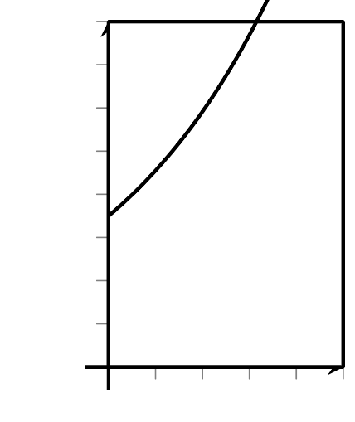

- graph 2
- 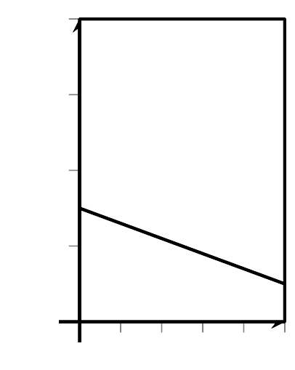

- graph 3
- 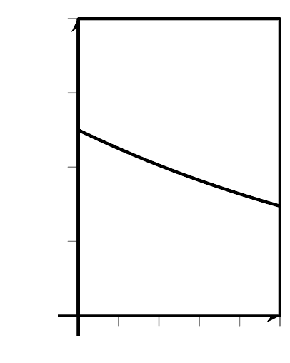

- graph 4
- 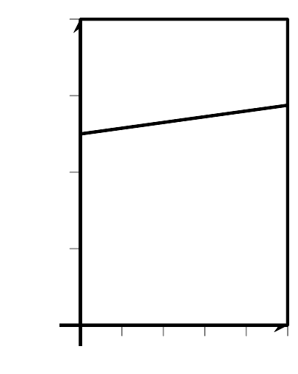
- To check, use technology to graph your equations. Make sure to use the same graphing window. Check that the graph of your equation matches the graph you chose.
© CC BY 2019 by Illustrative Mathematics®

