Lesson 5: More Estimating Probabilities
Let’s estimate some probabilities.

5.1: Is it Likely?
- If the weather forecast calls for a 20% chance of light rain tomorrow, would you say that it is likely to rain tomorrow?
- If the probability of a tornado today is $\frac{1}{10}$, would you say that there will likely be a tornado today?
- If the probability of snow this week is 0.85, would you say that it is likely to snow this week?

5.2: Making My Head Spin
Your teacher will give you 4 spinners. Make sure each person in your group uses a different spinner.
- Spin your spinner 10 times, and record your outcomes.
- Did you get all of the different possible outcomes in your 10 spins?
- What fraction of your 10 spins landed on 3?
- Next, share your outcomes with your group, and record their outcomes.
  - Outcomes for spinner A:
  - Outcomes for spinner B:
  - Outcomes for spinner C:
  - Outcomes for spinner D:
- Do any of the spinners have the same sample space? If so, do they have the same probabilities for each number to result?
- For each spinner, what is the probability that it lands on the number 3? Explain or show your reasoning.
- For each spinner, what is the probability that it lands on something other than the number 3? Explain or show your reasoning.
- Noah put spinner D on top of his closed binder and spun it 10 times. It never landed on the number 1. How might you explain why this happened?
- Han put spinner C on the floor and spun it 10 times. It never landed on the number 3, so he says that the probability of getting a 3 is 0. How might you explain why this happened?

Are you ready for more?
Design a spinner that has a $\frac{2}{3}$ probability of landing on the number 3. Explain how you could precisely draw this spinner.

5.3: How Much Green?
Your teacher will give you a bag of blocks that are different colors. Do not look into the bag or take out more than 1 block at a time. Repeat these steps until everyone in your group has had 4 turns.
- Take one block out of the bag and record whether or not it is green.
- Put the block back into the bag, and shake the bag to mix up the blocks.
- Pass the bag to the next person in the group.
- What do you think is the probability of taking out a green block from this bag? Explain or show your reasoning.
- How could you get a better estimate without opening the bag?

Lesson 5 Summary
Suppose a bag contains 5 blocks. If we select a block at random from the bag, then the probability of getting any one of the blocks is $\frac{1}{5}$.
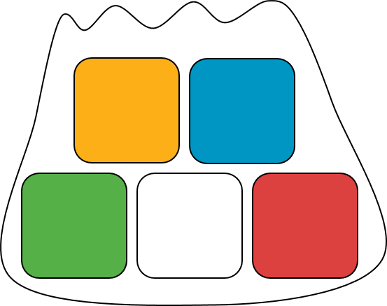
Now suppose a bag contains 5 blocks. Some of the blocks have a star, and some have a moon. If we select a block from the bag, then we will either get a star block or a moon block. The probability of getting a star block depends on how many there are in the bag.
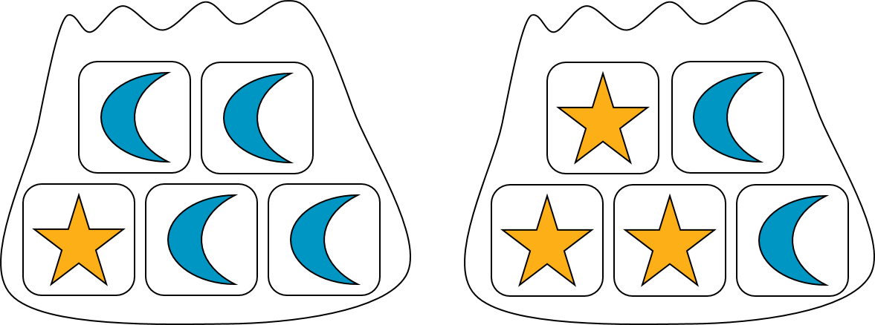
In this example, the probability of selecting a star block at random from the first bag is $\frac{1}{5}$, because it contains only 1 star block. (The probability of getting a moon block is $\frac{4}{5}$.) The probability of selecting a star block at random from the second bag is $\frac{3}{5}$, because it contains 3 star blocks. (The probability of getting a moon block from this bag is $\frac{2}{5}$.)
This shows that two experiments can have the same sample space, but different probabilities for each outcome.
© CC BY Open Up Resources. Adaptations CC BY IM.

