Lesson 15: Weighted Averages
- Let’s split segments using averages and ratios.

15.1: Part Way: Points
For the questions in this activity, use the coordinate grid if it is helpful to you.
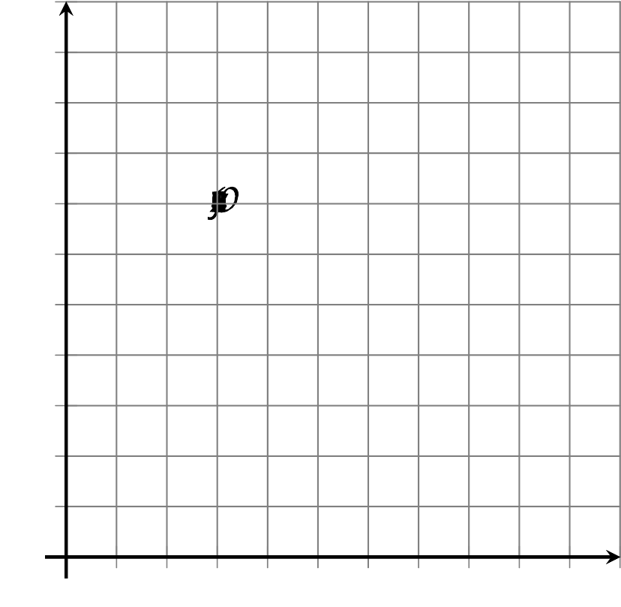
- What is the midpoint of the segment connecting $(1,2)$ and $(5,2)$?
- What is the midpoint of the segment connecting $(5,2)$ and $(5,10)$?
- What is the midpoint of the segment connecting $(1,2)$ and $(5,10)$?

15.2: Part Way: Segment
Point $A$ has coordinates $(2,4)$. Point $B$ has coordinates $(8,1)$.
- Find the point that partitions segment $AB$ in a $2:1$ ratio.
- Calculate $C=\frac{1}{3}A+\frac{2}{3}B$.
- What do you notice about your answers to the first 2 questions?
- For 2 new points $K$ and $L$, write an expression for the point that partitions segment $KL$ in a $3:1$ ratio.

Are you ready for more?
Consider the general quadrilateral $QRST$ with $Q=(0,0),R=(a,b),S=(c,d),$ and $T=(e,f)$.
- Find the midpoints of each side of this quadrilateral.
- Show that if these midpoints are connected consecutively, the new quadrilateral formed is a parallelogram.

15.3: Part Way: Quadrilateral
Here is quadrilateral $ABCD$.
- Find the point that partitions segment $AB$ in a $1:4$ ratio. Label it $B^{′}$.
- Find the point that partitions segment $AD$ in a $1:4$ ratio. Label it $D^{′}$.
- Find the point that partitions segment $AC$ in a $1:4$ ratio. Label it $C^{′}$.
- Is $AB^{′}C^{′}D^{′}$ a dilation of $ABCD$? Justify your answer.

Lesson 15 Summary
To find the midpoint of a line segment, we can average the coordinates of the endpoints. For example, to find the midpoint of the segment from $A=(0,4)$ to $B=(6,7)$, average the coordinates of $A$ and $B$: $\left(\frac{0+6}{2},\frac{4+7}{2}\right)=(3,5.5)$. Another way to write what we just did is $\frac{1}{2}(A+B)$ or $\frac{1}{2}A+\frac{1}{2}B$.
Now, let’s find the point that is $\frac{2}{3}$ of the way from $A$ to $B$. In other words, we’ll find point $C$ so that segments $AC$ and $CB$ are in a $2:1$ ratio.
In the horizontal direction, segment $AB$ stretches from $x=0$ to $x=6$. The distance from 0 to 6 is 6 units, so we calculate $\frac{2}{3}$ of 6 to get 4. Point $C$ will be 4 horizontal units away from $A$, which means an $x$-coordinate of 4.
In the vertical direction, segment $AB$ stretches from $y=4$ to $y=7$. The distance from 4 to 7 is 3 units, so we can calculate $\frac{2}{3}$ of 3 to get 2. Point $C$ must be 2 vertical units away from $A$, which means a $y$-coordinate of 6.
It is possible to do this all at once by saying $C=\frac{1}{3}A+\frac{2}{3}B$. This is called a weighted average. Instead of finding the point in the middle, we want to find a point closer to $B$ than to $A$. So we give point $B$ more weight—it has a coefficient of $\frac{2}{3}$ rather than $\frac{1}{2}$ as in the midpoint calculation. To calculate $C=\frac{1}{3}A+\frac{2}{3}B$, substitute and evaluate.
$\frac{1}{3}A+\frac{2}{3}B$
$\frac{1}{3}(0,4)+\frac{2}{3}(6,7)$
$\left(0,\frac{4}{3}\right)+\left(4,\frac{14}{3}\right)$
$(4,6)$
Either way, we found that the coordinates of $C$ are $(4,6)$.
© CC BY 2019 by Illustrative Mathematics®

