Lesson 12: Descompongamos áreas

Standards Alignments
Addressing | 5.NF.B.4, 5.NF.B.4.b

Teacher-facing Learning Goals
- Decompose a rectangle to find its area.

Student-facing Learning Goals
- Descompongamos rectángulos para encontrar su área.

Lesson Purpose
The mathematical purpose of this lesson is for students to apply what they know about multiplication of whole numbers and fractions to decompose a rectangle to find its area.
In previous lessons, students found the area of rectangles with one whole number side length and one fractional side length.
The purpose of this lesson is for students to apply what they know about decomposing rectangles with whole number side lengths to represent and find the area of rectangles with a mixed number side length. Students first find the area in a way that makes sense to them and then analyze different strategies for finding area.

Access for:

Students with Disabilities
- Engagement (Activity 2)

English Learners
- MLR1 (Activity 1)

Instructional Routines
Number Talk (Warm-up)

Lesson Timeline
Warm-up | 10 min
Activity 1 | 20 min
Activity 2 | 15 min
Lesson Synthesis | 10 min
Cool-down | 5 min

Teacher Reflection Question
What question do you wish you had asked today? When and why should you have asked it?

Cool-down
(to be completed at the end of the lesson) 5min
Descompongamos rectángulos

Standards Alignments
Addressing | 5.NF.B.4.b

Student-facing Task Statement
Encuentra el área de la región sombreada.
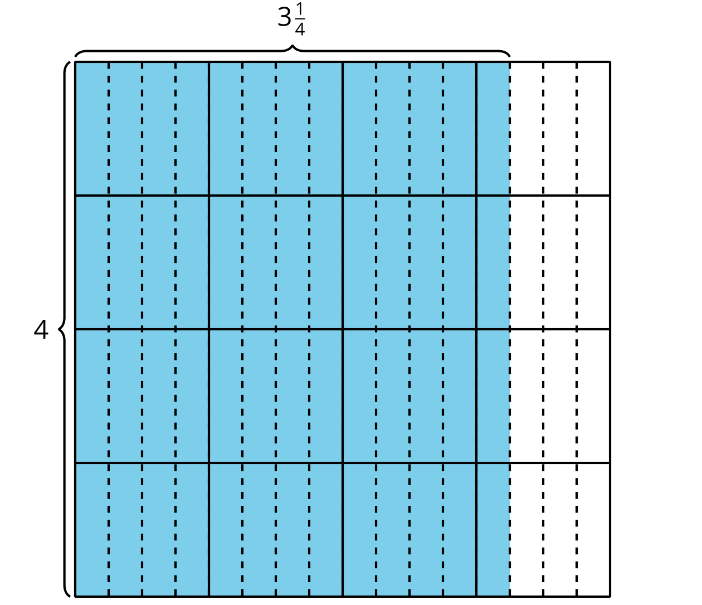

Student Responses
Sample responses:
- $4×3\frac{1}{4}$ square units
- 13 square units

