Lesson 18 Practice Problems
- Rewrite the rational function $g\left(x\right)=\frac{x−4}{x}$ in the form $g\left(x\right)=c+\frac{r}{x}$, where $c$ and $r$ are constants.
- The average cost (in dollars) per mile for riding $x$ miles in a cab is $c\left(x\right)=\frac{2.5+2x}{x}$. As $x$ gets larger and larger, what does the end behavior of the function tell you about the situation?
- The graphs of two rational functions $f$ and $g$ are shown. One of them is given by the expression $\frac{2−3x}{x}$. Which graph is it? Explain how you know.
- 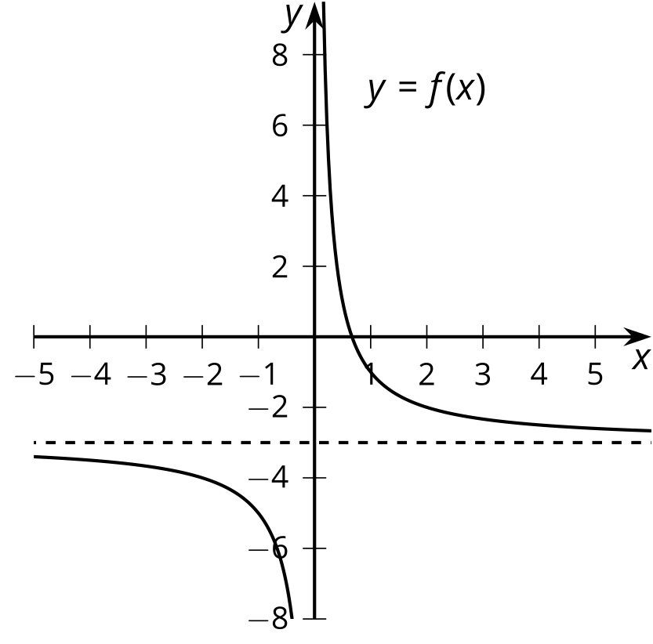
- 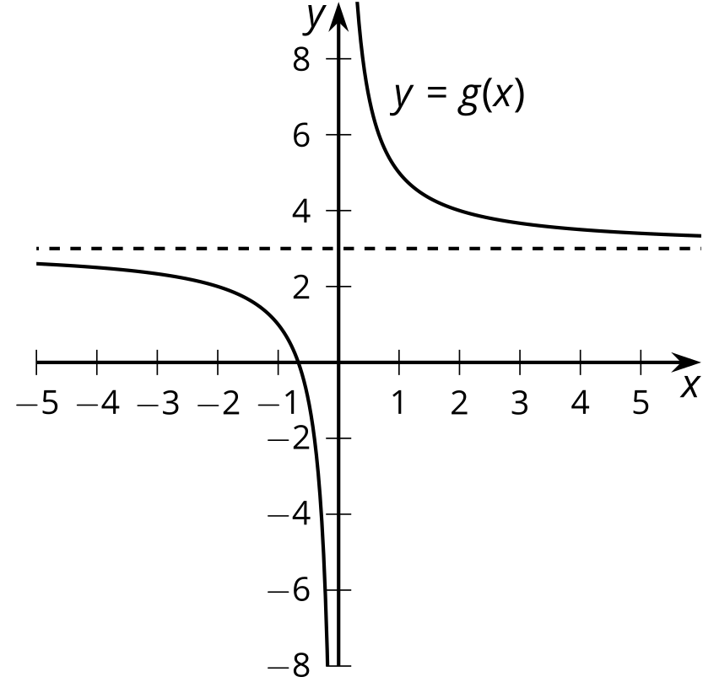
- Which polynomial function’s graph is shown here?
- 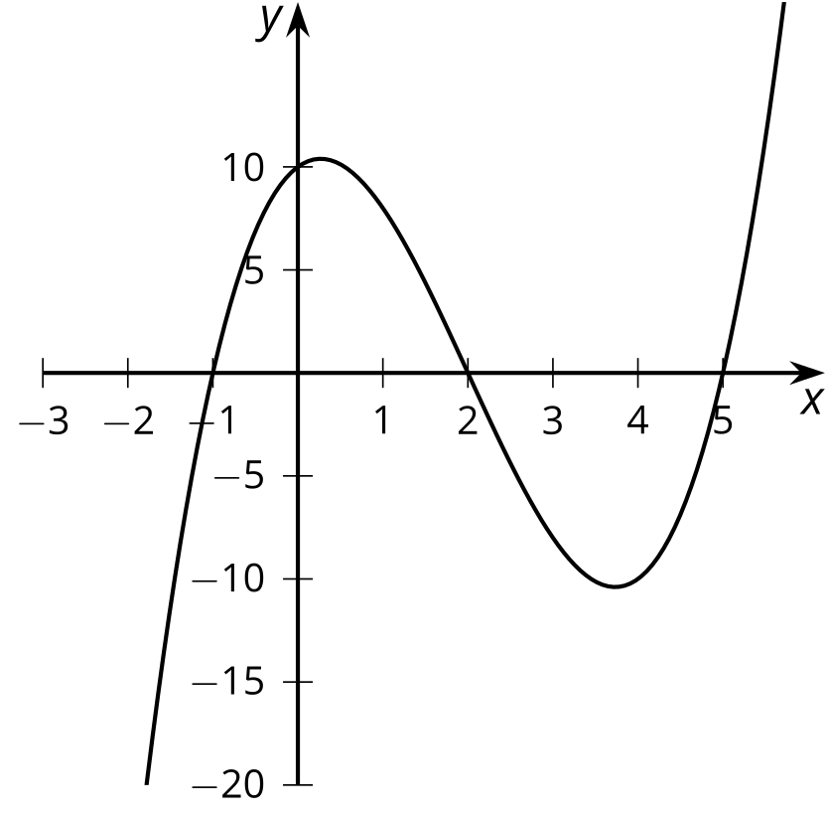
  - $f\left(x\right)=\left(x+1\right)\left(x+2\right)\left(x+5\right)$
  - $f\left(x\right)=\left(x+1\right)\left(x−2\right)\left(x−5\right)$
  - $f\left(x\right)=\left(x−1\right)\left(x+2\right)\left(x+5\right)$
  - $f\left(x\right)=\left(x−1\right)\left(x−2\right)\left(x−5\right)$
- (From Unit 2, Lesson 7.)
- State the degree and end behavior of $f\left(x\right)=5x^{3}−2x^{4}−6x^{2}−3x+7$. Explain or show your reasoning.
- (From Unit 2, Lesson 9.)
- The graphs of two rational functions $f$ and $g$ are shown. Which function must be given by the expression of $\frac{10}{x−3}$? Explain how you know.
- 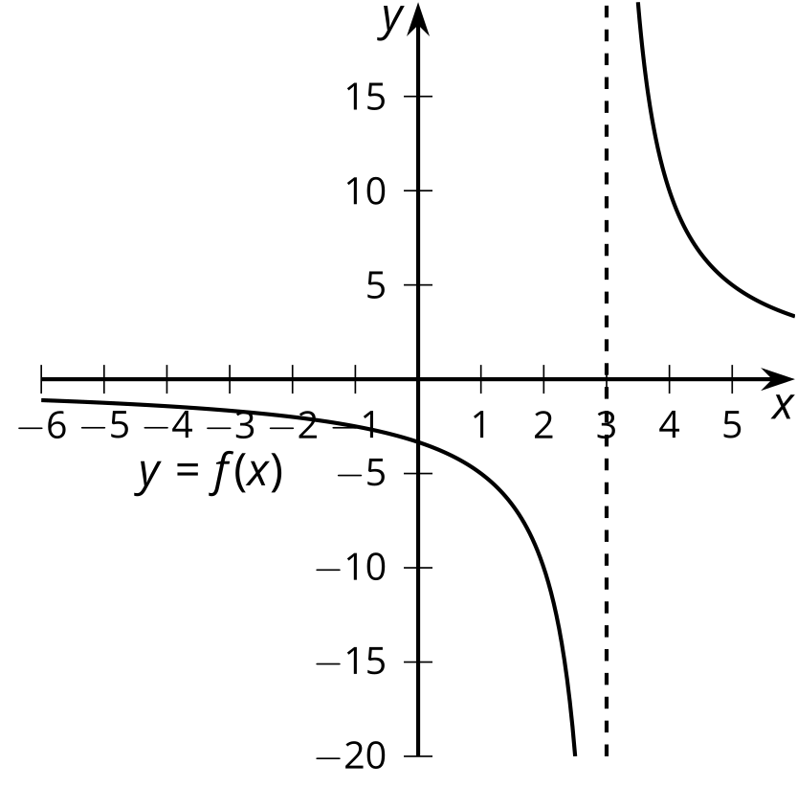
- 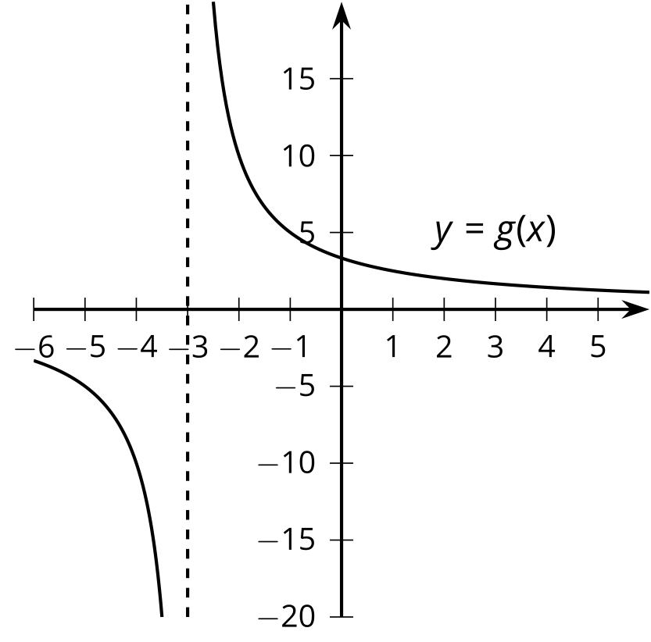
- (From Unit 2, Lesson 17.)
© CC BY 2019 by Illustrative Mathematics®

