Lesson 6: Problems about Pets
- Let’s solve problems and write equations.

Warm-up: Notice and Wonder: The Fish Tank
What do you notice?
What do you wonder?
There are some fish in the tank.
Some of the fish are red and some are blue.

6.1: Three Reads: Kiran’s Fish
Kiran has some fish in his fish tank.
He has 4 red fish and 5 blue fish.
How many fish does he have in all?
Show your thinking using drawings, numbers, or words.
Equation: ________________________________

6.2: Tyler's and Clare’s Pets
Tyler and Clare want to know how many pets they have together.
Tyler has 2 turtles.
Clare has 4 dogs.
Tyler wrote the equation $4+2=\boxed{6}$.
Clare wrote the equation $2+4=\boxed{6}$.
Do both equations match the story?
Why or why not?
Show your thinking using drawings, numbers, or words.

6.3: Centers: Choice Time
Choose a center.
Math Stories
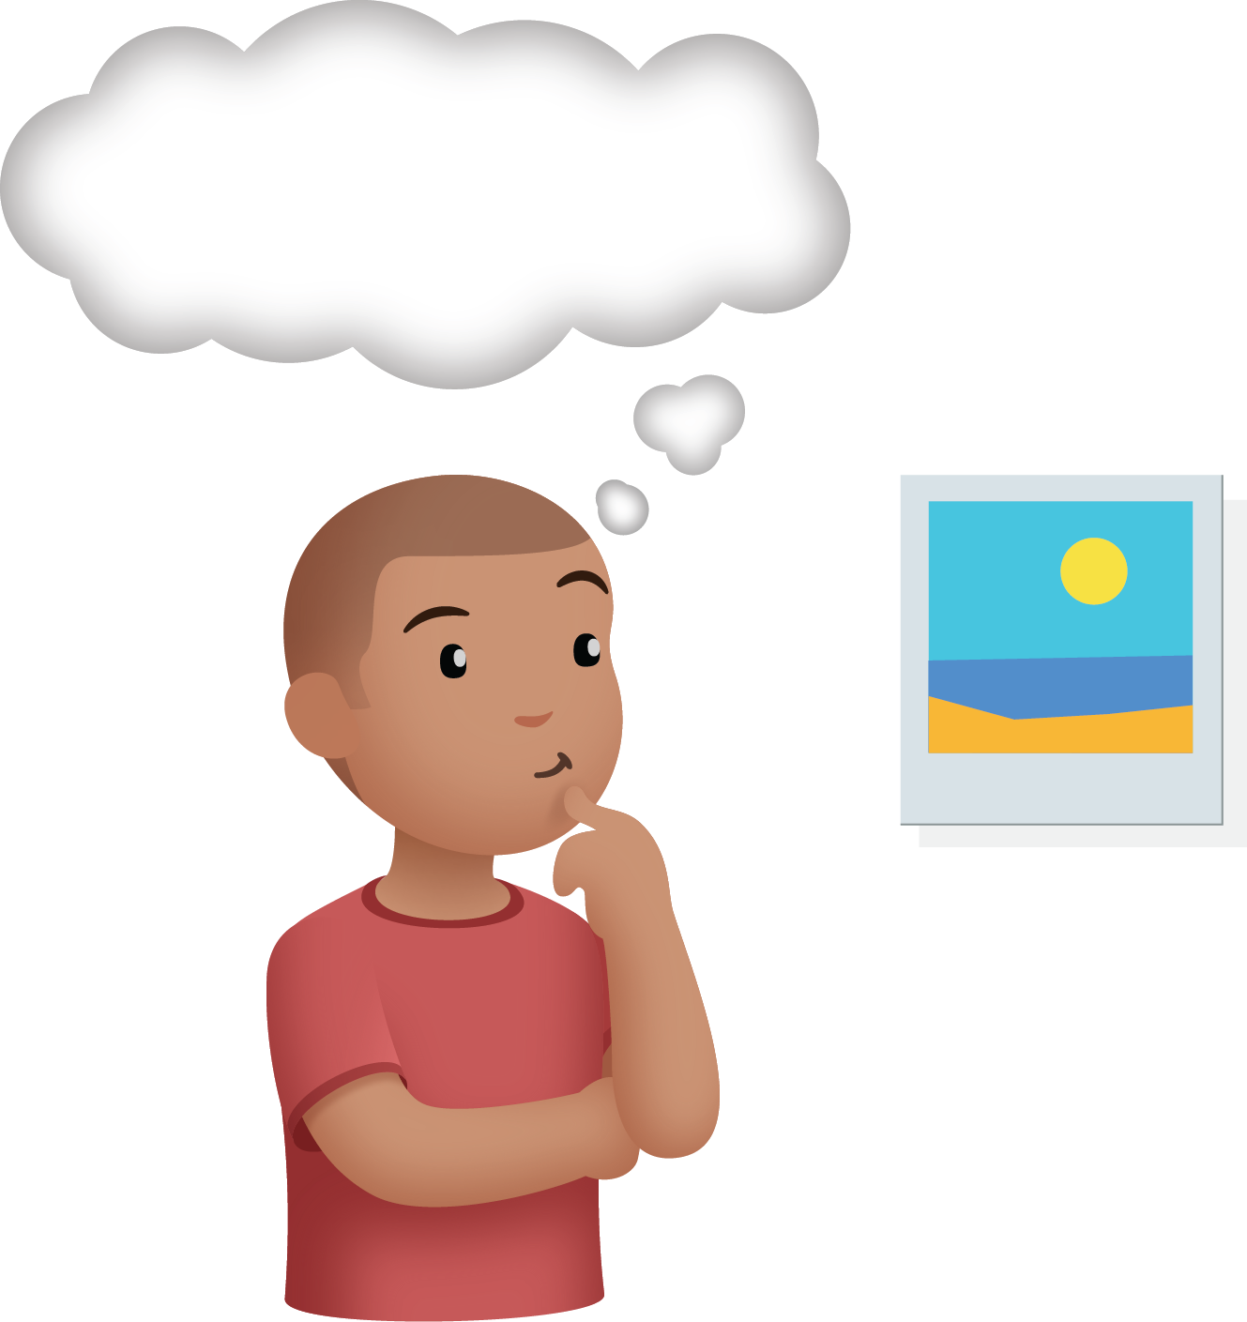
Find the Pair
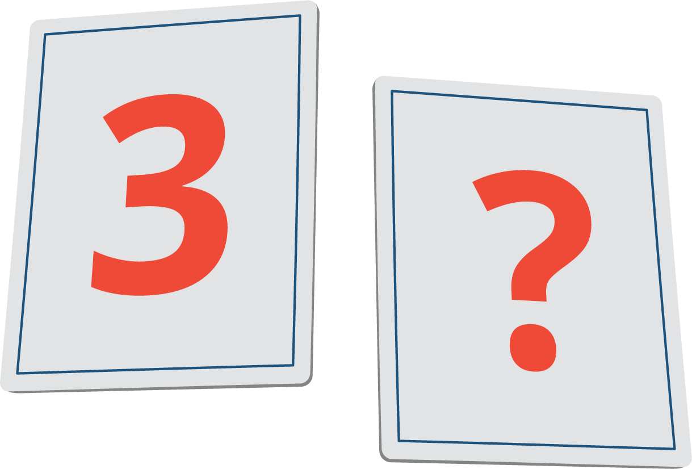
What’s Behind My Back
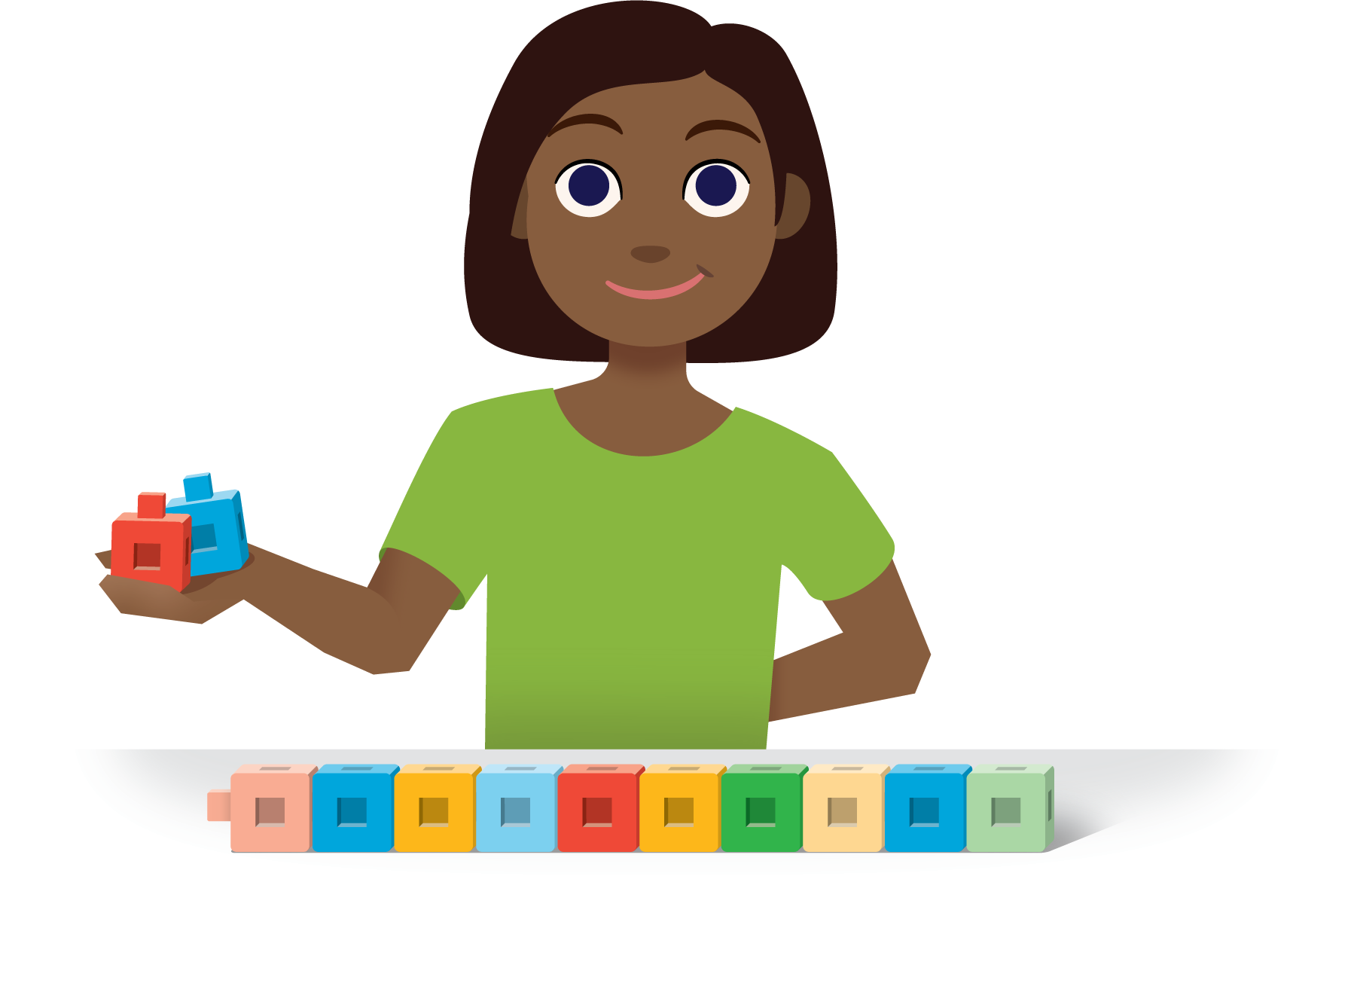
© CC BY 2021 Illustrative Mathematics®

