Unit 4 Lesson 5 Cumulative Practice Problems
- Use the tape diagram to find the value of $\frac{1}{2}÷\frac{1}{3}$. Show your reasoning.
- 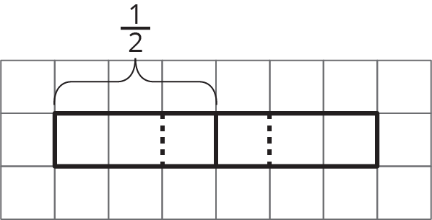
- What is the value of $\frac{1}{2}÷\frac{1}{3}$? Use pattern blocks to represent and find this value. The yellow hexagon represents 1 whole. Explain or show your reasoning.
- 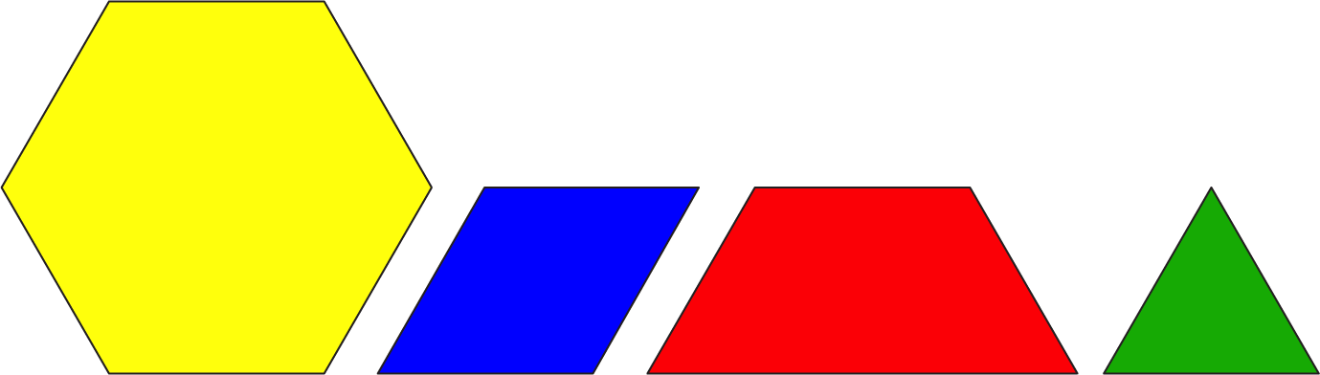
- Use a standard inch ruler to answer each question. Then, write a multiplication equation and a division equation that answer the question.
  - How many $\frac{1}{2}$s are in 7?
  - How many $\frac{3}{8}$s are in 6?
  - How many $\frac{5}{16}$s are in $1\frac{7}{8}$?
- Use the tape diagram to answer the question: How many $\frac{2}{5}$s are in $1\frac{1}{2}$? Show your reasoning.
- 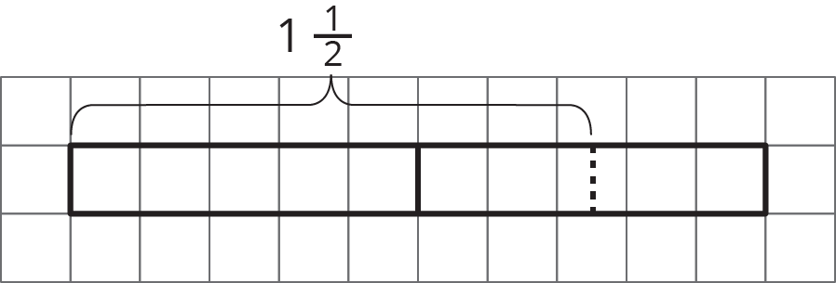
- Write a multiplication equation and a division equation to represent each sentence or diagram.
  - There are 12 fourths in 3.
  - 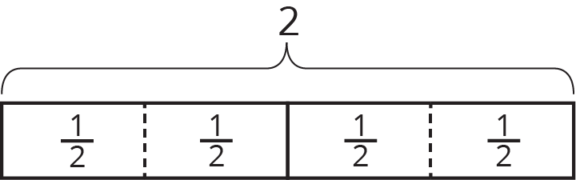
  - How many $\frac{2}{3}$s are in 6?
  - 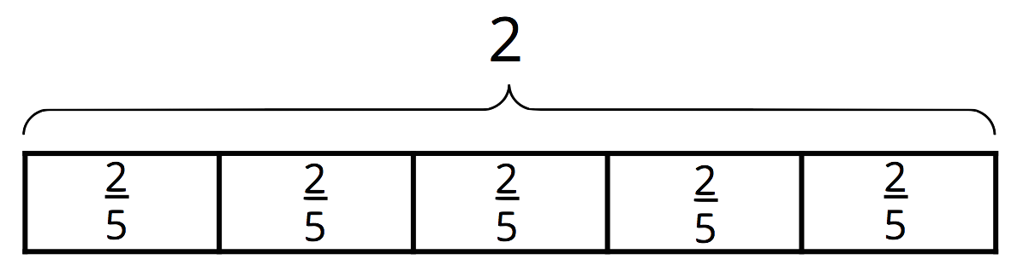
- (From Unit 4, Lesson 4.)
- At a farmer’s market, two vendors sell fresh milk. One vendor sells 2 liters for $3.80, and another vendor sells 1.5 liters for $2.70. Which is the better deal? Explain your reasoning.
- (From Unit 3, Lesson 5.)
- A recipe uses 5 cups of flour for every 2 cups of sugar.
  - How much sugar is used for 1 cup of flour?
  - How much flour is used for 1 cup of sugar?
  - How much flour is used with 7 cups of sugar?
  - How much sugar is used with 6 cups of flour?
- (From Unit 3, Lesson 6.)
© CC BY Open Up Resources. Adaptations CC BY IM.

