Lesson 16: Weighted Averages in a Triangle
- Let’s partition special line segments in triangles.

16.1: Triangle Midpoints
Triangle $ABC$ is graphed.
Find the midpoint of each side of this triangle.

16.2: Triangle Medians
Your teacher will tell you how to draw and label the medians of the triangle in the warm-up.
- After the medians are drawn and labeled, measure all 6 segments inside the triangle using centimeters. What is the ratio of the 2 parts of each median?
- Find the coordinates of the point that partitions segment $AN$ in a $2:1$ ratio.
- Find the coordinates of the point that partitions segment $BL$ in a $2:1$ ratio.
- Find the coordinates of the point that partitions segment $CM$ in a $2:1$ ratio.

Are you ready for more?
In the image, $AB$ is a median.
Find the length of $AB$ in terms of $a,b,$ and $c$.
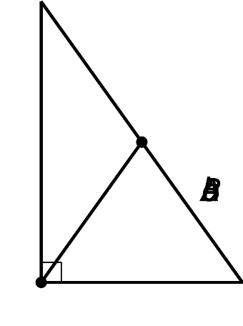

16.3: Any Triangle’s Medians
The goal is to prove that the medians of any triangle intersect at a point. Suppose the vertices of a triangle are $(0,0),(w,0),$ and $(a,b)$.
- Each student in the group should choose 1 side of the triangle. If your group has 4 people, 2 can work together. Write an expression for the midpoint of the side you chose.
- Each student in the group should choose a median. Write an expression for the point that partitions each median in a $2:1$ ratio from the vertex to the midpoint of the opposite side.
- Compare the coordinates of the point you found to those of your groupmates. What do you notice?
- Explain how these steps prove that the 3 medians of any triangle intersect at a single point.

Lesson 16 Summary
Here is a triangle with its medians drawn in. A median is a line segment drawn from a vertex of a triangle to the midpoint of the opposite side. Triangles have 3 medians, with 1 for each vertex.
Notice that the medians intersect at 1 point. This point is always $\frac{2}{3}$ of the distance from a vertex to the opposite midpoint. Another way to say this is that the point of intersection, $V$, partitions segments $AJ,BL,$ and $CK$ so that the ratios $AV:VJ,BV:VL,$ and $CV:VK$ are all $2:1$.
We can prove this by working with a general triangle that can represent any triangle. Since any triangle can be transformed so that 1 vertex is on the origin and 1 side lies on the $x$-axis, we can say that our general triangle has vertices $(0,0),(w,0)$, and $(a,b)$. Through careful calculation, we can show that all 3 medians go through the point $\left(\frac{a+w}{3},\frac{b}{3}\right)$. Therefore, the medians intersect at this point, which partitions each median in a $2:1$ ratio from the vertex to the opposite side’s midpoint.
© CC BY 2019 by Illustrative Mathematics®

