Lesson 4 Practice Problems
- Match each equation with a description of the function it represents.
  - $f\left(x\right)=2x+4$
  - $g\left(x\right)=2\left(x+4\right)$
  - $h\left(x\right)=4x+2$
  - $k\left(x\right)=4\left(x+2\right)$
  - To get the output, add 4 to the input, then multiply the result by 2.
  - To get the output, add 2 to the input, then multiply the result by 4.
  - To get the output, multiply the input by 2, then add 4 to the result.
  - To get the output, multiply the input by 4, then add 2 to the result.
- Function $P$ represents the perimeter, in inches, of a square with side length $x$ inches.
  - Complete the table.
- $x$ | - 0 | - 1 | - 2 | - 3 | - 4 | - 5 | - 6
  - $P\left(x\right)$
  - Write an equation to represent function $P$.
  - Sketch a graph of function $P$.
  - 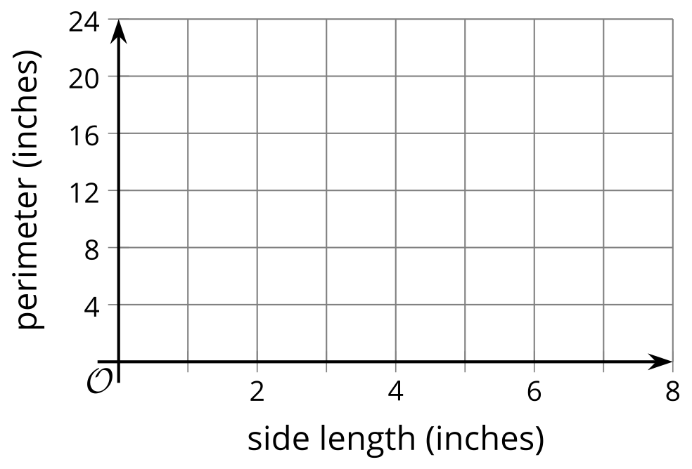
- Functions $f$ and $A$ are defined by these equations.
- $f\left(x\right)=80−15x$
- $A\left(x\right)=25+10x$
- Which function has a greater value when $x$ is 2.5?
- An equilateral triangle has three sides of equal length. Function $P$ gives the perimeter of an equilateral triangle of side length $s$.
  - Find $P\left(2\right)$
  - Find $P\left(10\right)$
  - Find $P\left(s\right)$
- Imagine a situation where a person is using a garden hose to fill a child's pool. Think of two quantities that are related in this situation and that can be seen as a function.
  - Define the function using a statement of the form “$\underset{_}{}$ is a function of $\underset{_}{}$. Be sure to consider the units of measurement.
  - Sketch a possible graph of the function. Be sure to label the axes.
  - Then, identify the coordinates of one point on the graph and explain its meaning.
- (From Unit 4, Lesson 1.)
- Function $C$ gives the cost, in dollars, of buying $n$ apples.
- Which statement best represents the meaning of $C\left(10\right)=9$?
  - The cost of buying 9 apples
  - The cost of 9 apples is $10.
  - The cost of 10 apples
  - Ten apples cost $9.
- (From Unit 4, Lesson 2.)
- Diego is baking cookies for a fundraiser. He opens a 5-pound bag of flour and uses 1.5 pounds of flour to bake the cookies.
- Which equation or inequality represents $f$, the amount of flour left in the bag after Diego bakes the cookies?
  - $f=1.5$
  - $f<1.5$
  - $f=3.5$
  - $f>3.5$
- (From Unit 2, Lesson 18.)
© CC BY 2019 by Illustrative Mathematics®

