Lesson 4: Division Situations
- Let’s solve and represent division problems.

Warm-up: Number Talk: Division
Find the value of each expression mentally.
- $35÷7$
- $1÷7$
- $36÷7$
- $37÷7$

4.1: Pounds of Blueberries
- Complete the missing parts of the table. Be prepared to explain your thinking.
- Discuss both your solutions with your group. What is the same? What is different?
Partner A
Equation | Situation
$4÷6=\frac{4}{6}$
Diagram
Partner B
Equation | Situation
Diagram
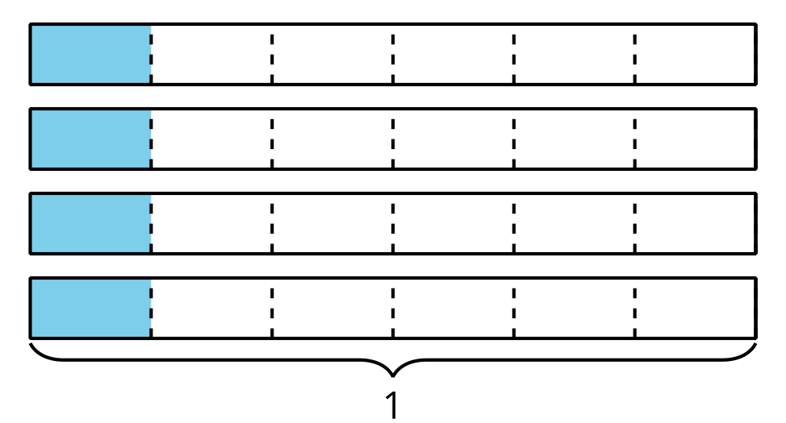
Partner C
Equation | Situation
Six students share
4 pounds of blueberries.
How many pounds of blueberries
did each student get?
Diagram

4.2: Grams of Gold
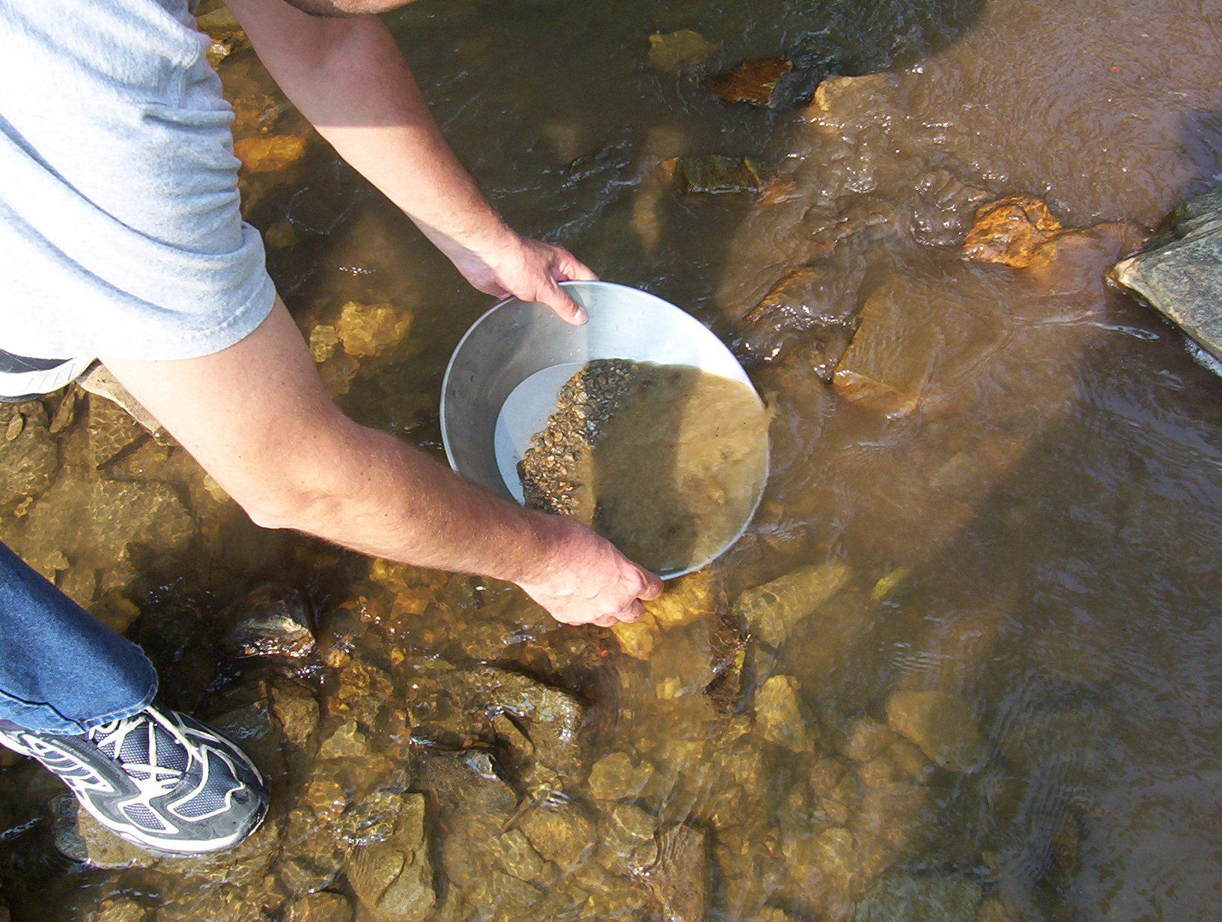
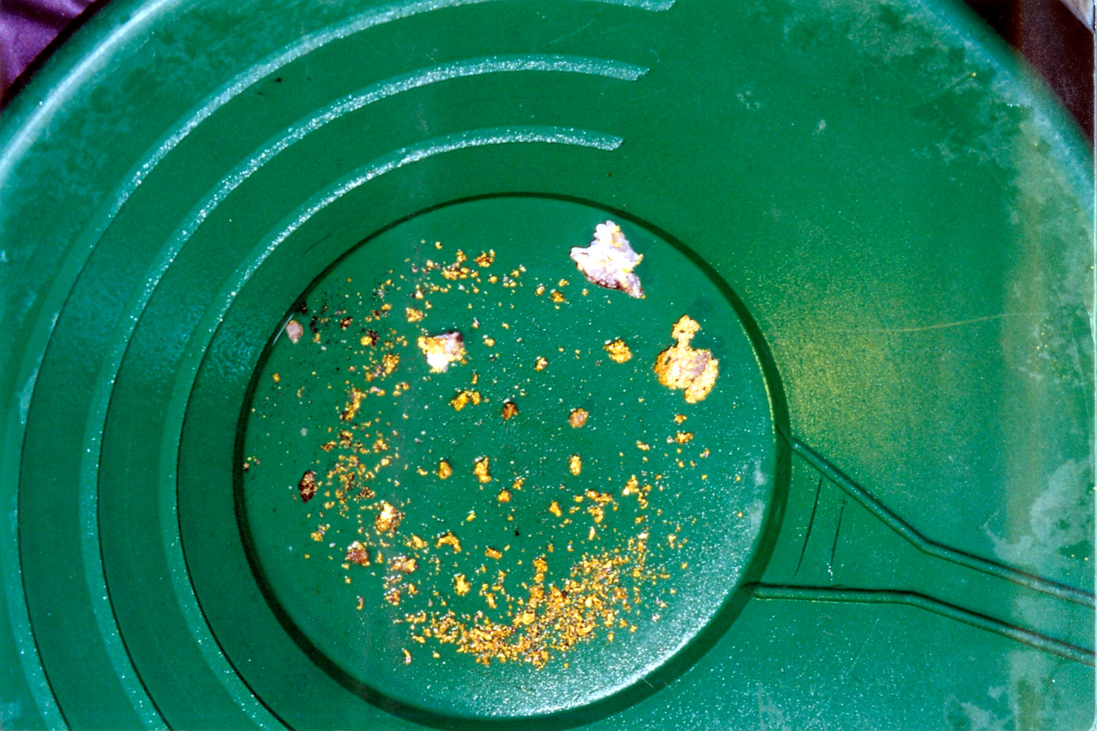
- A group of 3 friends spent the afternoon panning for gold. They shared the gold equally. If each friend got $\frac{4}{3}$ grams of gold, how much gold did they collect together? Explain or show your reasoning.
- A group of friends spent the afternoon panning for gold. They shared the gold equally. If they collected 5 grams of gold together and each friend got $\frac{5}{6}$ grams of gold after they shared it, how many friends shared the gold? Explain or show your reasoning.
© CC BY 2021 Illustrative Mathematics®

