Lesson 5: Estimate on a Number Line
- Let’s estimate numbers on a number line.

Warm-up: Estimation Exploration: What Number?
What number could this be?
- Record an estimate that is:
- too low | - about right | - too high
- Record an estimate that is:
- too low | - about right | - too high

5.1: Estimate the Numbers
- What number could this be? ____________
- What number could this be? ____________
- What number could this be? ____________
- What number could this be? ____________
- Which estimate are you most confident in? Why?
- Which estimate are you least confident in? Why?

5.2: Order the Numbers
- Pick a card and place it on the number line.
- Explain your thinking.
- As a group, revise the position of any cards.
- Repeat until all cards are placed.
- Draw and label points to represent each number on the number line.

Section Summary
Section Summary
In this section, we learned about the number line. It is like a ruler because it shows numbers as different length units from 0. A number line can be used to represent numbers and show how close or how far they are from 0 and each other. Numbers can be represented by tick marks and points on the number line and increase in value when moving to the right. We used tick marks and counted by 5 and 10 to help us locate and label numbers. We also estimated numbers by thinking about how close they were to zero and other numbers.
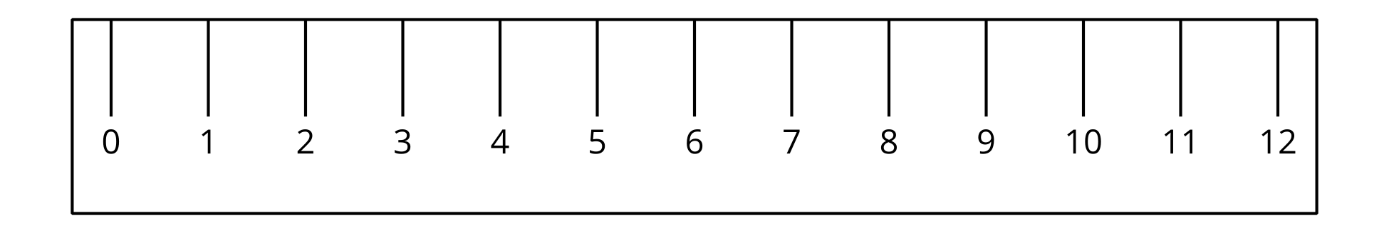
© CC BY 2021 Illustrative Mathematics®

