Lesson 1: How Would You Describe These Figures?

Standards Alignments
Addressing | 4.G.A.1

Teacher-facing Learning Goals
- Draw points, lines, and line segments, and identify them in geometric figures.

Student-facing Learning Goals
- Let’s draw and describe geometric figures.

Lesson Purpose
The purpose of this lesson is to motivate the need for geometric language for describing and drawing images and to introduce points, lines, and segments.
In earlier grades, students examined, described, compared, and contrasted attributes of two-dimensional figures. They may have used geometric terms such as point, line, and segment intuitively and informally.
This lesson serves two goals. The first is to elicit the language students have for talking about geometric figures, motivating a need to develop more precision in using geometric terminology (MP6). The second is to enable students to see that a line segment is a part of a line, so it has a start point and an endpoint. The cool-down for this lesson is designed to determine the types of words students use to describe figures. Students may choose to use informal or formal language.
In the next lesson, students will encounter the formal definitions of these geometric terms, but for now, the aim is simply to engage them in noticing and drawing these geometric figures. It is not necessary to expect students to distinguish between line segments and lines in this lesson.

Access for:

Students with Disabilities
- Action and Expression (Activity 1)

Instructional Routines
MLR2 Collect and Display (Activity 1), Notice and Wonder (Warm-up)

Materials to Gather
- Chart paper: Activity 1
- Index cards: Activity 1
- Rulers or straightedges: Activity 1, Activity 2

Materials to Copy
- Do You See What I See? (groups of 4): Activity 1

Required Preparation

Lesson Timeline
Warm-up | 5 min
Activity 1 | 25 min
Activity 2 | 15 min
Lesson Synthesis | 10 min
Cool-down | 5 min

Teacher Reflection Question
This is the first time students have formally encountered geometry in grade 4. What vocabulary did students bring to the lesson? How might you use their informal language to make formal connections in the next lesson?

Cool-down
(to be completed at the end of the lesson) 5min
Lines and More

Standards Alignments
Addressing | 4.G.A.1

Student-facing Task Statement
Here is a drawing on a card:
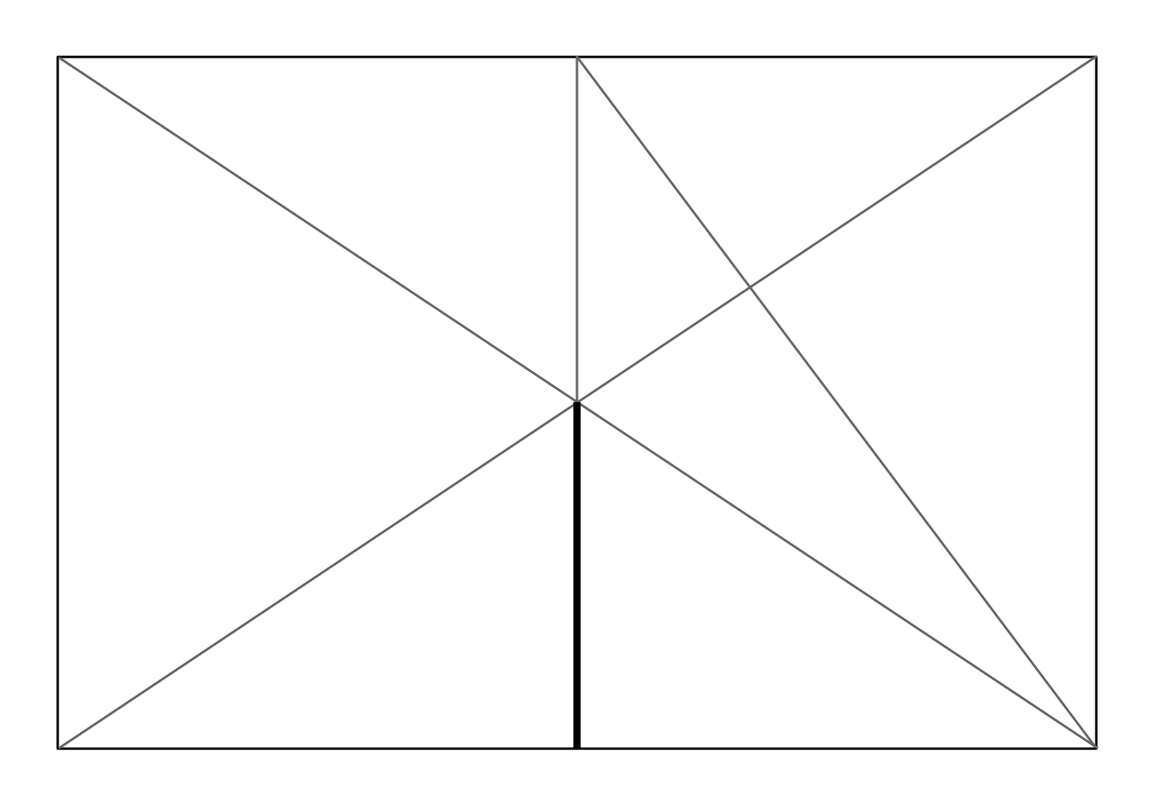
Write a description of the drawing that could be used by a classmate to make a copy.

Student Responses
Sample response: Draw two diagonal lines: one from the top left corner to the bottom right, and another from the bottom left corner to the top right. Draw a line that goes up and down through the point where the two diagonal lines cross. From the top of that line, draw a line to the bottom right corner. The bottom segment of the up-and-down line is thicker than the rest of the lines. The lines make a lot of triangles of different sizes.

