Lesson 5: Relate Division and Fractions
- Let's explain the relationship between division and fractions.

Warm-up: True or False: Interpret Fractions
Decide if each statement is true or false. Be prepared to explain your reasoning.
- $5÷2=\frac{5}{2}$
- $\frac{5}{2}=5\frac{1}{2}$
- $\frac{6}{2}=3$

5.1: Relate Pounds to People
 | Each person gets ________ pound(s) of blueberries.
 | more than 1 | exactly 1 | less than 1 | $\frac{1}{2}$
__________ people share 7 pounds of blueberries
_________ people share __________ pounds of blueberries
Three people share __________ pounds of blueberries
__________ people share __________ pounds of blueberries
- Fill in the blanks to match the rules in the table.
- How many pounds of blueberries did each person get when they got more than 1 pound of blueberries?
- How many pounds of blueberries did each person get when they got less than 1 pound of blueberries?
(Pause for teacher directions.)
- Work with your group to make a poster that shows or explains your thinking about the questions below.
  - What is true about all of the pairs of numbers that were used when each person got less than 1 pound of blueberries?
  - What is true about all of the pairs of numbers that were used when each person got more than 1 pound of blueberries?
  - What is true about all of the pairs of numbers that were used when each person gets exactly $\frac{1}{2}$ pound of blueberries?

5.2: Why Does It Work?
- What numbers can replace the question marks in each equation? Explain your reasoning. ?÷2=?2888882÷?=2? (Pause for teacher directions.)
- Work with your partner to explain why any division expression can be interpreted as a fraction. You can use diagrams, expressions, equations, and words.

Section Summary
Section Summary
We learned that there is a relationship between division and fractions.
We can see this relationship in diagrams, situations, and equations. This diagram represents 2 sandwiches being shared equally by 5 people. Each person will get $\frac{2}{5}$ of a sandwich. The equation, $2÷5=\frac{2}{5}$ also represents the situation.
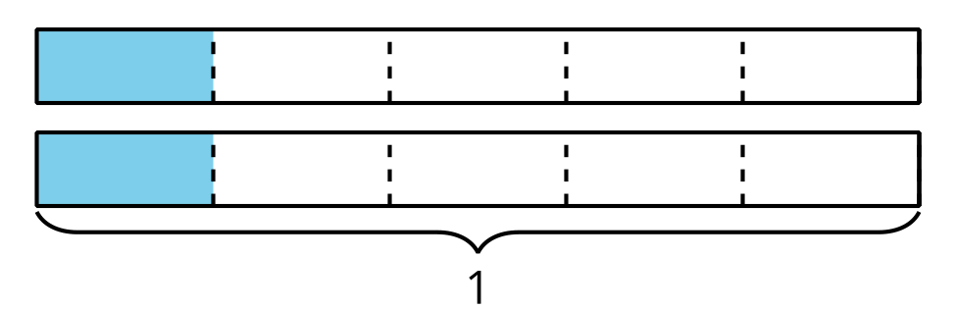
© CC BY 2021 Illustrative Mathematics®

