Lesson 6: Center Day 1
- Let’s put numbers on a number line.

Warm-up: Number Talk: Decompose and Subtract
Find the value of each expression mentally.
- $65−25$
- $65−27$
- $55−17$
- $46−18$

6.2: Centers: Choice Time
Choose a center.
Capture Squares
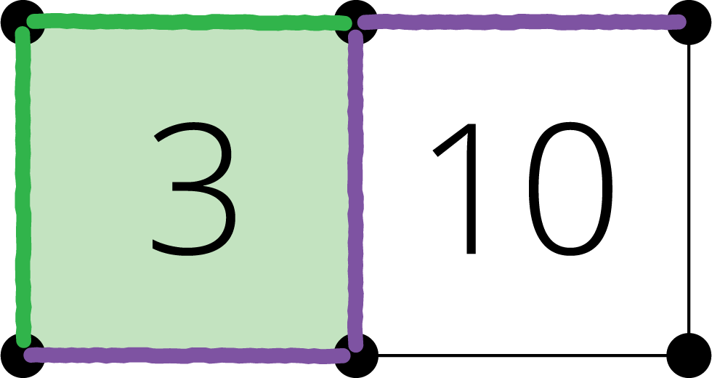
Number Line Scoot
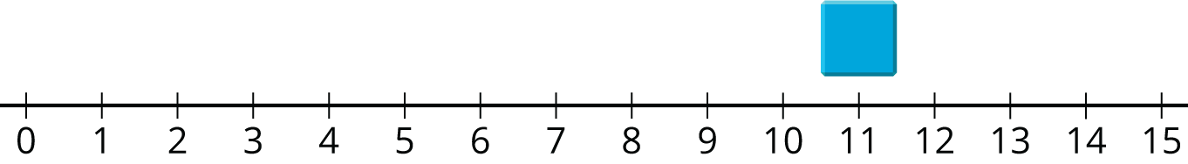
Number Puzzles
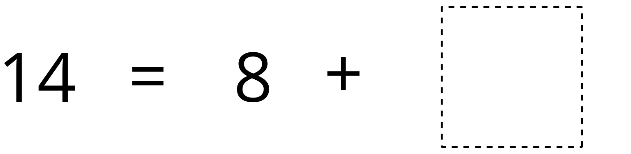
© CC BY 2021 Illustrative Mathematics®

