Lesson 8: Shake, Spill, and Cover
- Let’s solve a new kind of story problem.

8.1: Introduce Shake and Spill, Cover
total number of counters | red  counters | yellow  counters | equations
Round 1:
total number of counters | red  counters | yellow  counters | equations
10
10
10
10
10
10

8.2: Shake and Spill, Cover Problems

- 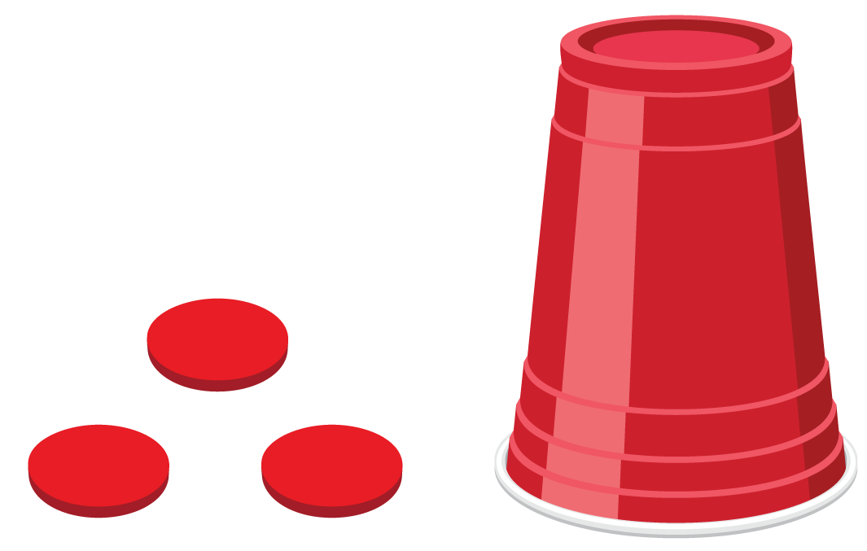
- There are 9 counters total.
How many counters are under the cup?
- Equation: ____________________________

- 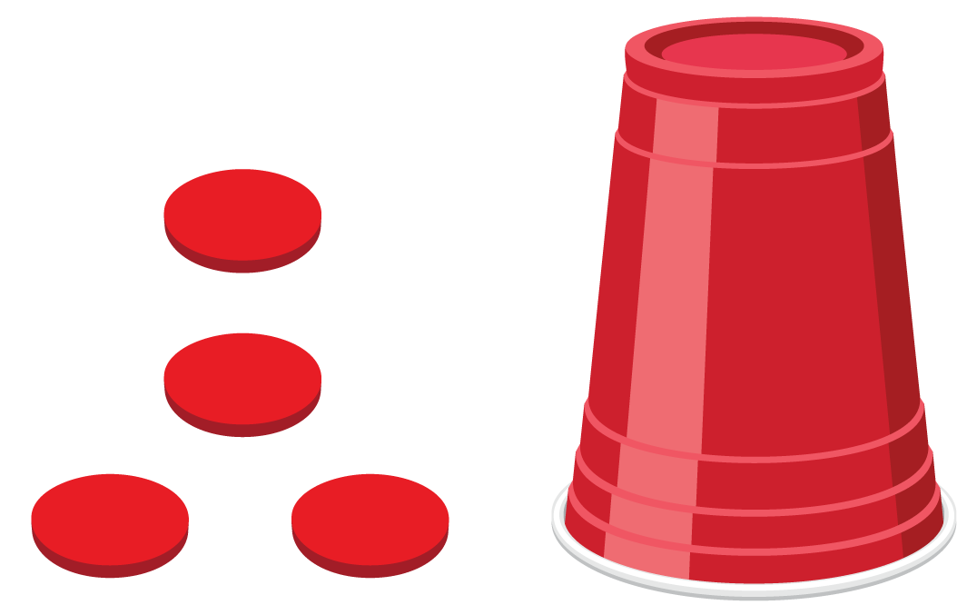
- There are 7 counters total.
How many counters are under the cup?
- Equation: ____________________________
- There are 6 counters outside the cup.
Some of the counters are under the cup.
There are 10 counters total.
How many counters are under the cup?
- Equation: ____________________________
- There are 3 counters outside the cup.
Some of the counters are under the cup.
There are 8 counters total.
How many counters are under the cup?
- Equation: ____________________________
© CC BY 2021 Illustrative Mathematics®

