Lesson 19: Flexible with Fractions (Optional)

Standards Alignments
Addressing | 4.NF.B.3.c, 4.NF.B.3.d, 4.NF.B.4, 4.NF.C.5
Building Towards | 4.NF.B.3.d, 4.NF.B.4

Teacher-facing Learning Goals
- Interpret and solve problems that involve the addition, subtraction, and multiplication of fractions.

Student-facing Learning Goals
- Let’s solve all kinds of problems involving fractions.

Lesson Purpose
The purpose of this lesson is for students to interpret and solve problems that involve adding, subtracting, and multiplying fractions.
This optional lesson gives students additional opportunities to integrate and apply the work from this unit to solve novel contextual problems. All three activities prompt students to make sense of and persevere in solving problems that involve adding, subtracting, and multiplying fractions. In the first two activities, students think abstractly and quantitatively to relate their calculations to a situation (MP2). The last activity encourages students to identify structure in expressions with many different operations involving fractions (MP7).
Completing all three activities will take more than 60 minutes. Consider expanding the lesson across 2 days or selecting one or two activities based on students' needs or interests and time constraints.

Access for:

Students with Disabilities
- Representation (Activity 1)

Instructional Routines
MLR6 Three Reads (Activity 2), Notice and Wonder (Warm-up)

Materials to Gather
- Rulers (inches): Activity 1
- Sticky notes: Activity 1
- Tools for creating a visual display: Activity 3

Materials to Copy
- Find a Match (groups of 24): Activity 3

Lesson Timeline
Warm-up | 10 min
Activity 1 | 25 min
Activity 2 | 20 min
Activity 3 | 25 min
Lesson Synthesis | 5 min
Cool-down | 5 min

Teacher Reflection Question
What evidence did you see of students thinking flexibly and choosing a method strategically as they worked to solve problems? For students who chose a fixed way of reasoning about fractional amounts, what questions could you ask to prompt them to be more strategic?

Cool-down
(to be completed at the end of the lesson) 5min
Han’s Design

Standards Alignments
Addressing | 4.NF.B.3.d, 4.NF.B.4

Student-facing Task Statement
Han is using small sticky notes to make an H shape to decorate a notebook that is 6 inches wide and 9 inches tall. His design is shown here.
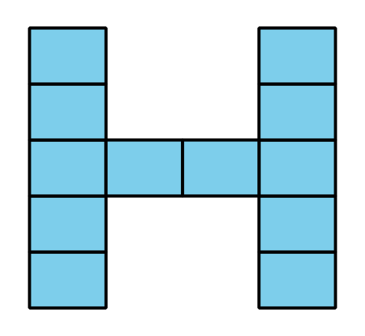
The longer side of the sticky note is $\frac{15}{8}$ inches. The shorter side is $\frac{11}{8}$ inches.
Is the notebook tall enough for his design? Show your reasoning.

Student Responses
Yes. Sample response: The H shape is $5×\frac{11}{8}$ or $\frac{55}{8}$ inches tall. The notebook is $9×\frac{8}{8}$ or $\frac{72}{8}$ inches tall.

