Unit 1 Lesson 2: Naming the Moves

1 A Pair of Quadrilaterals (Warm up)

Student Task Statement
Quadrilateral A can be rotated into the position of Quadrilateral B.
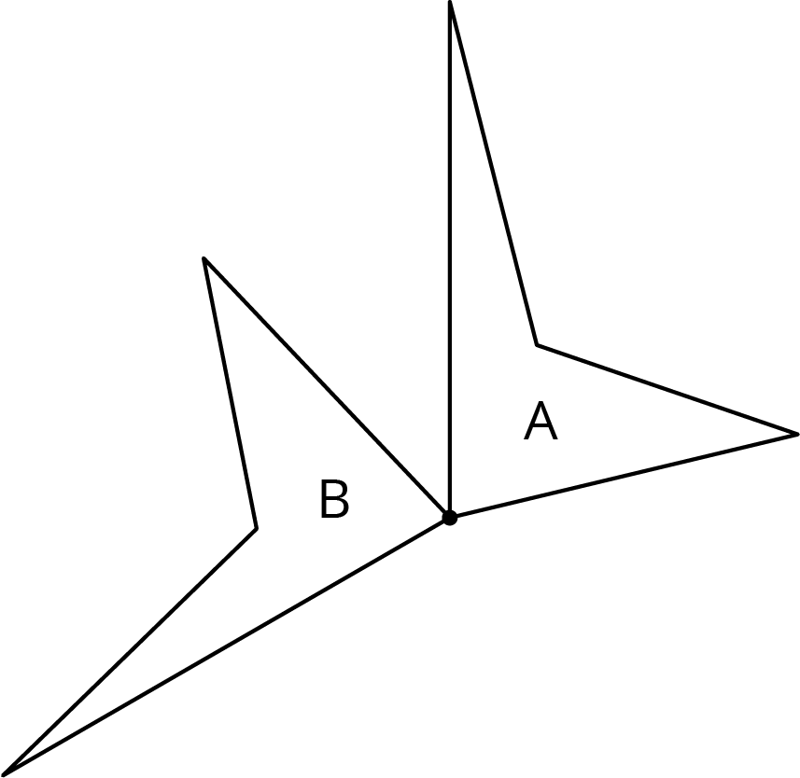
Estimate the angle of rotation.

2 How Did You Make That Move?

Student Task Statement
Here is another set of dance moves.
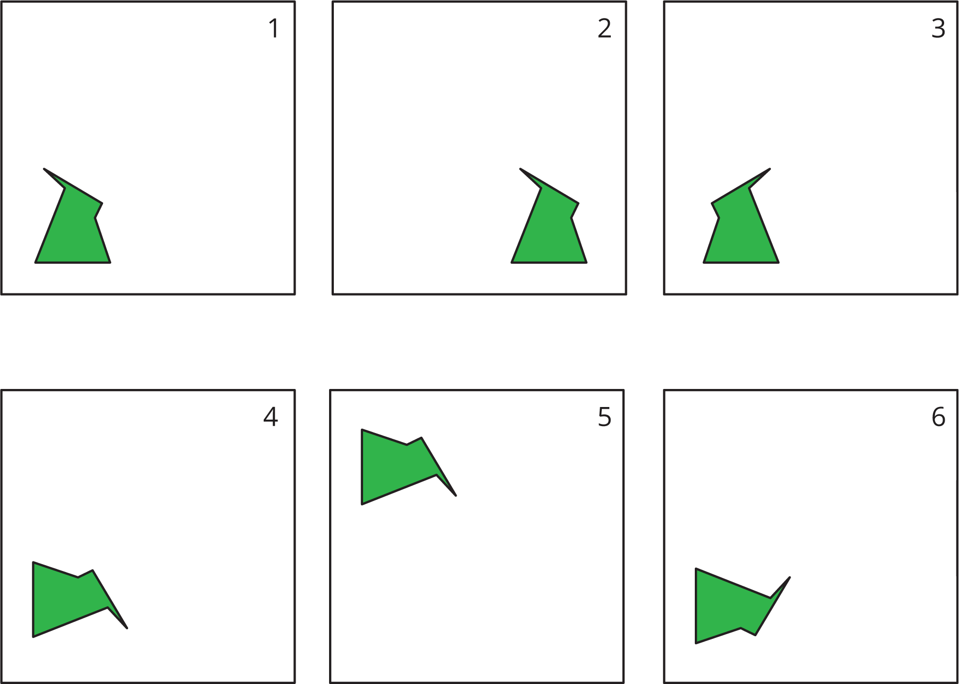
- Describe each move or say if it is a new move.
  - Frame 1 to Frame 2.
  - Frame 2 to Frame 3.
  - Frame 3 to Frame 4.
  - Frame 4 to Frame 5.
  - Frame 5 to Frame 6.
- How would you describe the new move?

Activity Synthesis
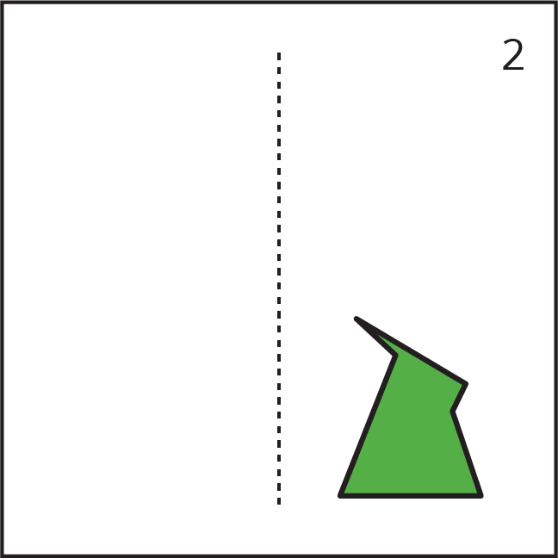

3 Card Sort: Move

Student Task Statement
Your teacher will give you a set of cards. Sort the cards into categories according to the type of move they show. Be prepared to describe each category and why it is different from the others.

Activity Synthesis
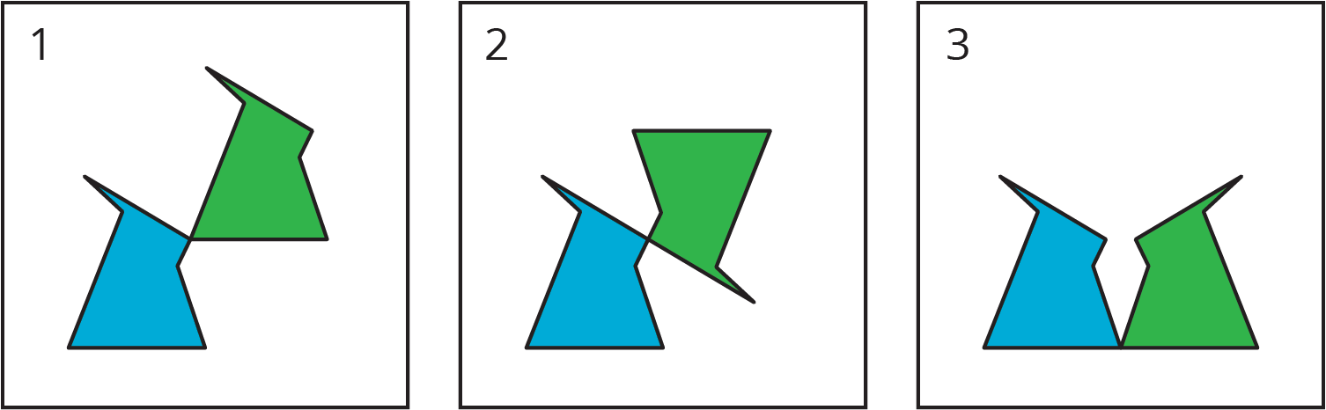

Images for Activity Synthesis
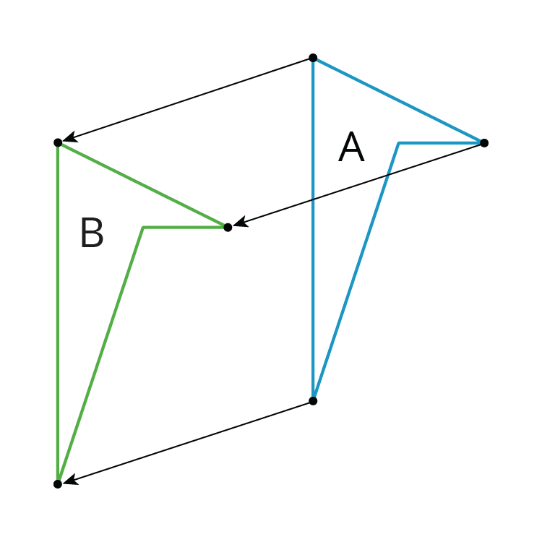
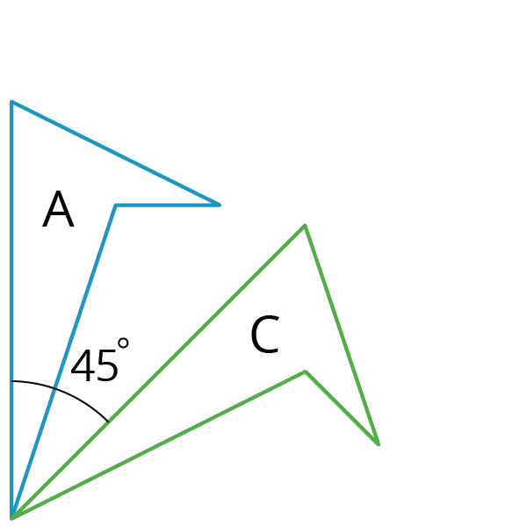
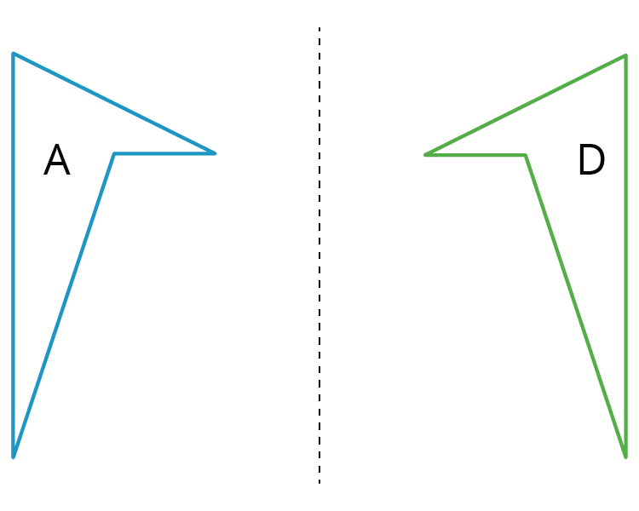
© CC BY Open Up Resources. Adaptations CC BY IM.

